CONTACT: Susan Krysiak FOR IMMEDIATE RELEASE
Director of Media Relations March 6, 2020
(609) 224-6036
skrysiak@capemaymac.org

Brenda Leonard is Mid-Atlantic Center for the Arts & Humanities (MAC) Volunteer of the Month for March

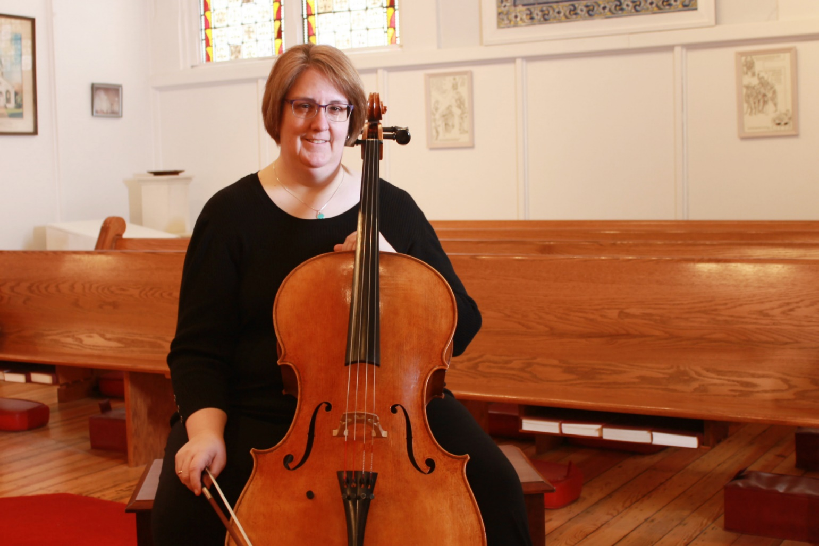

Shown here (photo by Susan Krysiak courtesy of MAC): Brenda Leonard of North Cape May, N.J. is the Mid-Atlantic Center for the Arts & Humanities (MAC) Volunteer of the Month for March. Leonard, who has a doctorate in musical arts, is a classically-trained professional cellist who generously shared her expertise and extraordinary musicianship with MAC as a presenter and educator in this winter’s Lunch & Learn program. She presented a special musical outreach program Jan. 29, consisting of a lecture about and mini-concert of Bach’s Cello Suites, which was exceptionally well-attended and well-received. Director of MAC’s Museum Education Division Melissa Palmer nominated her as Volunteer of the Month for her very engaging presentation, as well as for her assistance as an educator. “I nominated Brenda for jumping into programming, providing valuable feedback and ideas for upcoming educational program events,” said Palmer. “Sharing her passion for music with us and helping us in the Museum Education Division to provide the public with excellent and engaging programs is so very much appreciated. One of MAC’s strengths is drawing in people from the community who can share their expertise and passion with the public, and we are very fortunate that Brenda has embraced us in this way.” For information on the variety of MAC volunteer opportunities available, please contact Ayeshah Dickerson at 609-224-6029, or email adickerson@capemaymac.org. MAC is a multifaceted not-for-profit organization committed to promoting the preservation, interpretation, and cultural enrichment of the Cape May region for its residents and visitors.MAC membership is open to all. For information about MAC’s year-round schedule of tours, festivals, and special events, call 609-884-5404 or 800-275-4278, or visit MAC’s website at www.capemaymac.org.

###

