CONTACT: Susan Krysiak For Immediate Release
Director of Media Relations
609-224-6036
skrysiak@capemaymac.org

Magic & Mystery House Tour at Physick Estate focuses on Victorians’ fascination with illusion

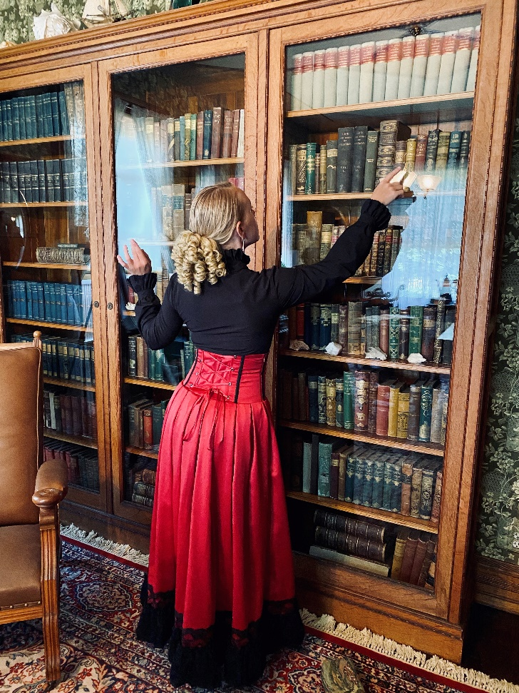

CAPE MAY – (May 18, 2021) (photo courtesy of Cape May MAC): Take a step back in time to the Victorian Era this spring and summer inside the 1879 Physick House Museum and learn about the Victorians’ fascination with magic, illusion, the mysterious and the odd. Visitors on the Magic & Mystery House Tour at the Emlen Physick Estate, 1048 Washington St. hear about the Great Lafayette, arguably the world’s greatest magician; Houdini, the astounding escape artist; Ionia, the Goddess of Mystery; and can decide for themselves whether Pepper’s Ghost is real, or just an Illusion. Tour-goers will learn about Sherlock Holmes, Jack the Ripper and much more. Tickets are limited to ensure social distancing and advance ticket purchase is recommended. These evening tours are offered Wednesdays and Saturdays in May; Tuesdays and Thursdays in June; and Fridays and Saturdays in July and August. Visit capemaymac.org for tickets and information. Adults $20; Children (ages 3-12) $15. Combine the tour with dinner at Vintage Restaurant on the grounds of the Physick Estate on select evenings for additional cost. Call 609-884-5404 for more information. Cape May MAC (Museums+Arts+Culture) is a multifaceted, not-for-profit organization committed to promoting the preservation, interpretation and cultural enrichment of the Cape May region for its residents and visitors. Cape May MAC membership is open to all. Visit capemaymac.org/support/membership to learn more. For information about Cape May MAC's year-round schedule of tours, festivals and special events, visit capemaymac.org. For information about historic accommodations, contact Cape May Historic Accommodations at capemaylodging.com. For information about restaurants, accommodations and shopping, call the Chamber of Commerce of Greater Cape May at 609-884-5508. For information on the city's COVID-19 response, please visit capemaystrong.org.

﻿###

