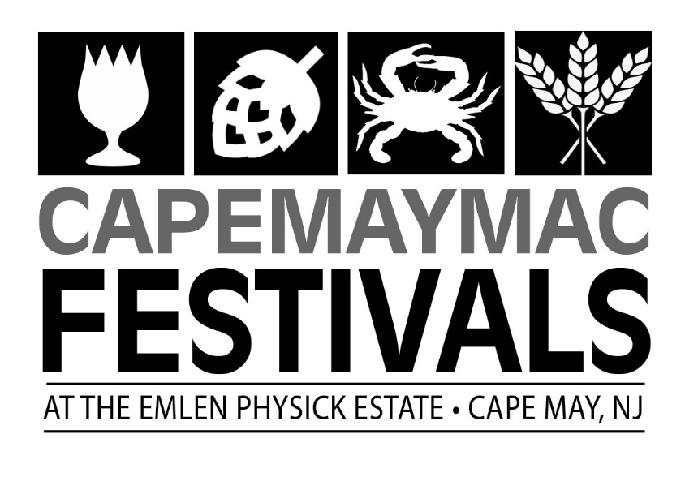
Craft Vendor Contract
Harvest Brew Festival Saturday, September 17, 2022
DEADLINE TO REGISTER (as long as vendor space is available)
Name _________________________________________
Email Address: ______________________________________________
Address: ___________________________________________________
City: __________________________ State: _________ Zip: _________
Contact Person: ____________________________ Phone: ___________
Description of items offered at event: ____________________________
___________________________________________________________
___________________________________________________________

General Guidelines:
- The Harvest Brew Festival will be held on the grounds of the Emlen Physick Estate, 1048 Washington Street, on September 18, 2021 from 10:00am – 5:00pm. The event is rain or shine.
- Exhibitors are responsible for providing their own 10 x 10 tent and tables. No generators.
- We only accept handmade, original pieces of art or collectibles.
- Spaces will be assigned upon arrival on site. Set-up time begins at 6:30am. We will not accept anyone after 9:30am. You are to unload your vehicle and them come back to set-up your space.
- All vendors are required to emphasize the theme of the festival, either beer or fall.
Insurance Requirements:
- Your application MUST have proof of insurance, listing the Mid-Atlantic Center for the Arts & Humanities as additionally insured for a minimum of $100,000 OR you must include an additional $10 fee to cover the insurance cost. Failure to include the proof of insurance or the $10 fee will result in your application being returned.

End of Festival Responsibilities:
- All vendors must have their products and any associated display materials cleared from the Emlen Physick Estate no later than 6:00pm on September 17, 2022. This is inclusive of any trash or debris associated with vendor area. You must remove your trash. DO NOT use the dumpster located on the grounds of the Emlen Physick Estate.
- You must pack up your items BEFORE bringing your vehicle onto the grounds.
Payment:
Number of spaces with vendor provide insurance at $175____________
Number of spaces without vendor provided insurance at $185________
There are NO refunds. This is a rain or shine event.
Credit Card Number ____________________________________________ Exp Date________ CID# _______
Or Check #____________________

I shall not hold Cape May MAC staff, volunteers or any of its representatives responsible for accidents to me, my staff, or property and I agree to assume all financial responsibility including but not limited to damages to property or injuries to person, which arise or are claimed to arise out of or in connection with my participation in the Harvest Brew Festival located at the Emlen Physick Estate.
I agree to comply with all applicable Federal, State and Local laws, rules and regulations while participating in the Harvest Brew Festival.
I have read all the rules and regulations of the Harvest Brew Festival and agree to abide by them.
Vendor Signature: ________________________________________ Date: ___________________
Printed Name: ___________________________________________

RETURN FORMS TO: Janice Corkery jcorkery@capemaymac.org
Cape May MAC
Po Box 340
Cape May, NJ 08204
Contact phone number: 609-224-6027

