CONTACT: Susan Krysiak FOR IMMEDIATE RELEASE
Director of Media Relations Feb. 7, 2021
(609) 224-6036
skrysiak@capemaymac.org

Cape May Lighthouse is open Feb. 14 for Valentine’s Day

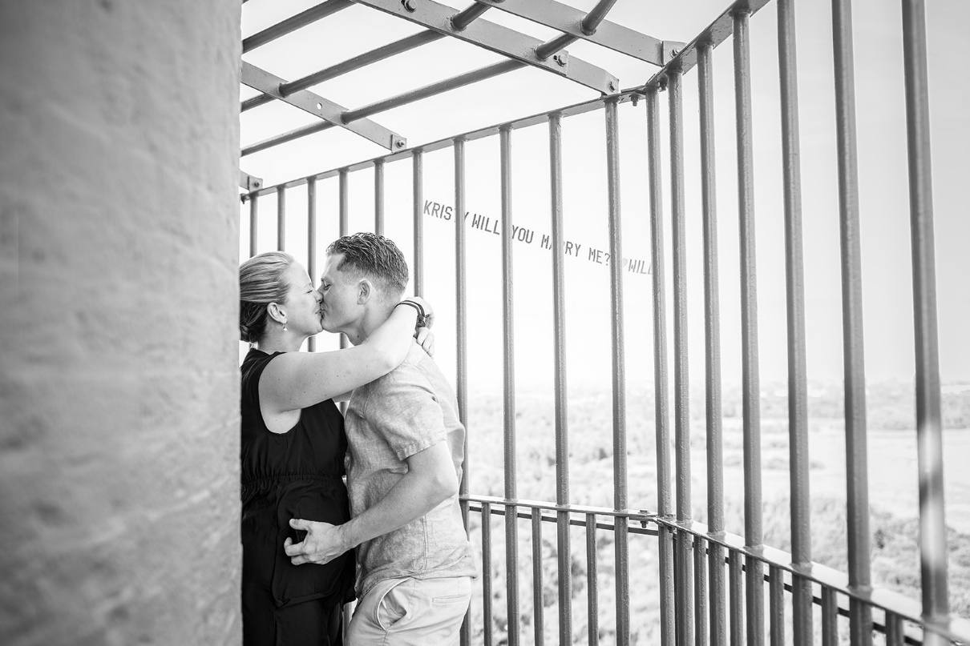

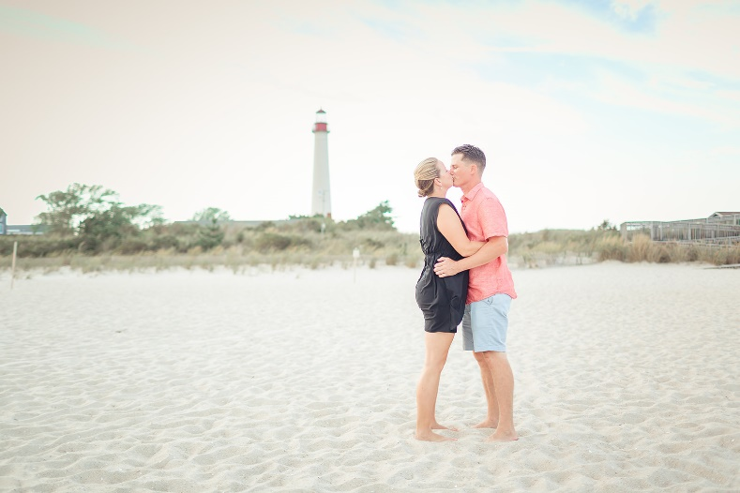

Shown here (photo courtesy of Cape May MAC): To the delight of all lighthouse lovers, the Cape May Lighthouse will open on Monday, Feb. 14 from noon to 3 p.m. Typically closed on Mondays during the off-season, the Lighthouse will be fully open for the holiday, inviting visitors to climb the 199 steps together for a brisk and beautiful viewing of the Delaware Bay. Uniquely scenic, the Lighthouse is a favorite locale for engagements, intimate weddings, and special memories with loved ones. Admission to climb is $12 for adults, and $8 for children aged 3-12. To learn how Cape May MAC can help you coordinate an unforgettably romantic day, visit https://capemaymac.org/plan/rent-a-venue/ or call Helen Mashuda, Cape May MAC Special Events/Wedding Coordinator, at (609) 224-6040. Cape May MAC (Museums+Arts+Culture) is a multifaceted, not-for-profit organization committed to promoting the preservation, interpretation and cultural enrichment of the Cape May region for its residents and visitors. Cape May MAC membership is open to all. Visit capemaymac.org/support/ membership to learn more. For information about Cape May MAC’s year-round schedule of tours, festivals and special events, visit capemaymac.org. For information about historic accommodations, contact Cape May Historic Accommodations at capemaylodging.com. For information about restaurants, accommodations and shopping, call the Chamber of Commerce of Greater Cape May at 609-884-5508.
###

