CONTACT: Susan Krysiak FOR IMMEDIATE RELEASE
Director of Media Relations
(609) 224-6036
skrysiak@capemaymac.org

Garden Club of Cape May members are Volunteers of the Month for January

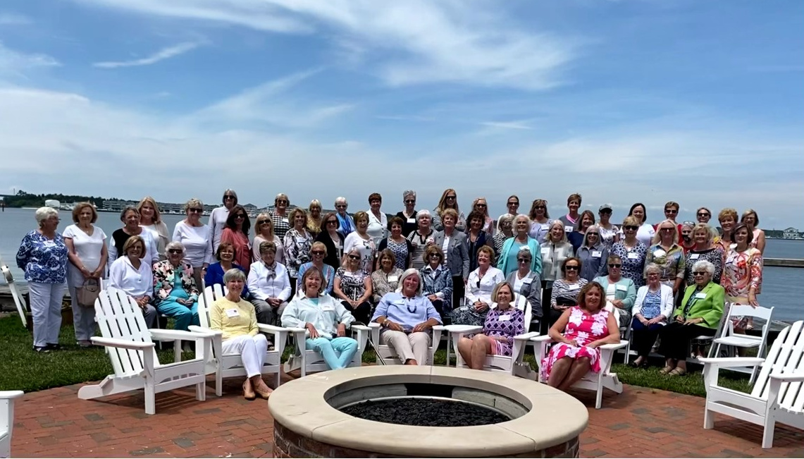

(Jan. 31, 2022) (photo courtesy of Cape May Garden Club): Shown here, Garden Club of Cape May members are the Cape May MAC (Museums+Arts+Culture) Volunteers of the Month for January. Cape May MAC Chief Outreach Strategist Mary Stewart nominated them for the honor, for their steadfast participation in Cape May MAC activities that have enhanced visitors’ experience at the Emlen Physick Estate: Scarecrow Alley and the Winter Wonder Walk. Each year, Cape May MAC puts out the call to community members to create their own homemade scarecrows for Scarecrow Alley, on display during the month of October on the grounds of the Emlen Physick Estate, 1048 Washington St., Cape May. Winter Wonder Walk has followed Scarecrow Alley for several years with winter-themed displays celebrating the winter months. “The members of the Garden Club of Cape May have created elaborate displays for each of these community events, coming up with unique themes and executing an outdoor display with panache,” said Stewart. “They tend them for the duration of the display for a month or longer, to keep them looking good. We appreciate their outstanding enthusiasm and commitment to these creative activities that attract visitors to the grounds and create a lot of joy and excitement.” Officers of the Garden Club of Cape May are President Debbie Yeager, Vice President Carol Venet, Treasurer Linda Gast, Recording Secretary Ellen Seward and Corresponding Secretary Glenda Unzelmann. Cape May MAC is a multifaceted not-for-profit organization committed to promoting the preservation, interpretation and cultural enrichment of the Cape May region for its residents and visitors. Cape May MAC membership is open to all. For information about our year-round schedule of tours, festivals and events, visit capemaymac.org.

###

