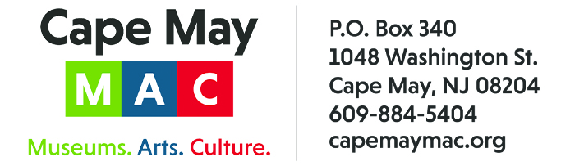

CONTACT:
Susan Krysiak For Immediate Release
Director of Media Relations April 28, 2022
609-224-6036
skrysiak@capemaymac.org

National Park Service app includes Cape May’s Underground Railroad Trolley Tour
Cape May MAC and Center for Community Arts launched this tour in 2017 and it’s now one of 13 sites in the new NPS Travel with Tubman app

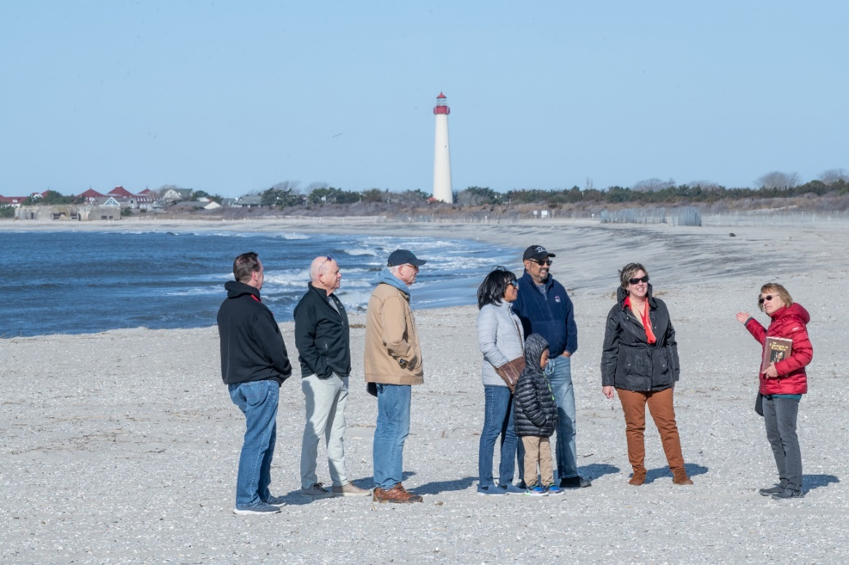
Photo by Frank Scott
Shown here, this beach at South Cape May Meadows, Cape May, N.J., is where tour-goers hear a story of the dangerous crossing to freedom across the Delaware Bay from Delaware and Maryland, the first stop on Cape May MAC’s Underground Railroad Trolley Tour. The tour is now part of a new National Park Service app called Travel with Tubman.

CAPE MAY, N.J. - A powerful advocate, freedom fighter, and hero, Harriet Tubman’s story takes form in a new trip-planning tool through the National Park Service (NPS) app. Travel with Tubman: Let Harriet Tubman Guide You on the Journey of a Lifetime highlights 13 sites that most affected Tubman throughout her life, representative of her 13 rescue missions to Maryland.
One of these 13 “sites” is Cape May MAC’s Underground Railroad Trolley Tour, the first stop of which is at South Cape May Meadows Beach off Mount Vernon Avenue. At the stop, tour-goers hear the story of six freedom seekers in 1860 who braved the Delaware Bay to cross to freedom by boat into New Jersey, guided by the light of the Cape May Lighthouse. The Cape May MAC/Center for Community Arts (CCA) Underground Railroad Trolley Tour is a Network to Freedom member, a minimum qualification for inclusion in the new app. Over 1,000 individuals have taken the tour since it launched in 2017.
“With hundreds of sites that relate to Harriet Tubman, it is a great honor that our Underground Railroad Trolley Tour was chosen by NPS to be included as one of the 13 sites in Travel with Tubman,” said Cape May MAC Board Member Barbara Dreyfuss, who was instrumental in researching and writing the Underground Railroad Trolley Tour and who successfully applied to have the NPS recognize it in the Network to Freedom.
“We are honored to be part of this NPS program that will help tell the important story of Harriet Tubman in Cape May,” said Cape May MAC Board Member Wanda Wise Evelyn, who also worked closely with the NPS coordinating Cape May’s part in the new app. Wise, who has centuries-old ties to the Cape May area, has done extensive research on Cape May’s Black history and has served on CCA’s History Committee.
Travel with Tubman launched April 18. It was developed as part of the year-long celebration of the bicentennial of Tubman’s birth. Together with community stewards and partners, the NPS National Underground Railroad Network to Freedom Program developed this tool to provide visitors with a guide for exploring Tubman’s life and legacy in national parks, National Heritage Areas, and historic sites across the eastern United States.
“It is a humbling experience to trace the footsteps of a hero like Harriet Tubman and reflect on everything she endured and accomplished during her lifetime. Thanks to the collaborative work of the National Underground Railroad Network to Freedom and its partners, Travel with Tubman can help visitors forge deeper connections through the power of place,” said NPS Director Chuck Sams. “This trip-planning tool highlights the story of Tubman and her iconic legacy in a new way, bringing to light some of the most significant sites associated with her life.”
Born on the Eastern Shore of Maryland, Harriet Tubman developed deep connections to faith, community, and family during her childhood. After she escaped slavery, Tubman felt an obligation to return to her birthplace and assist her family to freedom. She referred to herself as a conductor on the Underground Railroad and utilized her connections with other Underground Railroad activists across the Northeast to lead groups of enslaved people to freedom in Canada. Tubman also traversed the Southeast United States while she served as a scout, spy, and nurse during the American Civil War.

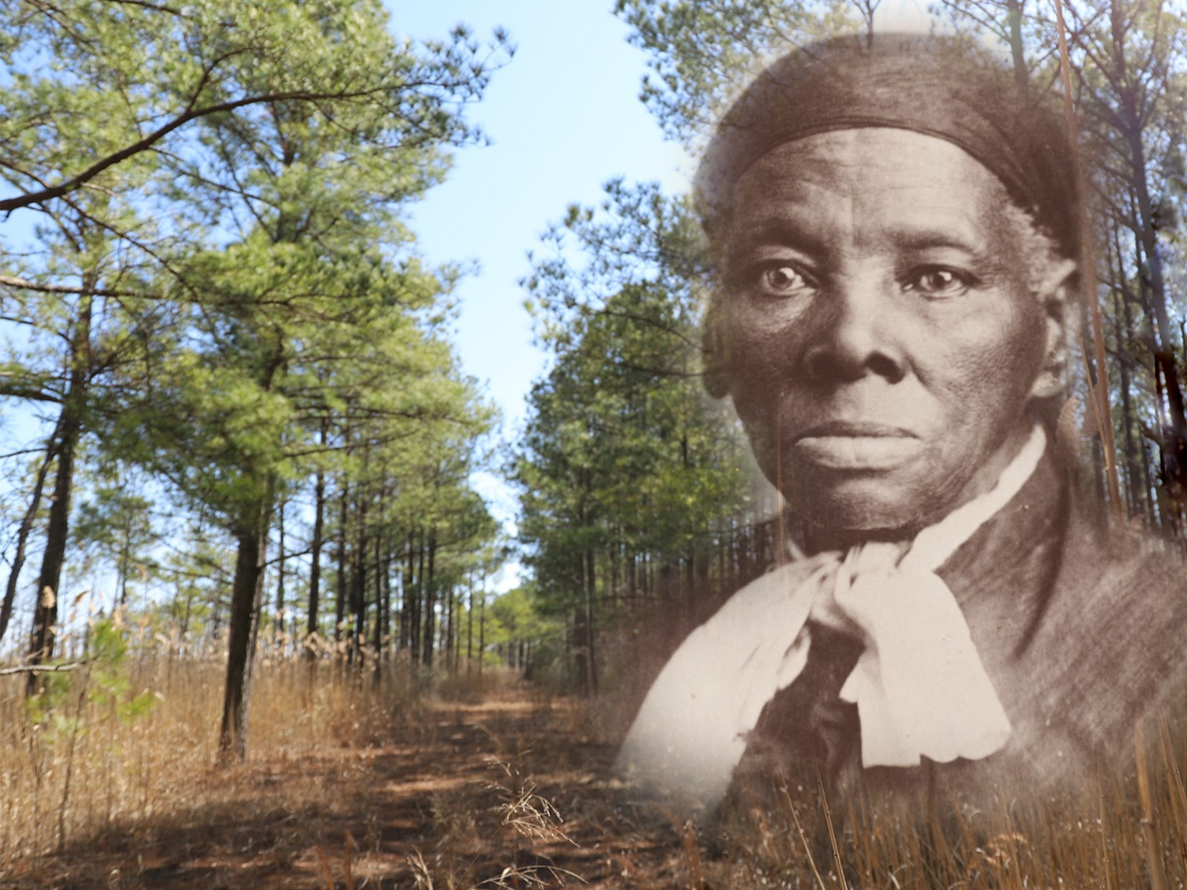
Courtesy of the National Park Service
Shown here, a new National Park Service app called Travel with Tubman launched April 18 that guides visitors up and down the east coast to learn about historic sites important to Harriet Tubman.

“After emancipating herself, Harriet Tubman continued to give back to her community in every way she knew how,” said NPS National Underground Railroad Network to Freedom Program Manager Diane Miller. “The National Park Service and our partners have a responsibility to come together and share her story with the world – and this tour is a great example of what we can accomplish by working together.”
Travel with Tubman is available online at https://www.nps.gov/articles/000/travel-with-tubman.htm and best viewed through the free NPS app, downloadable in the iOS App Store and Google Play Store. Users can also download and print “The Conductor,” or create their own guide to lead them on a once in a lifetime road trip. Share your photos from Tubman-related sites and show us how you #TravelWithTubman.
Cape May MAC Underground Railroad Trolley Tours are offered Saturdays, May 7-28 at 10:30 a.m., Saturdays, June 4-25 at 9:30 a.m., Thursdays, July 7-Aug. 25 at 9:30 a.m. and Saturdays, Sept. 3-Oct. 29 at 10 a.m. Advance purchase is recommended. Tickets for the tour may be purchased online at https://cmmac.ticketapp.org/portal/product/16 For more information visit capemaymac.org or call 609-884-5404.

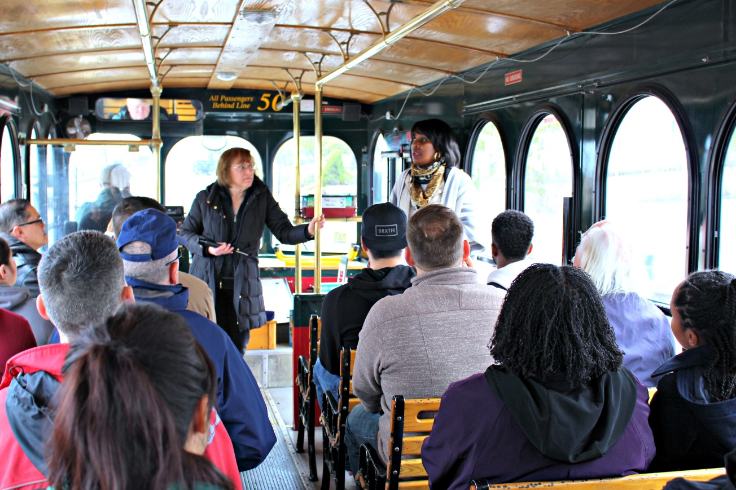
Photo by Susan Krysiak
Shown here, U.S. Coast Guard TRACEN Cape May members on Feb. 26, 2018 take Cape May MAC’s Underground Railroad Trolley Tour. The tour is part of a new National Park Service app called Travel with Tubman.

###

About the Network to Freedom:
The National Underground Railroad Network to Freedom serves to honor, preserve, and promote the history of resistance to enslavement through escape and flight, which continues to inspire people worldwide. The Network currently represents over 700 locations in 39 states, plus Washington D.C. and the U.S. Virgin Islands. Through its mission, the Network to Freedom helps to advance the idea that all human beings embrace the right to self-determination and freedom from oppression.

About the National Park Service:
More than 20,000 National Park Service employees care for America’s 423 national parks and work with communities across the nation to help preserve local history and create close-to-home recreational opportunities. Learn more at www.nps.gov.

About Cape May MAC:
Cape May MAC (Museums+Arts+Culture) is a multifaceted, not-for-profit organization committed to promoting the preservation, interpretation and cultural enrichment of the Cape May region for its residents and visitors. Cape May MAC membership is open to all. Visit capemaymac.org/support/membership to learn more. .For information about Cape May MAC’s year-round schedule of tours, festivals and special events, visit capemaymac.org or call 609-884-5404. For information about historic accommodations, contact Cape May Historic Accommodations at capemaylodging.com. For information about restaurants, accommodations and shopping, call the Chamber of Commerce of Greater Cape May at 609-884-5508.

