CONTACT: Susan Krysiak For Immediate Release
Director of Media Relations Aug. 20, 2022
609-224-6036
skrysiak@capemaymac.org

Halloween Happenings in Victorian Cape May feature ghosts & spirits tours, activities and events in October

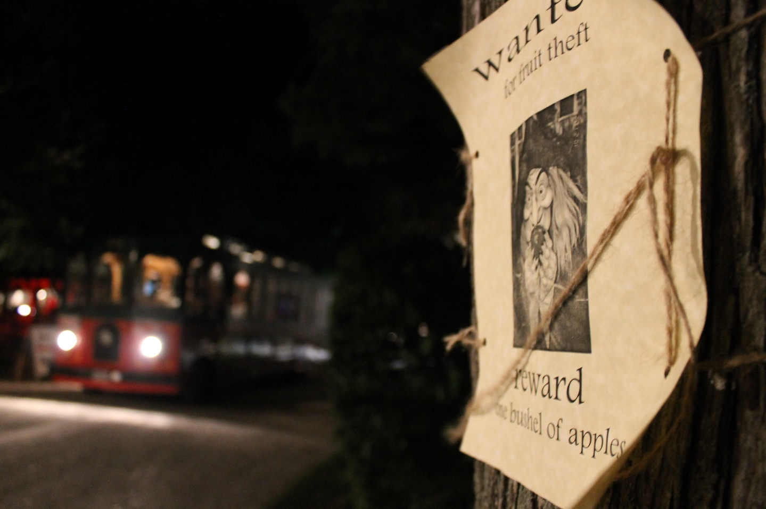
Photo by Susan Krysiak/Courtesy of Cape May MAC
Ghosts tours are one of Cape May MAC’s most popular tours during October and are also offered year-round..

CAPE MAY – October in Cape May is the spooky season with ghosts and spirits claiming their place along the backstreets and byways of this historic seaside town. Victorian Cape May, the nation’s oldest seashore resort, is surrounded on three sides by water at the southernmost point of New Jersey. The town holds echoes of seaside spirits who sometimes make their voices heard here. Seances, walking tours and trolley tours are all available as the weather cools and the evenings grow darker earlier. Many tours are also available year-round. Experience what some call one of the most haunted towns in the nation, during the eeriest time of the year, October. Some tours, activities and events sell out quickly and admissions are limited.
Ghosts of Cape May Trolley Tour
What was that shadow? Was it the undead of Cape May’s past wandering their beloved haunts? You might scoff, you might shudder, but rest assured, on board a trolley with an experienced guide you will begin to wonder what’s beyond when you hear the tales of hauntings unearthed in Cape May by renowned psychic medium and author Craig McManus on this half-hour evening tour. Begins and ends at the Ocean Street trolley stop.
Ghosts of the Lighthouse Trolley Tour
Travel along the ghostly path that leads to the Cape May Lighthouse during this hour-long evening trolley tour just as dusk darkens the shadows. You will visit the 1859 Cape May Lighthouse, silent witness to storms and tragedy for over a century of maritime history. Hear the tales of brazen pirates and lonely maids, with Cape May ghost stories unearthed by renowned psychic medium and author Craig McManus. Climb to the top of the lighthouse or stay below. Begins and ends at the Ocean Street trolley stop.
Graveyard, Ghosts & Mansion Combo Tour
Hear the stories and experiences of ghost activity in the 1879 Physick House Museum from the Cape May MAC tour guides who know them personally on this two-hour evening tour. It starts with a trolley ride to the historic Cold Spring Presbyterian Cemetery to see the graves of Dr. Emlen Physick and his family. At the graveyard you’ll hear EVPs (electronic voice phenomena) recorded by tour guides and staff at the estate. On your return trip to the Physick Estate hear about some unusual Victorian funereal customs. Then, inside the Physick House you will visit several rooms and hear several more EVPs while learning more about the activity observed there. Take the opportunity to talk to staff about their experiences, and a moment to wonder what it all means. Tour begins and ends at the Physick Estate.
Halloween Crafts & Collectibles Show
Visit the Emlen Physick Estate, 1048 Washington St., Saturday, Oct. 29, from 10 a.m. to 3 p.m. for this open-air show featuring wares of local vendors and crafters. Explore our 12th annual Scarecrow Alley which decorates the grounds. Feel free to come in costume to celebrate this festive holiday! Admission is free.
Historic Haunts Combination Tour
Take an evening trolley ride through the Historic District and hear stories of haunted Cape May. Step off the trolley at the Physick House Museum with your guide and see Cape May’s only Victorian house museum, reputed to be haunted, as you learn about Victorian Spiritualism. In the museum, guides will compare the methods of spirit contact used by the Victorians with those of today’s paranormal investigators. Selected rooms on both floors are included in the tour. Begins and ends at the Ocean Street trolley stop.
Murder Mystery Dinner: Off to the Races
Enjoy a three-course dinner and watch as the mystery and drama unfold around you Wednesdays, Sept. 28 and Oct. 5 during “Off to the Races,” an original mystery written by Jacklyn Fazio. When catastrophe strikes at one of the biggest and most important horse races of the year, everyone from the fans to the judges has their own opinions about what happened. Was this truly a tragic accident, or is something more sinister going on? And what could this mean for the future of the racetrack? Limited event. The Chalfonte Hotel, 301 Howard St.
Phantoms of the Physick Estate: The Spellbound Sisters
Ever since three strange sisters moved into the 1879 Emlen Physick Estate, Cape May has not been the same. Rumors say that these women might be using dark magic. Join in this interactive mystery play as you move through Cape May’s Victorian House Museum with three mysterious guides.
Scarecrow Alley
Walk the grounds of Cape May's original “haunted house,” the 1879 Physick Estate, 1048 Washington St., and enjoy the 12th Annual Scarecrow Alley during October, a community display of creative, scary and funny scarecrows built by local businesses, families, schools, community groups and Individuals. Every year is something new! Admission is free.
Séance at the Physick Estate
Psychic medium Craig McManus leads 25 lucky people through Cape May's original haunted house, the 1879 Physick House Museum, and shares his many supernatural encounters and experiences there. He might even channel a spirit or two.
Sherlock Holmes Weekend: Sherlock Holmes & Send in the Clowns!
Join fellow sleuths at Cape May Stage over a weekend of mystery with Sir Arthur Conan Doyle’s master sleuth, Sherlock Holmes, and his loyal friend Dr. John Watson, in an original mystery, “Sherlock Holmes & Send In the Clowns!” by Jacklyn Fazio who returns as writer, director and actress. When Sherlock and Watson find themselves under the big top, a simple favor for a friend turns into a spectacle that our heroes were not prepared to witness. Will they be able to figure out who is terrorizing the circus and its dedicated performers before it’s too late? Two weekends will be presented: Friday, Oct. 14-Sunday, Oct. 16 and Friday, Oct. 21-Sunday, Oct. 23. Weekends begin with registration at 7 p.m. Act I to start at 7:30 p.m. Saturday’s Search for Clues Tour will be from 1 p.m.-3 p.m. Act II will be back at Cape May Stage at 3:30. On Sunday, Act III will begin at 11 a.m. Stalk the streets of Cape May in your own search for clues to help fill in the missing pieces while competing for the grand prize: a weekend for two to next year’s performance. Tickets do not include meals. Cape May Stage is located at 405 Lafayette St. Packages including accommodations are available.
Spirits & Oddities Trolley Tour
Cats in ghostly form purr from the beyond. Beloved family members in photographs without their heads. Graves equipped with a torpedo to put off intruders. Victorians of the late 19th century had wild notions about the passage from life to death. Belief in ghosts and spirits was common and superstition abounded. Hear several Cape May ghost stories and more strange stories from Victorian Cape May history that are macabre, mysterious or just plain weird on this 30-minute evening tour. Begins and ends at the Ocean Street trolley stop.
New! Spirits, Magic & Mystery Combo Tour
Victorians of the late 19th century had wild notions about the passage from life to death, and were fascinated by mystery and illusion. Belief in ghosts and spirits was common and superstition abounded. Hear eerie ghost stories as you travel Cape May by trolley, along with strange stories from Victorian Cape May history that are macabre, mysterious or just plain weird. Then visit select rooms in the 1879 Physick House Museum and learn about the famous Harry Houdini who captivated Victorian audiences with his intricate escapes, Ionia, a Belgian beauty called the Goddess of Mystery, who Victorians loved for her spectacles of magic, and many more famous Victorian masters and mistresses of illusion. Begins & ends at the Washington Street Mall Trolley Stop.
Trick Or Treat At The Physick Estate
On Halloween some spooky characters await at the Emlen Physick Estate, with Halloween treats for good little ghosts and goblins, pirates and princesses from 5 p.m. to 7 p.m. Monday, Oct. 31.
Dept. 56 Halloween Display
Dozens of miniature skeletons, ghosts and spooky characters beckon in a Dept. 56 Halloween Display inside the porch of the Physick House Museum at the Emlen Physick Estate, 1048 Washington St. This colorful and spectacular display of Halloween-themed Dept. 56 collectibles, is offered daily through October. Free admission.
Fall Crafts & Collectibles Shows
Crafters and collectibles dealers from throughout the region display and sell their wares on the lawn of the Emlen Physick Estate, 1048 Washington St. during Victorian Weekend Crafts & Collectibles Show, 10 a.m. to 4 p.m. Sunday, Oct. 9. Free admission. Free parking available.
Crafters and antiques dealers from throughout the region display and sell their wares during Crafts & Collectibles By the Sea at Cape May Convention Hall, Beach Avenue at Stockton. 10 a.m. to 4 p.m. Saturday, Oct. 22. Admission $2.
Crafters and antiques dealers from throughout the region display and sell their wares during Fall Crafts & Collectibles Show at Cape May Convention Hall, Beach Avenue at Stockton. 10 a.m. to 4 p.m. Saturday, Nov. 5. Admission $2.

*COVID-19 protocols will follow CDC guidelines and government mandates and may change. Schedule is subject to change.

Cape May MAC (Museums+Arts+Culture) is a multifaceted not-for-profit organization committed to promoting the preservation, interpretation, and cultural enrichment of the Cape May region for its residents and visitors. Cape May MAC membership is open to all. For information about the organization’s year-round schedule of tours, festivals, and special events, call 609-884-5404 or visit capemaymac.org. For information about restaurants, accommodations and shopping, call the Chamber of Commerce of Greater Cape May at 609-884-5508. For information about historic accommodations, contact Cape May Historic Accommodations at www.capemaylodging.com.

