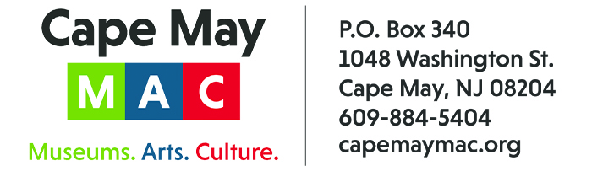

CONTACT: Susan Krysiak For Immediate Release
Director of Media Relations Aug. 24, 2022
609-224-6036
skrysiak@capemaymac.org

Harvest Brew Fest Sept. 17 features music, craft beers, family fun at Cape May’s Physick Estate

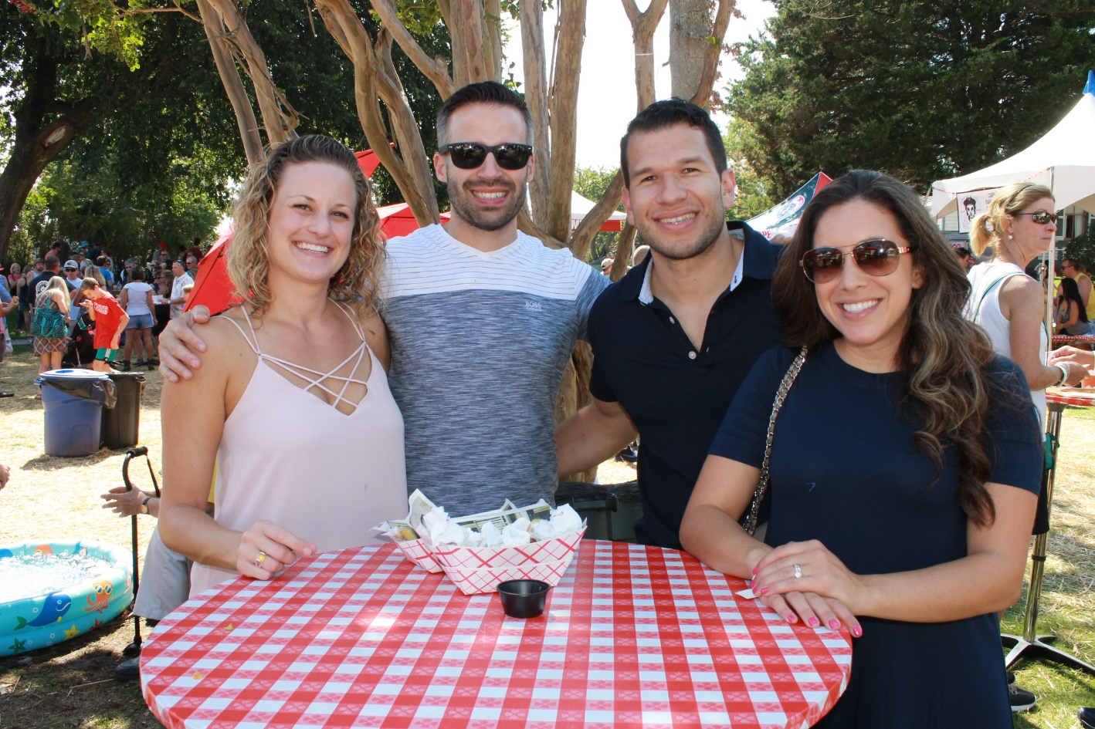
Photo courtesy of Cape May MAC
The Harvest Brew Fest at the Emlen Physick Estate is set for Sept. 17 from 10 a.m. to 5 p.m. this fall.

CAPE MAY – Come celebrate the cooling off of summer and the start of fall in South Jersey Saturday, Sept. 17 from 10 a.m. to 5 p.m. during Harvest Brew Fest, a full day of celebration and relaxation presented by Cape May MAC (Museums+Arts+Culture) and sponsored by PNC Bank, at the beautiful grounds of the Emlen Physick Estate, 1048 Washington St.
Enjoy craft beers and more during this all-day festival that features local food vendors, local artisans, local breweries and local musical talent. The festival is free to attend, and proceeds support the ongoing restoration of Cape May MAC historic sites, the 1879 Emlen Physick Estate, the 1859 Cape May Lighthouse and the 1942 World War II Lookout Tower, all on the national and New Jersey Registers of Historic Places.
Relax and listen to live music on the outdoor stage. Bring a lawn chair or spread out your beach blanket in the shade for a great afternoon and evening of musical performers. Corndog Blues is playing from 10 a.m. to 12 noon and Fat Mezz is playing from 1 p.m. to 5 p.m.
Food vendors include Gaiss’ Meat Market, Matt’s BBQ, Chank’s Grab & Go, House of Cupcakes, Bake’ n Bacon, Boy Scouts Hot Dog Stand and Mermaid Mutineer.
Beverage vendors include Cape May Brewing Company, 7 Mile Brewery, COHO Brewing Company, Gusto Brewery, Slack Tide Brewery, Ludlum Island Brewery, Mudhen Brewery, and Cold Spring Brewery, along with wine, and spirits from Nauti Spirits Distillery. Cape May Winery also sells a variety of wines by the bottle in the Carriage House Museum Shop.
Bring the entire family to enjoy kid-friendly activities including lawn games. Mystery Circus Arts will perform circus acts and magic shows from 11 a.m. to 4 p.m. Mackie the Stilt Walker will greet visitors. A cooling off tent for pets will be available. Purchase customized festival T-shirts produced on-site from Flying Fish Studio. Explore the variety of crafts and collectibles vendors on the estate grounds selling handmade and vintage items.
Admission to the grounds is free and free parking is available off site at the Cape May Elementary School, 921 Lafayette St. A free trolley shuttle will also operate from the Washington Street Mall Information Booth at Ocean Street to the estate throughout the day. There will be a charge for food, beverages and some activities.
Please bring ID for age identification to purchase alcoholic drinks.
Cape May MAC (Museums+Arts+Culture) is a multifaceted, not-for-profit organization committed to promoting the preservation, interpretation and cultural enrichment of the Cape May region for its residents and visitors. Cape May MAC membership is open to all. Visit capemaymac.org/support/membership to learn more. For information about Cape May MAC’s year-round schedule of tours, festivals and special events, visit capemaymac.org. For information about historic accommodations, contact Cape May Historic Accommodations at capemaylodging.com. For information about restaurants, accommodations and shopping, call the Chamber of Commerce of Greater Cape May at 609-884-5508.
###

