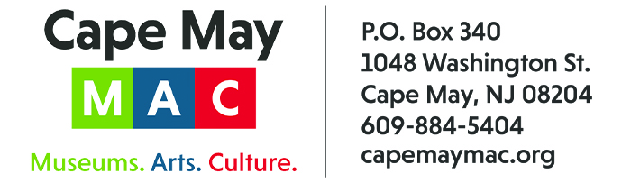

CONTACT: Susan Krysiak For Immediate Release
Director of Media Relations
609-224-6036
skrysiak@capemaymac.org

Murder is in the air with this fall’s Murder Mystery Dinner ‘Off to the Races’ at The Chalfonte Hotel

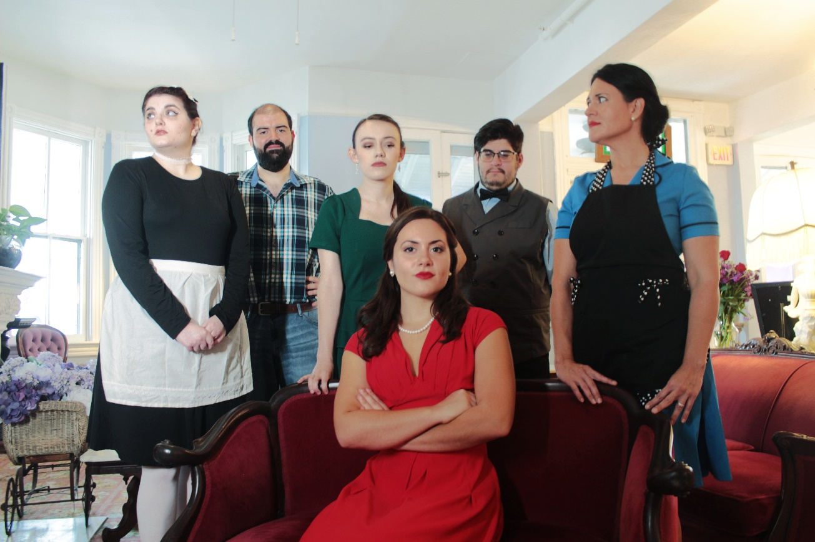

CAPE MAY – (Aug. 1, 2022) Enjoy a three-course dinner and watch as the mystery and drama unfold around you at Cape May’s historic Chalfonte Hotel during “Off to the Races,” an original mystery written by Jacklyn Fazio and presented by Cape May MAC (Museums+Arts+Culture). When catastrophe strikes at one of the biggest and most important horse races of the year, everyone from the fans to the judges has their own opinions about what happened. Was this truly a tragic accident, or is something more sinister going on? And what could this mean for the future of the racetrack? Offered Thursday, Sept. 28 and Wednesday, Oct. 5, from 7:30 p.m. to 9 p.m. Tickets are limited. Visit capemaymac.org or call 609-884-5404 to purchase tickets and for more information. Admission is $65 adults, $30 children (ages 3-12). Cape May MAC (Museums+Arts+Culture) is a multifaceted, not-for-profit organization committed to promoting the preservation, interpretation and cultural enrichment of the Cape May region for its residents and visitors. Cape May MAC membership is open to all.

﻿###

