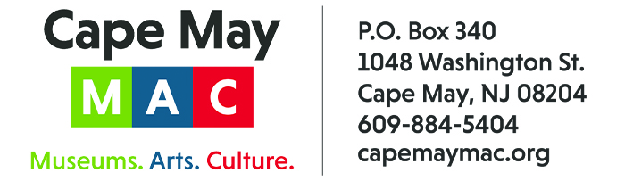

CONTACT: Susan Krysiak For Immediate Release
Director of Media Relations
609-224-6036
skrysiak@capemaymac.org

Sherlock & Watson lead you on a new mystery this fall, ‘Sherlock Holmes & Send in the Clowns!’

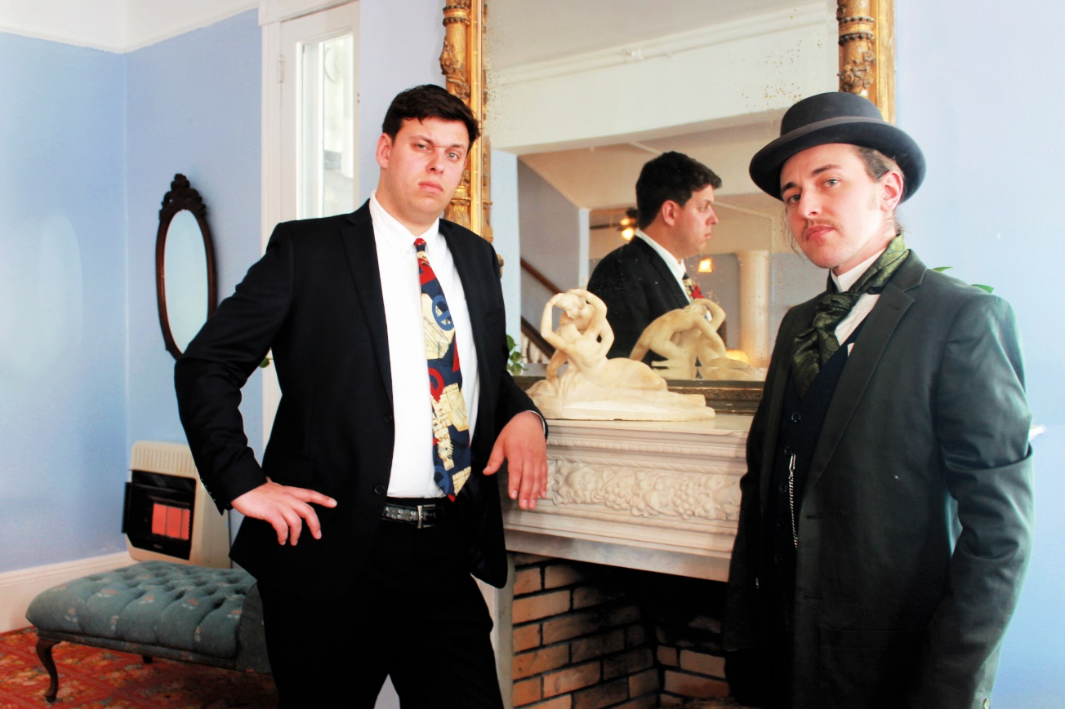

CAPE MAY – (Aug. 1, 2022) (photo courtesy of Cape May MAC) Join fellow sleuths over a weekend of mystery with Sir Arthur Conan Doyle’s master sleuth, Sherlock Holmes, and his loyal friend Dr. John Watson, in a new original mystery, “Sherlock Holmes & Send In the Clowns!” by Jacklyn Fazio, at the historic Cape May Stage. When Sherlock and Watson find themselves under the big top, a simple favor for a friend turns into a spectacle that our heroes were not prepared to witness. Will they be able to figure out who is terrorizing the circus and its dedicated performers before it’s too late? Two weekends will be presented: Friday-Sunday, Oct. 14-16 and Oct. 21-23. Weekends begin with registration at 7 p.m. Act I begins at 7:30 p.m. Saturday’s Search for Clues Tour will be from 1 p.m.to 3 p.m. when you stalk the streets of Cape May in search of clues to fill in the missing pieces while competing for the grand prize: a weekend for two to next year’s performance. Act II is back at Cape May Stage at 3:30 p.m. On Sunday, Act III begins at 11 a.m. Tickets do not include meals. Cape May Stage is located at 405 Lafayette St. Packages including accommodations are available. Visit capemaymac.org or call 609-884-5404 for tickets and more information. Cape May MAC (Museums+Arts+Culture) is a multifaceted, not-for-profit organization committed to promoting the preservation, interpretation and cultural enrichment of the Cape May region for its residents and visitors. Cape May MAC membership is open to all. Visit capemaymac.org/support/membership to learn more.

﻿###

