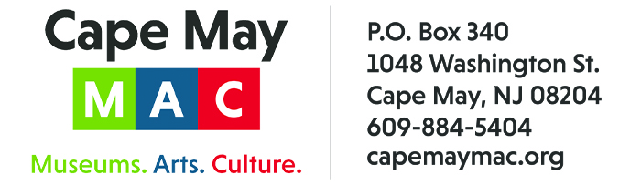

CONTACT: Susan Krysiak For Immediate Release
Director of Media Relations
609-224-6036
skrysiak@capemaymac.org

Celebrate Cape May’s history and architecture this fall during Victorian Weekend in Cape May

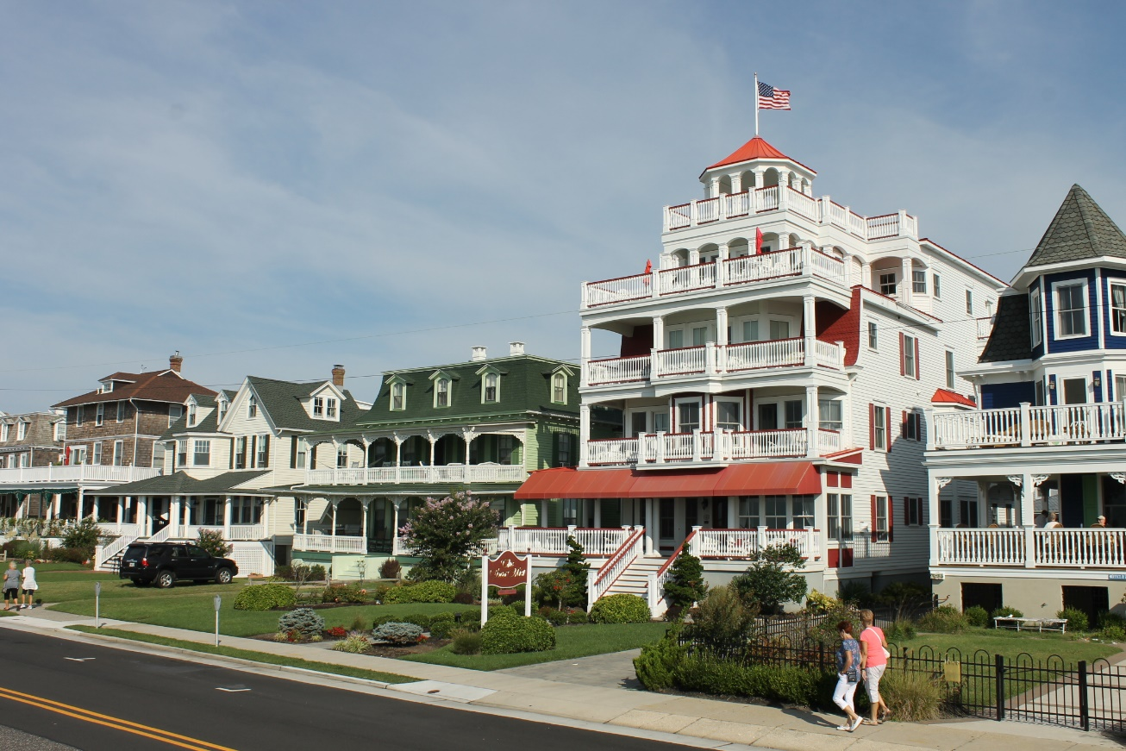

CAPE MAY – (Aug. 26, 2022) Celebrate the Victorian history and architecture of America’s First Seaside Resort, Cape May, N.J., during Victorian Weekend Oct. 7-10. presented by Cape May MAC (Museums+Arts+Culture). Trolley tours, house tours, walking tours, custom tours, a Victorian Weekend Crafts & Collectibles Show and more are featured during this long holiday weekend. Shown here, the Mansions by the Sea Trolley Tour takes visitors along Beach Avenue and into the east side of Cape May to learn the stories of some of Cape May’s most impressive seaside ”cottages.” For more information visit capemaymac.org or call 609-884-5404. Cape May MAC (Museums+Arts+Culture) is a multifaceted, not-for-profit organization committed to promoting the preservation, interpretation and cultural enrichment of the Cape May region for its residents and visitors. Cape May MAC membership is open to all.

﻿###

