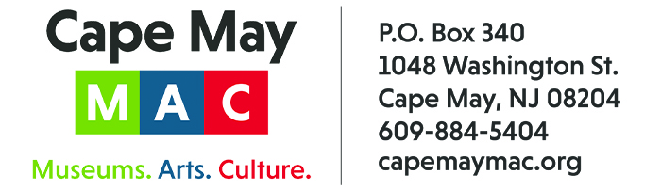

CONTACT: Susan Krysiak For Immediate Release
Director of Media Relations Aug. 24, 2022
609-224-6036
skrysiak@capemaymac.org

Create your own scarecrow, compete for prizes in the 2022 Scarecrow Contest at Cape May’s Physick Estate
Individuals and groups are invited to participate in this year’s 14th annual competition

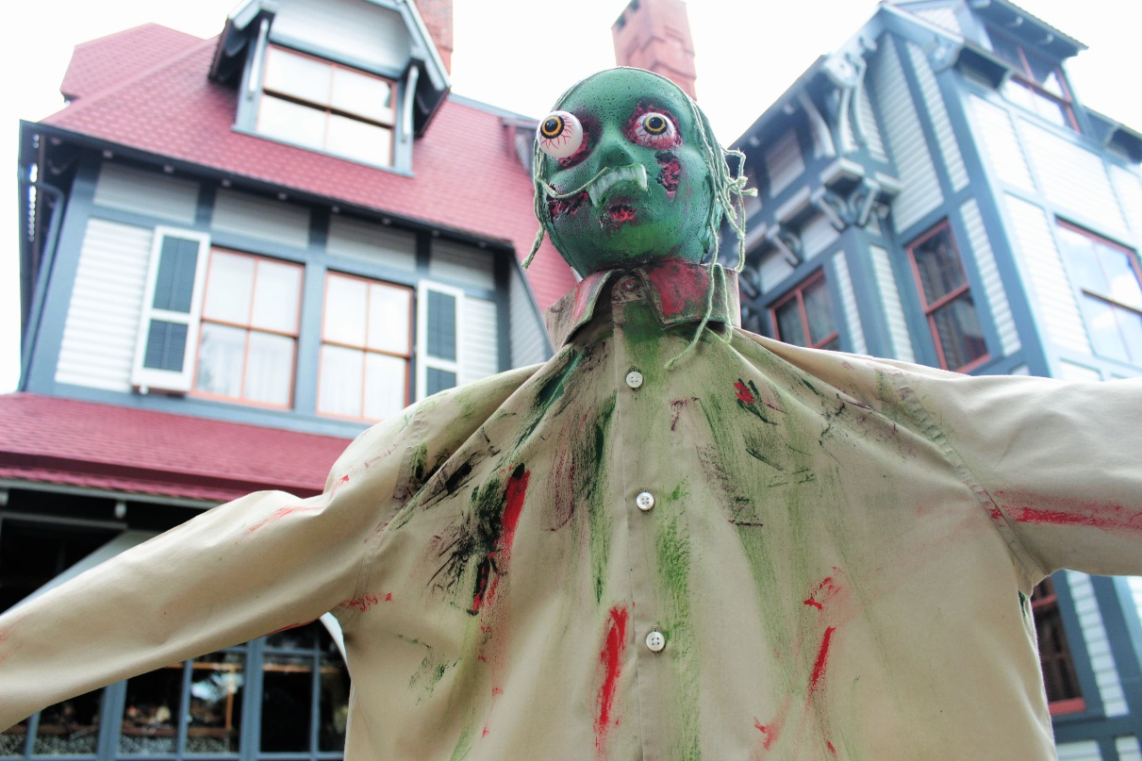
Scarecrows created by members of the community decorate the grounds at the 1879 Emlen Physick Estate during October along Scarecrow Alley, an annual tradition in its 14th year.

CAPE MAY – Create your own scarecrow that will take up residence beside others along “Scarecrow Alley” this Halloween season, when the grounds of the Emlen Physick Estate, 1048 Washington St., are transformed into a spectacle of scary and silly, all original, handmade specters, from Saturday, Oct. 1 through Monday, Oct. 31.
The 14th Annual Scarecrow Contest presented by Cape May MAC (Museums+Arts+Culture) is this October, and planning and preparations are underway. Rally friends, family, schoolmates and colleagues, or come up with your own idea, for creating a uniquely scary, silly, weird or wacky scarecrow. Registration is free. Register your entry and compete for prizes, with an overall prize of $200 earmarked for the People’s Choice Award given to the creator of the scarecrow that receives the most votes from visitors to the estate.
Application forms are available at capemaymac.org/scarecrow-alley at https://capemaymac.org/scarecrow-alley/ Submit your registration form by Sept. 30 to Cathy Baldacchini at 609-224-6024 or cbaldacchini@capemaymac.org.
Scarecrows may be dropped off at the Physick Estate Monday, Sept. 26 through Friday, Sept. 30, between 9 a.m. and 3 p.m. Participants register in one of five categories: (1) Individuals or Families, (2) Businesses (3) Non-profit, Church, Club, or Scout Troop, (4) School Class or (5) Munchkin (Children ages 3-10). Cape May MAC will have straw and wooden cross stakes available which can be picked up at the Maintenance Barn between 9 a.m. and 4 p.m.
All entrants receive a 4-feet-by-4-feet area to decorate, and larger spaces are available upon request. Multiple scarecrows, whimsical characters and miscellaneous props may be displayed. Scarecrows may reflect a special theme or promote your organization or business. Scarecrows must be in good taste. No political, religious or controversial themes, please. Cape May MAC reserves the right to reject entries.
Visitors to the Physick Estate will be encouraged to vote for their favorite scarecrow by filling out a ballot in the Carriage House. Friends and family members are encouraged to visit the Estate and vote for their favorites.
Winners will be announced Thursday, Nov. 3. Prizes include a People’s Choice Award of $200 for the scarecrow with the most votes, $100 in the individual/family category, a display ad on Cape May MAC’s website in the business category, a pizza party for the winning non-profit, community or scout group, and for the winning “munchkin” entry and 10 of his or her friends, and a pizza party and free Cape May Lighthouse climb for the winning school class.
Cape May MAC (Museums+Arts+Culture) is a multifaceted, not-for-profit organization committed to promoting the preservation, interpretation and cultural enrichment of the Cape May region for its residents and visitors. Cape May MAC membership is open to all. Visit capemaymac.org/support/membership to learn more. For information about Cape May MAC’s year-round schedule of tours, festivals and special events, visit capemaymac.org. For information about historic accommodations, contact Cape May Historic Accommodations at capemaylodging.com. For information about restaurants, accommodations and shopping, call the Chamber of Commerce of Greater Cape May at 609-884-5508. For information on the city’s COVID-19 response, please visit capemaystrong.org.

###

