CONTACT: Susan Krysiak For Immediate Release
Director of Media Relations Nov. 10, 2022
609-224-6036
skrysiak@capemaymac.org

Cape May MAC’s ‘An Old-fashioned Christmas Exhibit,’ Nov. 18-Jan. 1, rings in holiday cheer

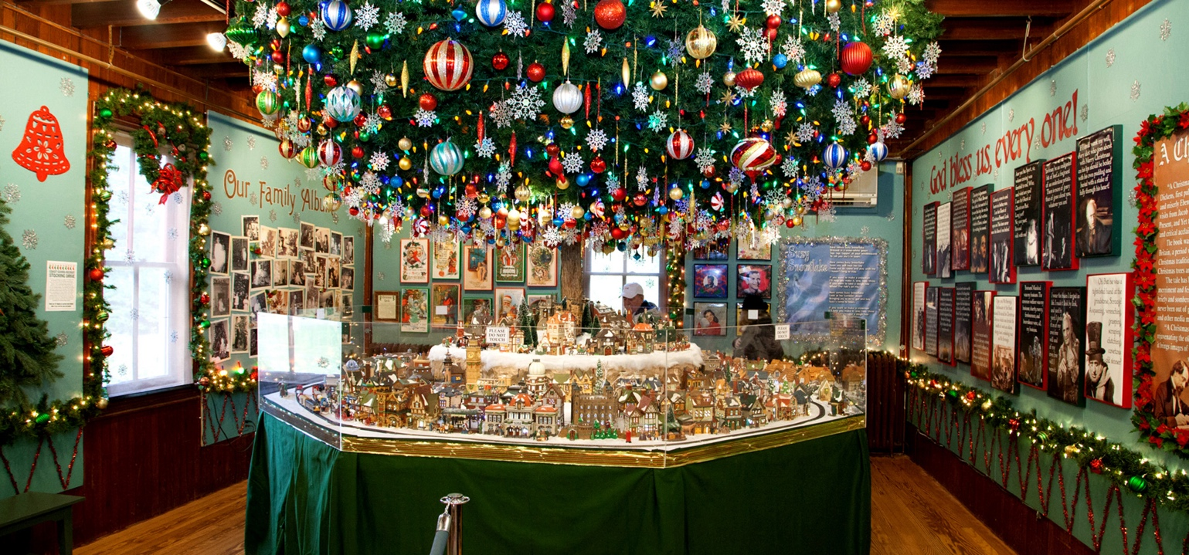

Pictured here (photo courtesy of Cape May MAC): Since 2011, the yuletide display “An Old-Fashioned Christmas Exhibit: Holiday Traditions through the Years,” has been a beloved tradition of Cape May MAC’s (Museums+Arts+Culture) festive holiday season. Hosted at the Carroll Gallery on the grounds of the 1879 Emlen Physick Estate, this charming exhibit has welcomed thousands of holiday visitors, both young and old, over the years. Experience holiday traditions complete with a stately Christmas tree, a Dept. 56 Dickens Village, model trains, nostalgic photos from Christmas past, toys and much more. Cape May MAC received a donation in 2009 of an extensive Dept. 56 Dickens Village Collection from Ernie & Betsy Heegard. The collection has become the integral piece in this exhibit, which is open daily Nov. 18 through Jan. 1, 2022 (with exceptions on Thanksgiving and Christmas Day). Admission is free. Cape May MAC is a multifaceted not-for-profit organization committed to promoting the preservation, interpretation and cultural enrichment of the Cape May region for its residents and visitors. Cape May MAC membership is open to all. For information about our year-round schedule of tours, festivals and events, visit capemaymac.org.

###

