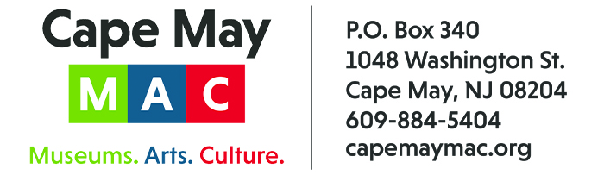

CONTACT:
Susan Krysiak For Immediate Release
Director of Media Relations Nov. 14, 2022
609-224-6036
skrysiak@capemaymac.org

Cape May MAC presents 49th Annual Christmas Candlelight House Tours on Dec. 3, 10 & 17

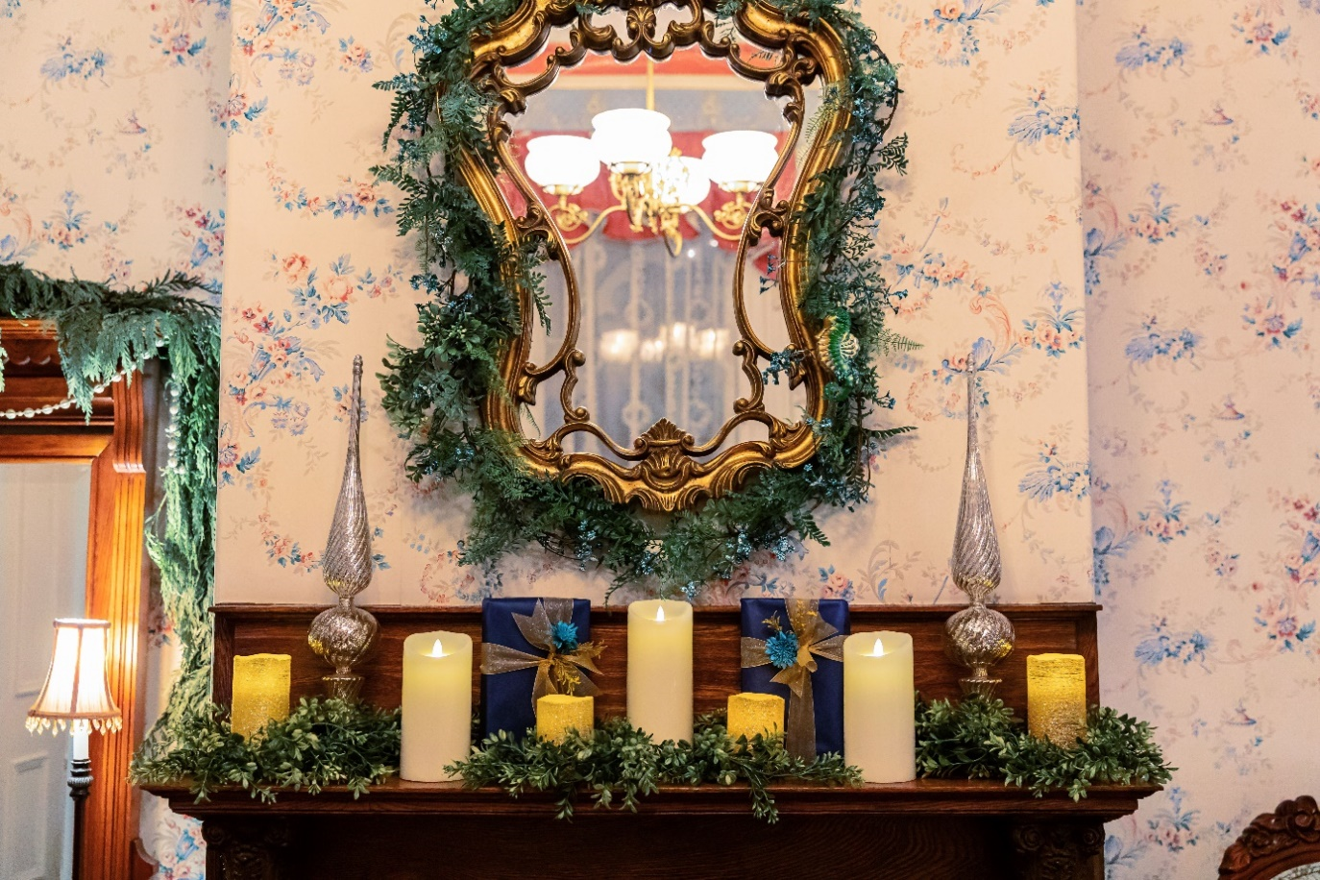
Courtesy of Cape May MAC

CAPE MAY – Cape May MAC (Museums+Arts+Culture) launched the Cape May Christmas Candlelight House tour in 1974 and ever since it has been a highlight of the Christmas season in Cape May, America’s only National Historic Landmark City. On three nights in December visitors travel to homes, inns, B&Bs, churches and hotels, stepping across the thresholds to take in interiors beautifully decorated for the holidays. Over a dozen properties are on tour each of three evenings. The three Christmas Candlelight House Tours of the 2022 season are Saturday, Dec. 3, 10 and 17, from 5:30 p.m. to 8:30 p.m.
Maps and wristbands for ticket purchasers are provided in advance or at central locations at the start of the tour and must be presented at each participating location for entry. A trolley shuttle travels on a planned route with limited stops, but walking is encouraged. The tour is limited, and advance purchase is highly recommended.
Featured properties on Saturday, Dec. 3, are:
Angel of the Sea, 5 Trenton Ave., The Bedford Inn, 805 Stockton Ave., Beauclaire’s B&B Inn, 23 Ocean St., The Carriage House at the Emlen Physick Estate, 1048 Washington St., The Dormer House, 800 Columbia Ave., Episcopal Church of the Advent (hospitality), Washington & Franklin Streets, Franklin’s Key, 313 Franklin St., Inn of Cape May (Ocean 7), 7 Ocean St., The Mainstay Inn, 635 Columbia Ave., The Mason Cottage, 623 Columbia Ave., and The Montreal Beach Resort (Harry’s Ocean Bar & Grille), 1025 Beach Ave. and the Physick House Museum, 1048 Washington St.
Featured properties on Saturday, Dec. 10, are:
Angel of the Sea, 5 Trenton Ave., Beauclaire’s B&B Inn, 23 Ocean St., The Bedford Inn, 805 Stockton Ave., Cape May United Methodist Church, 635 Washington St., The Carriage House at the Emlen Physick Estate, 1048 Washington St., The Cherry House, 627 Hughes St., The Colonial House Museum, 653½ Washington St., Inn of Cape May (Ocean 7), 7 Ocean St., Kiwanis Club of Cape May (hospitality), 1041 Beach Ave., The Lorelei, 238 Perry St., The Mainstay Inn, 635 Columbia Ave., The Mason Cottage, 623 Columbia Ave., The Montreal Beach Resort (Harry’s Ocean Bar & Grille), 1025 Beach Ave. the Physick House Museum, 1048 Washington St. and The Queen Victoria B&B, 102 Ocean St.,
Featured properties on Saturday, Dec. 17, are:
Beauclaire’s B&B Inn, 23 Ocean St., The Bedford Inn, 805 Stockton Ave., Cape Island Baptist Church (hospitality), 115 Gurney St., The Carriage House at the Emlen Physick Estate, 1048 Washington St., The Colonial House Museum, 653½ Washington St., The Dormer House, 800 Columbia Ave., Franklin at 721, 721 Franklin St., Inn of Cape May (Ocean 7), 7 Ocean St., Judson Bennett House, 835 Washington St., The Lorelei, 238 Perry St., The Mainstay Inn, 635 Columbia Ave. and The Montreal Beach Resort (Harry’s Ocean Bar & Grille), 1025 Beach Ave. and the Physick House Museum, 1048 Washington St.
Ticket purchasers may show their wristbands to receive a discount coupon at Montreal Beach Resort (Harry’s Ocean Bar & Grille), 1025 Beach Ave., and Inn of Cape May (Ocean 7), 7 Ocean St.
Christmas Candlelight House Tours include admission to the Physick House Museum at the Emlen Physick Estate, 1048 Washington St., Cape May’s Victorian House Museum authentically decorated for Christmas, and the exhibit “An Old-Fashioned Christmas: Holiday Traditions through the Years” in the Carroll Gallery in the Carriage House located on the grounds of the Physick Estate. The exhibit’s main attraction is a display featuring a Dept. 56 Dickens Village, model trains and vintage Christmas memorabilia, all beneath the boughs of a giant Christmas tree. While there, letters to Santa can be deposited for mailing to the North Pole.
Admission to the Christmas Candlelight House Tour is $45 for adults and $30 for children (ages 3 to 12). The tour is limited, therefore it is strongly recommended that tickets be purchased online in advance by visiting www.capemaymac.org or by calling 609-884-5404.
Any remaining tickets on the day of the tour may be purchased at the Washington Street Mall Information Booth, Washington and Ocean Streets. Properties on the tour are subject to change.
For those who are unable to take the tour, a Virtual Christmas Candlelight House Tour Video is available. This virtual video tour is a timeless, intimate look inside 10 Cape May homes and inns, with the stories behind each one. This is a Cape May experience for viewing anytime, anywhere, and can be viewed as often as you like after online purchase, for $30 via Vimeo On Demand. Proceeds support Cape May MAC. Purchase online via this link that features a trailer you can watch first. https://capemaymac.org/experience/christmas-in-capemay/christmas-candlelight-house-tour.
Cape May MAC (Museums+Arts+Culture) is a multifaceted, not-for-profit organization committed to promoting the preservation, interpretation and cultural enrichment of the Cape May region for its residents and visitors. Cape May MAC membership is open to all. Visit capemaymac.org/support/membership to learn more. For information about Cape May MAC’s year-round schedule of tours, festivals and special events, visit capemaymac.org. For information about historic accommodations, contact Cape May Historic Accommodations at capemaylodging.com. For information about restaurants, accommodations and shopping, call the Chamber of Commerce of Greater Cape May at 609-884-5508.

###

