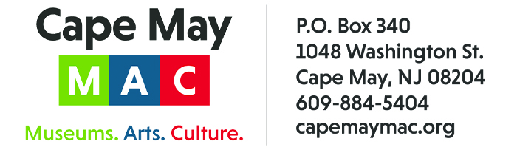

CONTACT: Susan Krysiak For Immediate Release
Director of Media Relations Nov. 15, 2022
(609) 224-6036 or (800) 275-4278 Ext. 153
skrysiak@capemaymac.org

Celebrate Christmas in Cape May during six weeks of holiday tours and activities

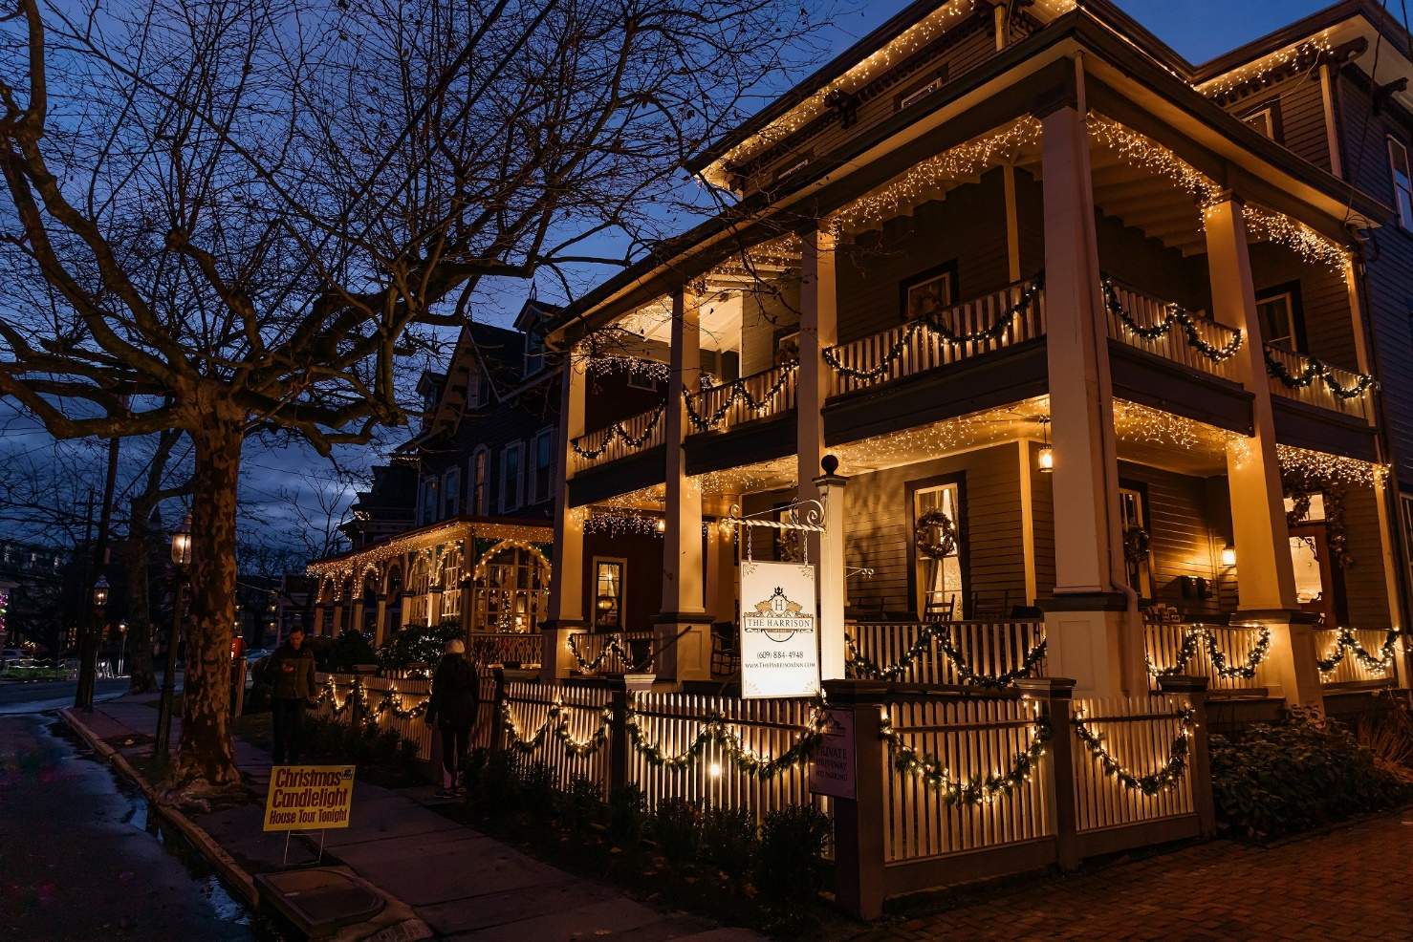
PHOTO CAPTION: (Photo courtesy of Cape May MAC) Over a dozen properties are on tour during the annual Christmas Candlelight House Tour Dec. 3, 10 and 17.

CAPE MAY — Cape May welcomes visitors with an abundance of old-fashioned cheer for the Christmas holiday! There are six weeks of festive tours and events presented by Cape May MAC (Museums+Arts+Culture) that celebrate the season, from Friday, Nov. 18 through Sunday, Jan. 1, 2023. Victorian Cape May at Christmas is a beautiful place to make holiday memories with family and friends. Soak in the sights and sounds as you travel on trolley rides, delight in the city’s holiday lights, tour homes beautifully decorated for the holiday, share breakfast with the jolly man in the red suit, and much more this holiday season.
Holiday Preview Weekend and Christmas Tree Lighting Ceremony
Daytime and evening holiday tours and events begin the weekend before Thanksgiving during Holiday Preview Weekend, Nov. 18-20. Visit the Emlen Physick Estate, 1048 Washington St., when Santa arrives by trolley to switch on the lights on the huge estate Christmas tree during the Christmas Tree Lighting Ceremony, Saturday, Nov. 19, 5 p.m. to 7:30 p.m. Returning this year is one of the highlights from last year’s celebration: a free performance of holiday favorites by the Atlantic Brass Band. The Physick House Museum is open to the public for free self-guided tours as well this evening. Bring a donation for the Cape May Community Food Closet. This year collections will be donated in honor of the late Kathy Makowski.
49th Annual Christmas Candlelight House Tour
Cape May’s Christmas Candlelight House Tour has been a beloved annual tradition for nearly half a century! Since 1974, thousands of people on three nights in December walk the city’s historic walkways along gas lit streets and visit homes, inns, churches and hotels, stepping across the thresholds to take in interiors beautifully decorated for the holiday. Tours are Saturday, Dec. 3, 10 and 17 from 5:30 p.m. to 8:30 p.m. Experience this exciting annual tradition — the longest running tour in Cape May history! Tickets are limited.
Physick Family Christmas House Tour
On this guided living history tour of the magnificent 1879 Physick Estate, Cape May’s only Victorian house museum, decorated in true Victorian style for Christmas, your guide portrays a member of the Physick family in the early 1900s and shares stories and traditions. Friday-Sunday afternoon, Nov. 25-27 and Wednesdays, Fridays, Saturdays & Sunday afternoons, Dec. 2-23.
Evening Yuletide House Tour
On this guided tour of the first-floor rooms of the 1879 Physick House Museum, authentically decorated for a Victorian Christmas, see and hear how the Physick family might have entertained friends and family and celebrated in traditional Victorian fashion during the holidays. Monday and Wednesday evenings, Nov. 28, 30 & Dec. 5-28.
New! ’Tis the Season: The Forgotten Caroler
An unexpected winter storm brings all of the Bennett family's plans to a crashing halt! It seems that not even a joyful troupe of carolers can help restore the family's holidays spirit. Is all hope lost? This original play written by Jennifer Hickok brings the audience along as the drama of a Victorian Christmas gone wrong unfolds from room to room on the first floor of the 1879 Physick House Museum. Immerse yourself in this delightful and inspiring Victorian Christmas story that revels in the magic of the season. Thursday and Friday evenings, Dec. 1-23.
New! All That Glitters - Victorians Ring in a New Century Trolley Tour
It’s the Christmas season in the late Victorian age and Mrs. Frances Brooks leads this first-person trolley tour as she does her important holiday shopping around town, regaling all with then and now stories of the many shops, hotels, landmarks and personalities that make up the lively Cape Island social landscape of her time. This tour immerses you in Cape May social history and takes two steps back in time, as Mrs. Brooks reflects on her present and her past, including memories of her dearest friends, the Physicks. Fridays, Dec. 2-23: 3:30 p.m. Saturdays, Dec. 3-17: 2:30 p.m. and 3:30 p.m. Sundays, Dec. 4-18: 2:15 p.m.
Santa’s Trolley Ride
Mrs. Claus comes direct from the North Pole to lead this tour! She tells stories and leads holiday songs on this jolly holiday trolley ride through town. Santa greets all at the Gazebo on the grounds of the 1879 Emlen Physick Estate. Begins and ends at the Physick Estate, 1048 Washington St. (with free parking available). Saturday mornings and at noon and Sunday mornings, Nov. 26-Dec. 18.
Ghosts of Christmas Past Trolley Rides
Listen to dramatic tales of Christmas woe featuring Victorian ghosts, told by a member of the East Lynne Theater Company, on this ride along the historic streets of Cape May. You’ll be happy you live now, not then. Evenings, Fridays, Nov. 18-25, Saturdays, Nov. 12-26, Sunday, Nov. 27, Fridays & Sundays, Dec. 2-23
Lamplighter Christmas Tour
See inside a selection of Cape May bed & breakfast inns and private homes, specially decorated for the holidays on this self-guided evening walking tour that includes a visit to An Old-fashioned Christmas Exhibit at the Physick Estate Carriage House. Fridays, Nov. 25-Dec. 16, Saturday, Nov. 26, Monday, Dec. 26, Wednesday, Dec. 28: 5:30 p.m. - 7:30 p.m.
Holiday Inns Tour
See several of Cape May’s bed & breakfast inns festively decorated for the holidays during this self-guided afternoon tour with continuous trolley shuttle service. Mondays-Wednesdays, Nov. 28-30, Dec. 5-7, Thursdays, Dec. 1, 8: 1 p.m.-3:30 p.m.
An Old-fashioned Christmas Exhibit
The wonders of the season are on display at “An Old-Fashioned Christmas Exhibit: Holiday Traditions through the Years,” in the Carroll Gallery, at the Carriage House on the grounds of the Emlen Physick Estate, 1048 Washington St. Here you can experience an exhibit of holiday traditions complete with a giant Christmas tree, a Dept. 56 Dickens Village, model trains, nostalgic photos from Christmas past and more. Admission is free. Daily except Thanksgiving and Christmas.
Holiday Shopping
Complete your holiday gift-giving list during the Holiday Crafts & Collectibles Shows and at Cape May’s renowned museum shops. Stop into the Museum Shops on Museum Store Sunday, Nov. 27 to support their unique mission for some special deals and giveaways. Shop for unique hand-made gifts and seasonal decorations during Holiday Crafts & Collectibles Show, over two days, Friday, Nov. 25 and Saturday, Nov. 26 from 10 a.m. to 4 p.m., Cape May Convention Hall, Beach Avenue at Stockton. Admission is $2. Cape May MAC has three museum shops: the Carriage House Museum Shop at the Emlen Physick Estate, 1048 Washington St., that offers a variety of gifts and holiday ornaments, the World War II Lookout Tower, Sunset Boulevard, which has military and maritime history gifts, and the Cape May Lighthouse Museum Shop, Cape May Lighthouse, 215 Lighthouse Ave., offering maritime gifts, clothing, toys and more.
Vintage
Vintage Restaurant, on the grounds of the Emlen Physick Estate, offers an eclectic menu for brunch and dinner. Call 609–224–6064 for reservations and takeout orders or visit OpenTable.com. Vintage is dog-friendly, has outdoor seating options and take-out is available. Parking is free. Open Friday-Sunday for dinner, Saturday, Sunday for brunch through Dec. 1. Open Friday, Saturday for dinner, Saturday, Sunday for brunch, Dec. 2-18. Open Dec. 29-Jan. 1 for dinner and Dec. 31 and Jan. 1 for brunch.
Breakfast with Santa at Bella Vida & Breakfast with Santa at Ocean 7
Don’t miss these opportunities to welcome special guest Santa Claus, himself, as he takes time away from executive oversight of his workshop and his world touring schedule to visit Bella Vida Garden Cafe, 406 Broadway, West Cape May, and Ocean 7, Inn of Cape May, 7 Ocean St., Cape May, on select dates leading up to Christmas. Breakfast with Santa at Bella Vida is offered on Sundays, Nov. 27 and Dec. 18, with two seatings, at 9 a.m. and 11 a.m. Breakfast with Santa at Ocean 7 is offered on Saturdays, Nov. 26, Dec. 3, 10 and 17, with seatings every half hour from 8 a.m. to 12:30 p.m. Santa will meet and greet his fans with time for photos and sharing of wish lists.
Brunch & Bingo at Bella Vida
Laugh along with your friends as you play a little bingo, compete for prizes and enjoy a fashion show by Lace Silhouettes/Cotton Company. It’s all over a scrumptious brunch at Bella Vida Garden Café, 406 Broadway, West Cape May. Saturdays, Nov. 19, Jan. 14, Feb. 11, Feb. 25, March 18, March 25: 9 a.m.
Cape May Lighthouse
Climb the 199 steps up the original, cast-iron spiral stairway to the top of the 1859 Cape May Lighthouse and see a staggering view of the Delaware Bay and Atlantic Ocean, the surrounding nature trails of Cape May Point State Park, and Cape May Point Borough. Interpretive panels on the grounds, at the base and on the climb tell stories of Lighthouse Keepers, the surrounding area, and how the lighthouse functioned historically and today. The Cape May Lighthouse is the third beacon at this location. Still an active aid to navigation, it was restored and is maintained by Cape May MAC (Museums+Arts+Culture). Since Cape May MAC opened it to the public in 1988, more than 2.5 million visitors have climbed to the top. The Cape May Lighthouse is listed in the State and National Registers of Historic Places. Fridays, Saturdays, Sundays, Nov. 18-Dec. 23; Dec. 26-31: noon to 4 p.m.
Whale and Dolphin Watching with the Cape May Whale Watcher
Take a boat ride this fall and see whales and dolphins! Unlike other areas where whales are a great distance from shore, Cape May offers many sightings both within the Delaware Bay or within 10 miles of land. Marine biologists, naturalists and whale lovers alike enjoy sightings in areas like Cape May. Captain Jeff leads the excursion and will point out local history along with many types of marine life. Fridays-Sundays through Nov. 27, Saturdays, Sundays, Dec. 3-11: 1 p.m.
Lunch & Learn: A Closer Look at Veterans Day
Once a year our country sets aside a day to recognize and honor those of us that served. What did we expect? What did we go through? What experiences did we share? Let’s take a serious and lighthearted look at what we went through and what made us what we are today. Presenter: Mike Urbanski, Cape May MAC. Wednesday, Nov. 16 at noon in person at the Cape May Lutheran Church: 509 Pittsburgh Ave. and available on Zoom with registration in advance.
Lunch & Learn: Non-Profits: They’re Not All the Same!
In this holiday season, we are encouraged to “give, and give generously.” Cape May MAC Director and CEO Jody Alessandrine offers insight into the various ways non-profits are funded, as well as how to give in ways that make a difference, from his many years of working in the world of nonprofit organizations. Presenter: Jody Alessandrine, Cape May MAC. Wednesday, Dec. 7 at noon in person at the Cape May Lutheran Church, 509 Pittsburgh Ave. and available on Zoom with registration in advance.
Lunch & Learn: A History of Christmas Carols
Did you know carols weren’t originally for Christmas? And the version you know of your favorite carol probably isn’t the “right” one, because no such thing exists! Let’s look at the convoluted history of Christmas carols and have fun listening to some, both new and old. Presenter: Brenda Leonard, Cape May MAC. Wednesday, Dec. 21 at noon in person at the Cape May Lutheran Church, 509 Pittsburgh Ave. and available on Zoom with registration in advance.
Lunch & Learn: New Year’s Resolutions
New Year's resolutions are a tradition. We resolve to do good, accomplish goals, improve behaviors at the beginning of the year. Did you know that the tradition goes back thousands of years and across the globe? Learn about the history of the tradition, including some of the best and worst resolutions in history in this illustrated presentation. Presenter: Mary Stewart, Cape May MAC. Wednesday, Jan. 4 at noon in person at the Cape May Lutheran Church: 509 Pittsburgh Ave. and available on Zoom with registration in advance. To register, call 609-884-5404
Virtual Christmas Candlelight House Tour Video
In 2020, Cape May MAC announced a new way to experience Cape May at Christmas for those unable to visit during the holidays: the Virtual Christmas Candlelight House Tour Video. This virtual video tour is a timeless, intimate look inside 10 Cape May homes and inns, with the stories behind each one. This is a Cape May experience for viewing anytime, anywhere, and can be viewed as often as you like after online purchase, for $30 via Vimeo On Demand. Proceeds support Cape May MAC. Purchase online via this link that features a trailer you can watch first.
Also, the East Lynne Theater Company presents “Christmas Presents from the Past,” a delightful holiday production! Plus, guided tours of the Physick House Museum and Cape May’s most popular trolley tour, the Historic District Trolley Tour, are both offered regularly through the holiday season. Tickets for all tours and events may be purchased online at capemaymac.org or by visiting or calling the Emlen Physick Estate Hill House Visitor Services Office at 609-884-5404.
Masks or facial coverings are suggested on trolley and indoor tours; limits on admissions will be managed to comply with current CDC guidelines. Schedules are subject to change.
Cape May MAC (Museums+Arts+Culture) is a multifaceted not-for-profit organization committed to promoting the preservation, interpretation and cultural enrichment of the Cape May region for its residents and visitors. Cape May MAC membership is open to all. For information about our year-round schedule of tours, festivals and events, visit capemaymac.org.

