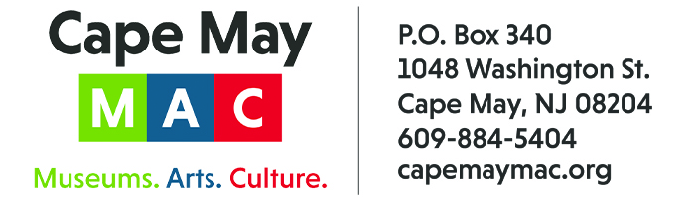

CONTACT: Susan Krysiak For Immediate Release
Director of Media Relations
609-224-6036
skrysiak@capemaymac.org

Santa Claus plans area visits to Bella Vide Café and Ocean 7 during worldwide tour leading up to Christmas

CAPE MAY – (Nov. 14, 2022) (Photo courtesy of Cape May MAC) Don’t miss these opportunities to welcome special guest Santa Claus, himself, as he takes time away from executive oversight of his workshop and his world touring schedule to visit Bella Vida Garden Cafe, 406 Broadway, West Cape May, and Ocean 7, Inn of Cape May, 7 Ocean St., Cape May, on select dates leading up to Christmas. All of these events are presented by Cape May MAC (Museums+Arts+Culture). Breakfast with Santa at Bella Vida is offered on Sundays, Nov. 27 and Dec. 18, with two seatings, at 9 a.m. and 11 a.m. The menu offers two menu choices for adults and children. Breakfast with Santa at Ocean 7 is offered on Saturdays, Nov. 26, Dec. 3, 10 and 17, with seatings every half hour from 8 a.m. to 12:30 p.m. Breakfast features a buffet including omelet and pancake stations. Santa will stop at each table to meet and greet his fans with time for photos and sharing of wish lists. Visit capemaymac.org or call 609-884-5404 to purchase tickets and for more information. Cape May MAC (Museums+Arts+Culture) is a multifaceted, not-for-profit organization committed to promoting the preservation, interpretation and cultural enrichment of the Cape May region for its residents and visitors. Cape May MAC membership is open to all.

﻿###

