CONTACT: Susan Krysiak For Immediate Release
Director of Media Relations Feb. 3, 2023
609-224-6036
skrysiak@capemaymac.org

Visit Cape May during Presidents’ Day Weekend

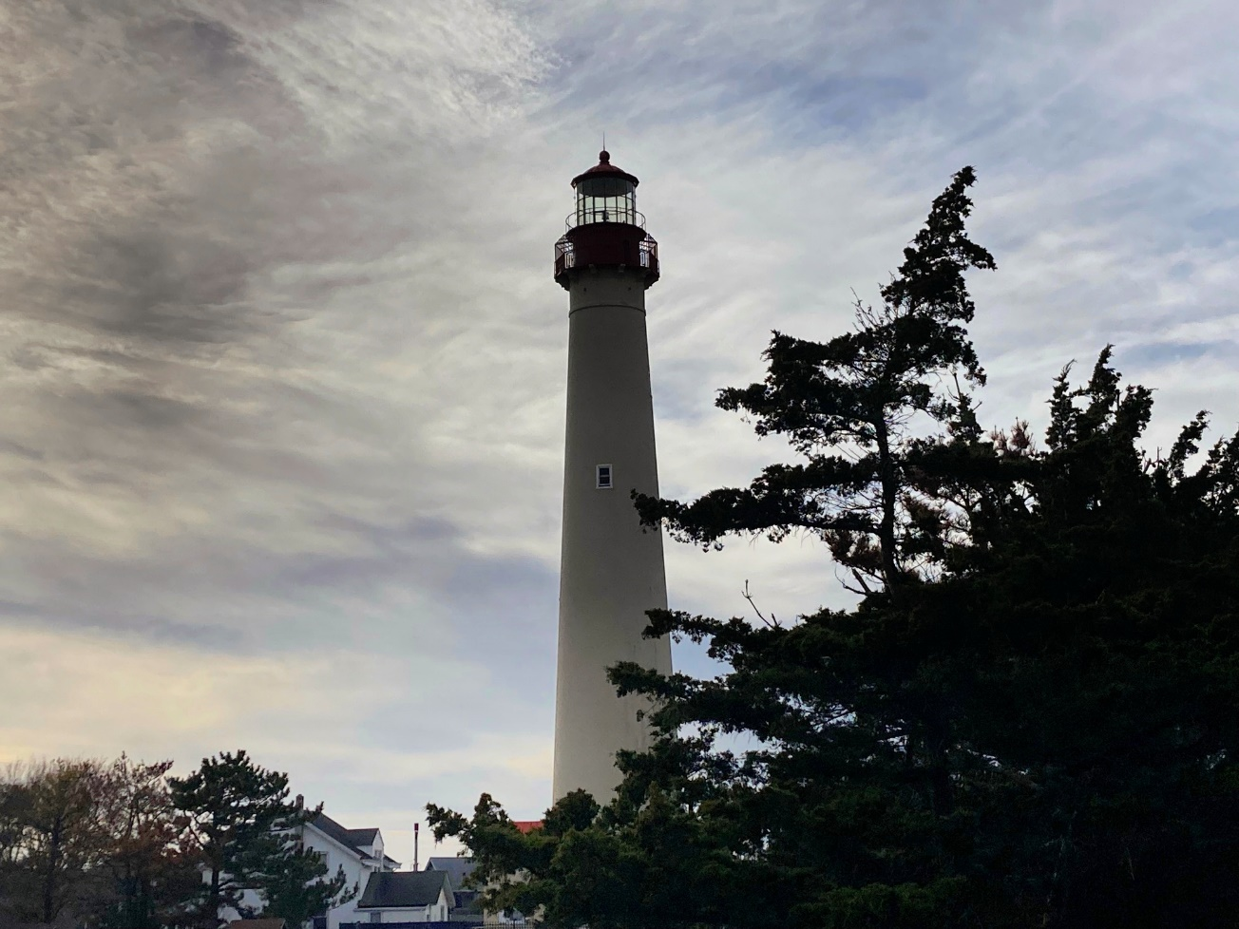
Photo Courtesy of Cape May MAC

CAPE MAY, N.J. – Have you ever visited Cape May in winter? Some say it’s their favorite time of year here. Presidents’ Day Weekend Feb.17-20 is right around the corner and a great time to take a road trip to Cape May. Take your time and explore America’s First Seaside Resort on this holiday devoted to remembering our presidential leaders, Washington and Lincoln—you might discover a new reason to love Cape May.
Crafts & Collectibles In Winter
On Feb. 18 and 19, the 2023 crafts & collectibles shows kick off. Throughout the year, the Craft & Collectibles Shows present unique wares from vendors and crafters from the northeast. This winter show is $2 admission, at Cape May Convention Hall and runs from 10 a.m. to 4 p.m.
Roots of Cape Island Trolley Tour
The roots of Cape Island and the surrounding area’s economy are in whaling and farming, and while new industries have evolved since then, that heritage is still celebrated today. Hear how whalers centuries ago eked out a dangerous but lucrative living near Town Bank and discover the area’s rich farming heritage. Learn about the Union Bethel community in 1831 in which Black residents thrived and the diverse community that continues to contribute to the vibrancy of island life today. This tour begins and ends at the Washington Street Mall Information Booth and runs on select Saturday mornings.
Historic District Trolley Tour
On this charming trolley tour, guides will explain Cape May’s fascinating history as the oldest seaside resort and how it has survived and thrives to this day. This narrated tour travels through portions of Cape May’s historic district and takes a look at Cape May's Victorian architecture. This tour runs from Fridays to Sundays each week and begins and ends at the Ocean Street Trolley Stop.
Mansions by the Sea Trolley Tour
From the 1900s to today, Cape May has been home to beautiful feats of architecture. This narrated tour travels along Beach Drive and delves into the history behind iconic seaside mansions. This tour will run on Feb. 20, beginning and ending at the Ocean Street trolley stop.
Ghosts of Cape May Trolley Tour
What was that shadow? Was it the undead of Cape May’s past wandering their beloved haunts? You might scoff, you might shudder, but rest assured: on board a trolley with an experienced guide you will begin to wonder what’s beyond when you hear the tales of hauntings unearthed in Cape May by renowned psychic medium and author Craig McManus. This tour will run Feb. 17, 18 and 19, beginning and ending at the Ocean Street trolley stop.
Emlen Physick Estate Tour
Take a guided tour of the first and second floors of the 1879 Physick House Museum, for an in-depth look at Victorian architecture and the period, reflecting one Victorian family’s lifestyle. This tour is offered daily Presidents' Day Weekend.
Cape May Lighthouse is open!
Climb the 199 steps for a wintery panorama of Delaware Bay. The 1859 Cape May Lighthouse is open on weekends and holidays from 11 a.m. to 2 p.m.
To purchase tickets in advance, visit capemaymac.org or call 609-884-5404. In the event of inclement weather, check back for schedule changes.
Cape May MAC is a multifaceted not-for-profit organization committed to promoting the preservation, interpretation and cultural enrichment of the Cape May region for its residents and visitors. Cape May MAC membership is open to all. For information about our year-round schedule of tours, festivals and events, visit capemaymac.org or call 609-884-5404.

###

