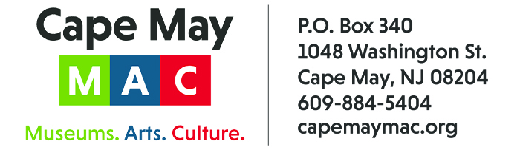

CONTACT: Susan Krysiak For Immediate Release
Director of Media Relations
609-224-6036
skrysiak@capemaymac.org

NJM Insurance Group provides grant funds to support HVAC system in Cape May’s Physick House Museum

CAPE MAY, N.J. – NJM Insurance Group, West Trenton, N.J., has provided a grant of $5,000 to Cape May MAC (Museums+Arts+Culture) as a contribution to matching funds to support critical improvements to the HVAC system in the Physick House Museum, located on the grounds of the Emlen Physick Estate, 1048 Washington St.
The Physick House Museum is Victorian Cape May’s only Victorian House Museum. It is the gem of the city, and the effort to save the estate from demolition is the reason Cape May MAC was created in 1970. It became a major focus of Cape May’s renaissance boom as a tourism destination and designation as a National Historic Landmark City in 1976. It continues to be one of Cape May’s most visited and identifiable attractions.
Thousands of visitors take guided tours of the Physick House Museum each year, yet the house does not have a fire suppression system and a climate control system (HVAC). Cape May MAC has received planning grants and a capital grant from the New Jersey Historic Trust for this purpose. The grants require matching funds.
The grant from NJM Insurance Group is a leap forward toward the matching funds needed to facilitate the planning and implementation of a new HVAC system. It is an investment in the present and future preservation of this historic site. The Physick House Museum is often cited as the best example of Victorian Stick Style architecture in the country.
“We are so very grateful to NJM Insurance Group for their generous gift to help us reach this important financial, historic preservation and community goal,” said Cape May MAC Director & CEO Jody Alessandrine. “We will continue to be grateful to NJM Insurance Group through these projects’ completion and for years to come. Maintaining climate control in the Physick House Museum and protecting the structure and its some 6,000 works d’art are critical to the long-term preservation of everything about this unique 1879 structure.””
“NJM is pleased to have supported Cape May MAC since 2016 through our charter membership in the 2020 Society,” said Pat Hartpence, NJM Corporate Giving Officer. “We are very proud to continue this partnership by helping to preserve the grandeur of the Physick House Museum, one of Cape May’s many notable historic landmarks.”
ABOUT CAPE MAY MAC
Cape May MAC (Museums+Arts+Culture) is a multifaceted, not-for-profit organization committed to promoting the preservation, interpretation and cultural enrichment of the Cape May region for its residents and visitors since 1970. Cape May MAC membership is open to all. Visit capemaymac.org/support/membership to learn more. For information about Cape May MAC’s year-round schedule of tours, festivals and events, visit capemaymac.org.
ABOUT NJM INSURANCE GROUP
Founded in 1913, NJM is among the Mid-Atlantic region's leading property and casualty insurers. One of the Company's core values is to support the communities it's privileged to serve, a value exercised through year-round employee volunteer efforts at local nonprofits and a formal corporate giving program. NJM operates in a mutual fashion for the exclusive benefit of its policyholders and is consistently recognized for its award-winning customer service, superior claims handling, and overall customer satisfaction. NJM's personal insurance products are available direct to consumers in Connecticut, Maryland, New Jersey, Ohio, and Pennsylvania. The Company also works with a preferred network of independent agents to deliver business insurance in Connecticut, Delaware, Maryland, New Jersey, New York and Pennsylvania. Visit njm.com to learn more.
###

