CONTACT: Susan Krysiak FOR IMMEDIATE RELEASE
Director of Media Relations
(609) 224-6036
skrysiak@capemaymac.org

Cape May Wine Trails feature lunch and trolley transport to two Cape May County wineries for tours and tastings

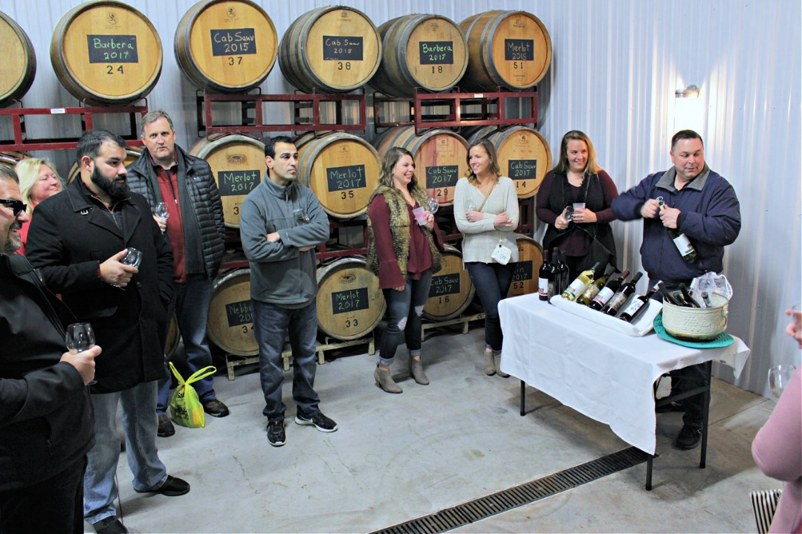

(Feb. 15, 2023) (photo courtesy of Cape May MAC): Cape May County, New Jersey vineyards are producing delicious wines and Cape May Wine Trails are a chance to enjoy them with round-trip transportation via trolley included. Board a Cape May MAC (Museums+Arts+Culture) trolley at the historic Emlen Physick Estate, 1048 Washington St., in Cape May, N.J. and travel to Pier House in Cape May for a delicious lunch. Then it’s back on board the trolley for an afternoon of touring and sampling wine selections by vintners at Jessie Creek Winery and Natali Vineyards. Guests will receive a tour, tasting and souvenir glass at Jessie Creek Winery and a tasting with cheese and crackers at Natali Vineyards. Cape May Wine Trails are offered at 10:45 a.m. on Saturday, May 6 and Fridays, Sept. 22 and Oct. 6. (Feb. 18, April 29 sold out!) The tour returns to the Physick Estate by 5 p.m. Admission is $125 per person inclusive. This tour is for adults ages 21 and over. Cape May Wine Trails are presented by Cape May MAC (Museums+Arts+Culture), a multifaceted, not-for-profit organization committed to promoting the preservation, interpretation and cultural enrichment of the Cape May region for its residents and visitors. Cape May MAC membership is open to all. For information about our year-round schedule of tours, festivals and events, visit capemaymac.org.

###

