CONTACT: Susan Krysiak For Immediate Release
Director of Media Relations Feb. 22, 2023
609-224-6036
skrysiak@capemaymac.org

Cape May’s Carroll Gallery Exhibit: ‘Quackery: The Age of Questionable Medical Marvels’ April 14-Oct. 31
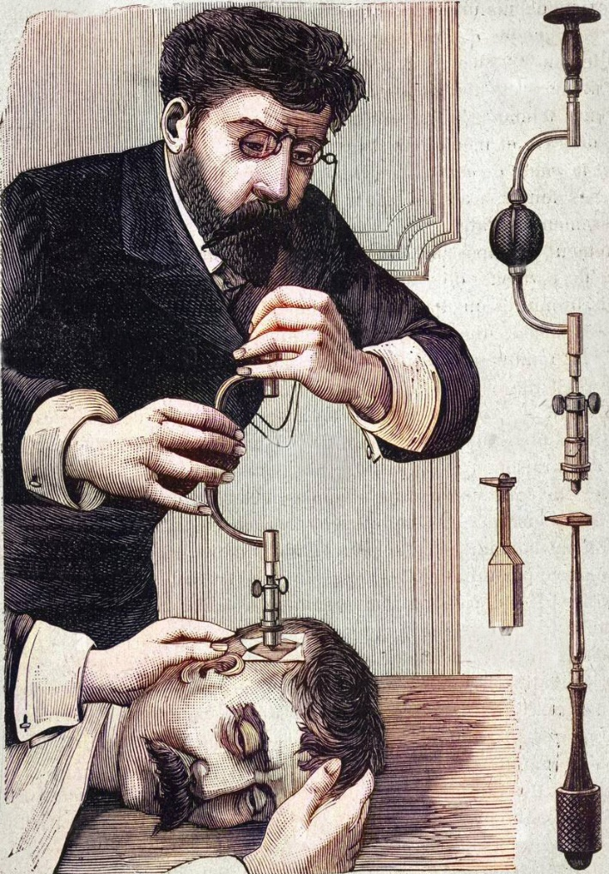
(Image in public domain, 1887) The ancient practice of “Trepanning” was the act of boring a hole in a patient’s skull. It was practiced during the American Civil War to treat head wounds.

CAPE MAY, N.J. – Cape May MAC (Museums+Arts+Culture) presents “Quackery: The Age of Questionable Medical Marvels,” an exhibit featuring some of the so-called medical marvels of the late 19th and early 20th century, open to the public April 14 through Oct. 31. Many of these “curatives” were not only ineffective, but they were also downright dangerous. Learn about these so-called remedies, and the societal and economic forces that unleashed these questionable treatments on the public, driven by hucksterism, false advertising and get-rich-quick schemes. Check out Prof. Hudzik’s Medicine Wagon—a replica of what would have been used to purvey such cure-alls, complete with a QR code to hear what his spiel would have sounded like!
Two things came together in the 19th century to create the great boom in quackery. First, there were many technological advances as part of the Industrial Revolution: the harnessing of electricity and electro-magnetism, the discovery of radiation and radium, the detection of microscopic “germs” as the cause of disease, the isolation of vitamins to combat malnutrition and the introduction of powerful drugs like opiates and cocaine. The second great innovation of the 19th century was the development of the free enterprise system – laissez faire capitalism. This unleashed a flood of energy to make money by filling any demand the market produced. During this “go getter” era, after the government-directed mercantilist system disappeared and before the 20th century introduction of government protections, hucksterism ruled.
This free exhibit is in the Carroll Gallery in the Carriage House on the grounds of the Emlen Physick Estate, 1048 Washington St., Cape May, N.J. and is open daily, April 14 through Oct. 31. Times vary.
Cape May MAC is a multifaceted not-for-profit organization committed to promoting the preservation, interpretation and cultural enrichment of the Cape May region for its residents and visitors. Cape May MAC membership is open to all. For information about our year-round schedule of tours, festivals and events, visit capemaymac.org or call 609-884-5404.

###

