CONTACT: Susan Krysiak For Immediate Release
Director of Media Relations Feb. 16, 2023
609-224-6036
skrysiak@capemaymac.org

Climb the Cape May Lighthouse at night under the light of the full moon or under the new moon when the stars shine

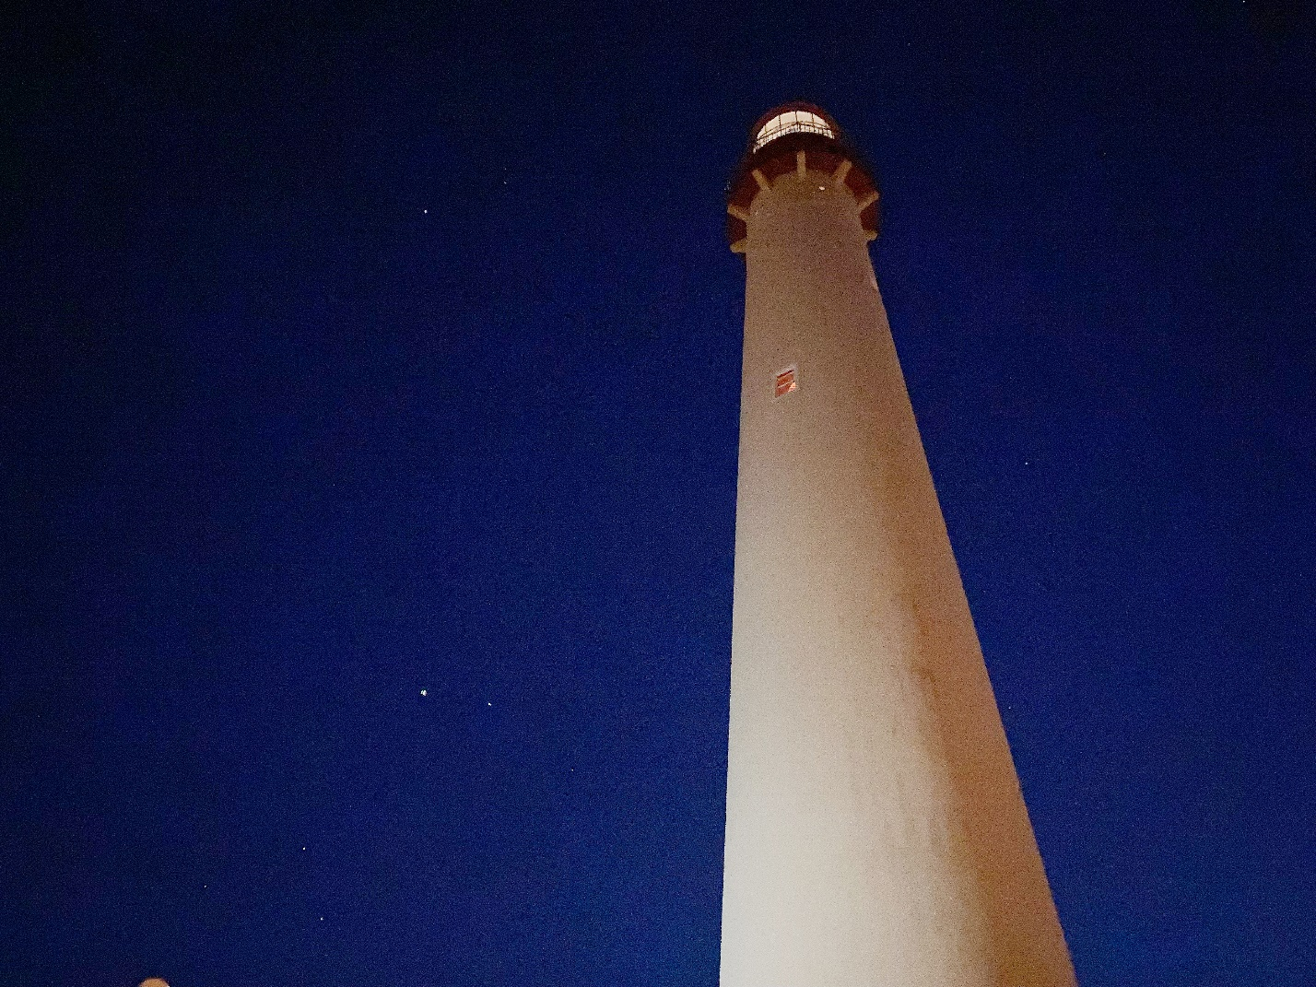
Photo by Susan Krysiak/Courtesy of Cape May MAC

CAPE MAY, N.J. – Cape May MAC (Museums+Arts+Culture) offers nighttime climbs in 2023 at the Cape May Lighthouse, with Lighthouse Full Moon Climbs on select full moon dates, and Stairway to the Stars offered during select new moon dates.

Follow the light of the full moon on up the 199 original, cast-iron spiral staircase steps to the top of the Cape May Lighthouse during the Lighthouse Full Moon Climbs. Enjoy a nighttime view of the surrounding area lit by the light of the full moon, nearly 156 feet above the Delaware Bay and Atlantic Ocean. Interpretive panels along the climb tell stories of Lighthouse Keepers, the surrounding area, and how the lighthouse functioned historically, and are located at landings along the way.
Stairway to the Stars is held on evenings of the new moon and the start of a new 29.5-day lunar cycle, when the moon is so dark it blends in with the night sky and is invisible to the naked eye. Climb to the top and see stars and constellations that are more visible on clear nights during the new moon. Binoculars are permitted if securely worn around the neck at all times.
Mark your calendar now for these nighttime climbs in 2023:
Lighthouse Full Moon Climbs are offered 8 p.m. to 10 p.m. on April 6, May 5, June 3, July 2, Aug. 1 and Aug. 30, and 7 p.m. to 9 p.m. on Sept. 29 and Oct. 28.
Stairway to the Stars is offered 8 p.m. to 10 p.m. on April 20, May 19, June 18, July 17, Aug. 16 and Sept. 14, and 7 p.m. to 9 p.m. on Oct .14 and Nov. 13.
Admission for these special evening climbs is $20 adults, and $10 for children ages 3-12. Tickets are available for purchase on site the evening of the event. Since it opened to the public in 1988, more than 2.5 million people have climbed the 199 steps to the Watch Gallery at the top of the Cape May Lighthouse during the day. Fewer have seen the grand vista of the evening sky from atop this majestic beacon. The 1859 Cape May Lighthouse is a state historic site and the third beacon on this site. Still an active aid to navigation, it was restored and is maintained by Cape May MAC, while the U.S. Coast Guard maintains the light, itself.
The lighthouse is in Cape May Point State Park, Lower Township (next to Cape May Point Borough Hall in Cape May Point), at 215 Lighthouse Ave., and normally closes at dusk. The Cape May Lighthouse is open regularly for visiting and climbing during daytime hours. Tickets for climbing during daytime hours are available for purchase online or on site. Visit capemaymac.org for ticket prices and current schedule.
Cape May MAC (Museums+Arts+Culture) is a multifaceted, not-for-profit organization committed to promoting the preservation, interpretation and cultural enrichment of the Cape May region for its residents and visitors. Cape May MAC membership is open to all. Visit capemaymac.org/support/membership to learn more. For information about Cape May MAC’s year-round schedule of tours, festivals and events, visit capemaymac.org. For information about historic accommodations, contact Cape May Historic Accommodations at capemaylodging.com. For information about restaurants, accommodations and shopping, call the Chamber of Commerce of Greater Cape May at 609-884-5508.

###

