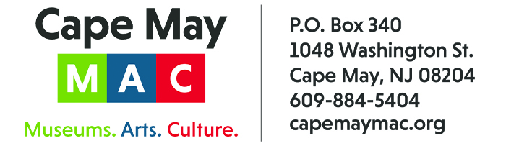

CONTACT: Susan Krysiak For Immediate Release
Director of Media Relations
609-224-6036
skrysiak@capemaymac.org

Join Holmes & Watson April 14-16 in Cape May for ‘Sherlock Holmes & Send in the Clowns’

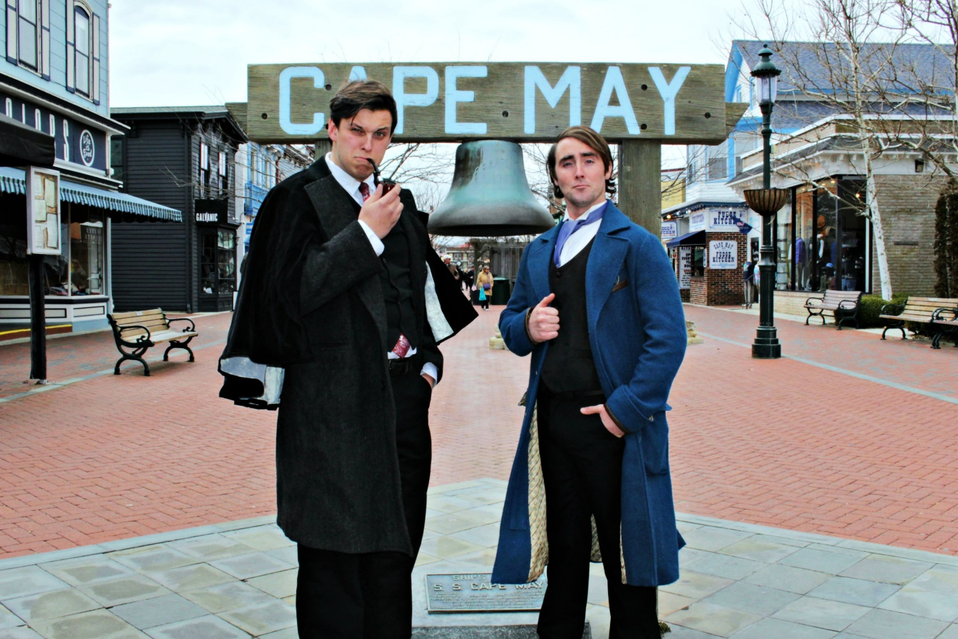

CAPE MAY – (March 14, 2023) (photo courtesy of Cape May MAC) Sir Arthur Conan Doyle’s master sleuth, Sherlock Holmes, and his loyal friend Dr. John Watson, follow the clues in an original mystery, “Sherlock Holmes & Send In the Clowns,” by Jacklyn Fazio. When Sherlock and Watson find themselves under the big top, a simple favor for a friend turns into a spectacle that our heroes were not prepared to witness. Will they be able to figure out who is terrorizing the circus and its dedicated performers before it’s too late? Join in and follow the story as the mystery unfolds, Friday-Sunday, April 14-16 at the event’s new location, La Mer Beachfront Resort, 1317 Beach Ave. Weekends begin with registration at 7 p.m. on Friday evening with light refreshments, then Act I begins at 7:30 p.m. Saturday’s Search for Clues Tour will send participants on their own search for clues on the streets of Cape May from 1 p.m.to 3 p.m., to fill in the missing pieces and compete for the grand prize: a weekend for two to next year’s performance. Act II begins at La Mer Beachfront Resort at 3:30 p.m. with light refreshments. On Sunday, lunch is served beginning at 11:30 a.m. and Act III begins immediately after. A cash bar is available. Tickets are limited. Admission is $150 per person. Accommodations may be arranged directly through La Mer Beachfront Resort. Visit capemaymac.org or call 609-884-5404 for tickets and more information. Cape May MAC (Museums+Arts+Culture) is a multifaceted, not-for-profit organization committed to promoting the preservation, interpretation and cultural enrichment of the Cape May region for its residents and visitors.

﻿###

