CONTACT: Susan Krysiak For Immediate Release
Director of Media Relations Feb. 15, 2023
609-224-6036
skrysiak@capemaymac.org

Cape May MAC launches new daily calendar app
App will help visitors and residents choose and purchase tours with ease
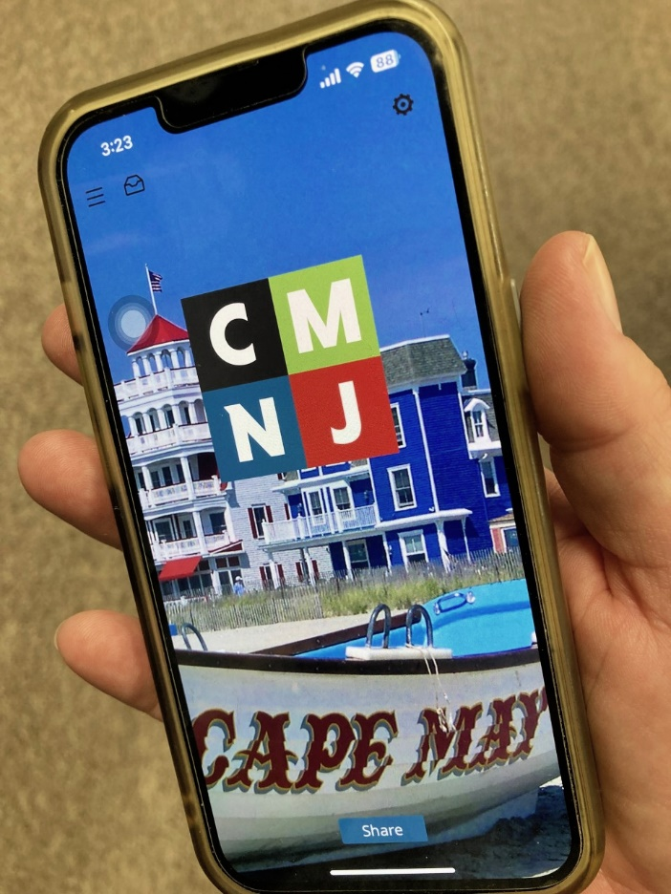
Photo courtesy of Cape May MAC

CAPE MAY, N.J. – Cape May MAC (Museums+Arts+Culture) announces the creation of a new mobile app. The app, self-titled “Cape May MAC,” will allow users to view a daily calendar of tours and events in an easily accessible format and to purchase tour and event tickets directly in the app. Users will be able to sort through tours and events by location—such as the Cape May Lighthouse, the World War II Lookout Tower, and/or the Physick House Museum—and by thematic groupings such as walking tours, house tours, trolley tours and more.
In addition to the daily calendar, users will be able to view a map of the local area populated by Cape May MAC partners, including restaurants and small businesses. This business directory feature will provide users with information about each listing, from photos to operating hours, and will continue Cape May MAC’s mission to enrich the greater Cape May region for its residents and visitors.
“We're excited that this new app creates an even more user-friendly way to view our tour and event calendar, and to book tickets directly from your phone with ease,” said Cape May MAC Chief Outreach Officer Eliza Lotozo.
The Cape May MAC app is free to download and available in the Apple App Store and the Google Play store for download on both iOS and Android devices. If you are a local business interested in being listed in the app’s business directory, please contact Cape May MAC’s Advertising Representative Joe McLaughlin, at jmclaughlin@capemaymac.org.
Cape May MAC is a multifaceted not-for-profit organization committed to promoting the preservation, interpretation and cultural enrichment of the Cape May region for its residents and visitors. Cape May MAC membership is open to all. For information about our year-round schedule of tours, festivals and events, visit capemaymac.org.

###

