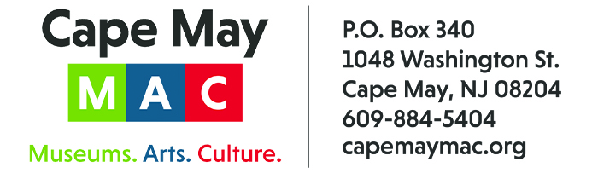

CONTACT: Susan Krysiak FOR IMMEDIATE RELEASE
Director of Media Relations
(609) 224-6036
skrysiak@capemaymac.org

Roger Henry is Cape May MAC Volunteer of the Month for February
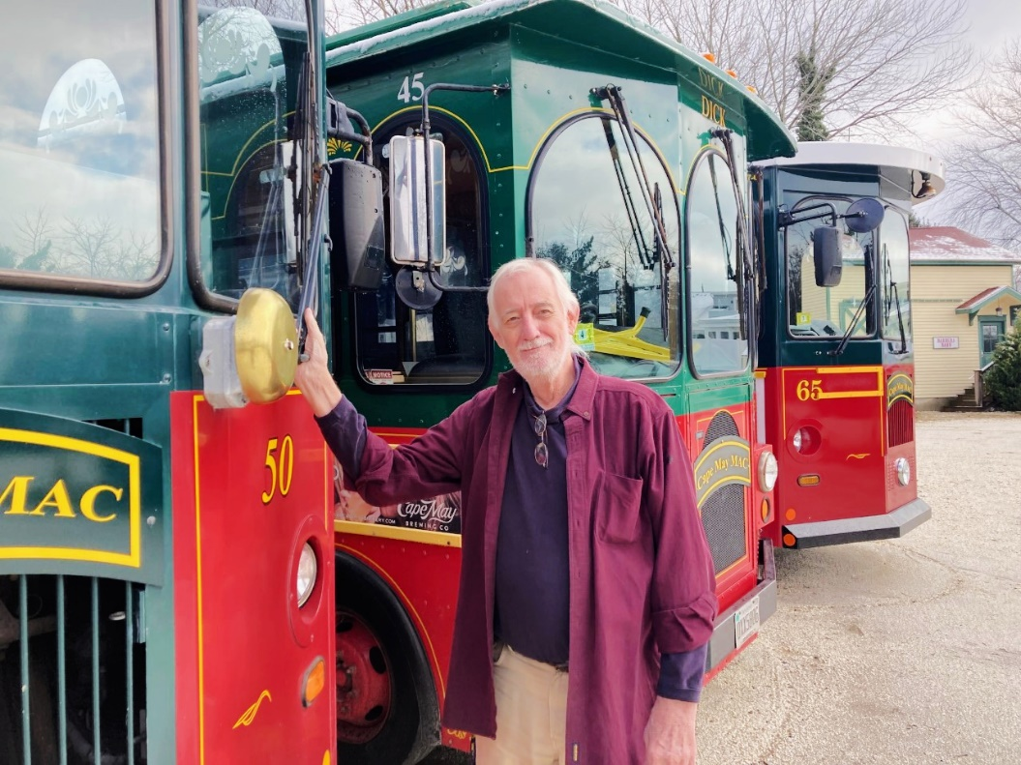

(Feb. 2, 2023) (photo courtesy of Cape May MAC): Roger Henry, of North Cape May, N.J. is the Cape May MAC (Museums+Arts+Culture) Volunteer of the Month for February. He was nominated by Cape May MAC Volunteer and Member Engagement Manager Sara Kornacki. “Roger is a long-time volunteer who recently retired from single-handedly maintaining the sparkle in the trolley brass for the last five years,” Kornacki said. “Roger originally became involved with Cape May MAC as a museum instructor before lending his skills as a volunteer on the Grounds Crew team, then managing the brass maintenance on our signature fleet of trolleys. Roger showed up every week in season for five years. His hard work, genuine spirit, kindness and sense of humor have made him a joy to have, and we are very grateful for his service.” For information about volunteer opportunities at Cape May MAC, contact Sara Kornacki at 609-224-6029 or skornacki@capemaymac.org. Cape May MAC is a multifaceted not-for-profit organization committed to promoting the preservation, interpretation and cultural enrichment of the Cape May region for its residents and visitors. Cape May MAC membership is open to all. For information about the year-round schedule of tours, festivals and events, visit capemaymac.org.

###

