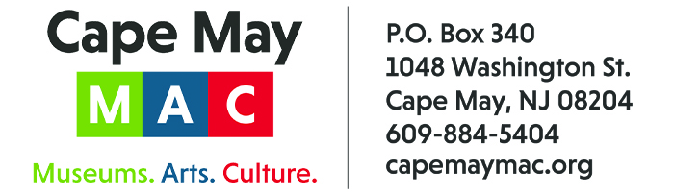

CONTACT: Susan Krysiak FOR IMMEDIATE RELEASE
Director of Media Relations
(609) 224-6036
skrysiak@capemaymac.org

Carol Crossed is Cape May MAC Volunteer of the Month for January

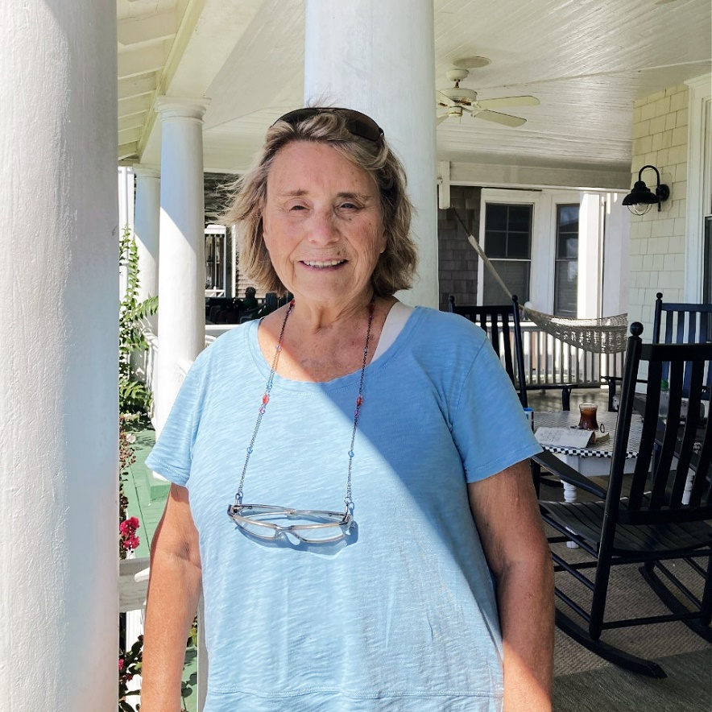

(Jan. 12, 2023) (photo courtesy of Cape May MAC): Carol Crossed, of Cape May, N.J. and Rochester, N.Y., is the Cape May MAC (Museums+Arts+Culture) Volunteer of the Month for January. She was nominated by Cape May MAC Chief Outreach Strategist Mary Stewart. “Carol approached us to present a program for our Lunch & Learn program,” Stewart said. “She wanted to speak on the topic of a book she published in 2019, called, "Vintage Tweets: Suffrage Era Postcards." Carol spoke about the 400 postcards in her personal collection which tell of the struggle between support and opposition in the early woman’s movement. ‘Vintage Tweets’ is a tribute to one of the most radical eras in U.S. history and was released in conjunction with the opening of the National Woman Suffrage Centennial at a book signing in Seneca Falls, N.Y. The topic is both timely and appropriate to our interpretation of the Victorian era and her kind donation of her time helped us to further our mission of interpretation and cultural enrichment.” Crossed is recipient of the 1996 Susan B Anthony Award, Peaceful Solutions in Non-violence Award, Women's Wall of Fame in Seneca Falls, N.Y., the Gaudete Medal, and the 2018 Catherine McAuley Award, given by the Sisters of Mercy. She purchased and restored the birthplace of Susan B Anthony in Adams, Mass. The home opened as a museum in 2010. To recognize this accomplishment, she was awarded the Northern Berkshire Massachusetts Business and Professional Women Award. “We are honored by her generosity and very grateful to Carol for giving her time and sharing her knowledge with the Cape May community in this way. Cape May MAC Lunch & Learn programs are a wonderful and free community asset for learning about all sorts of topics of history, thanks to people like Carol who share their time and expertise,” Stewart said. Cape May MAC is a multifaceted not-for-profit organization committed to promoting the preservation, interpretation and cultural enrichment of the Cape May region for its residents and visitors. Cape May MAC membership is open to all. For information about the year-round schedule of tours, festivals and events, visit capemaymac.org.

###

