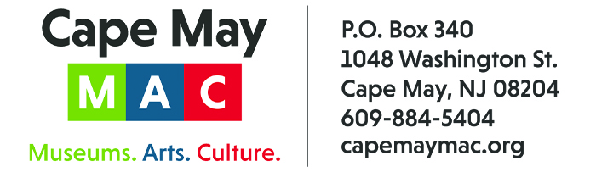

CONTACT: Susan Krysiak FOR IMMEDIATE RELEASE
Director of Media Relations
(609) 224-6036
skrysiak@capemaymac.org

Larry Hume is Cape May MAC Volunteer of the Month for March
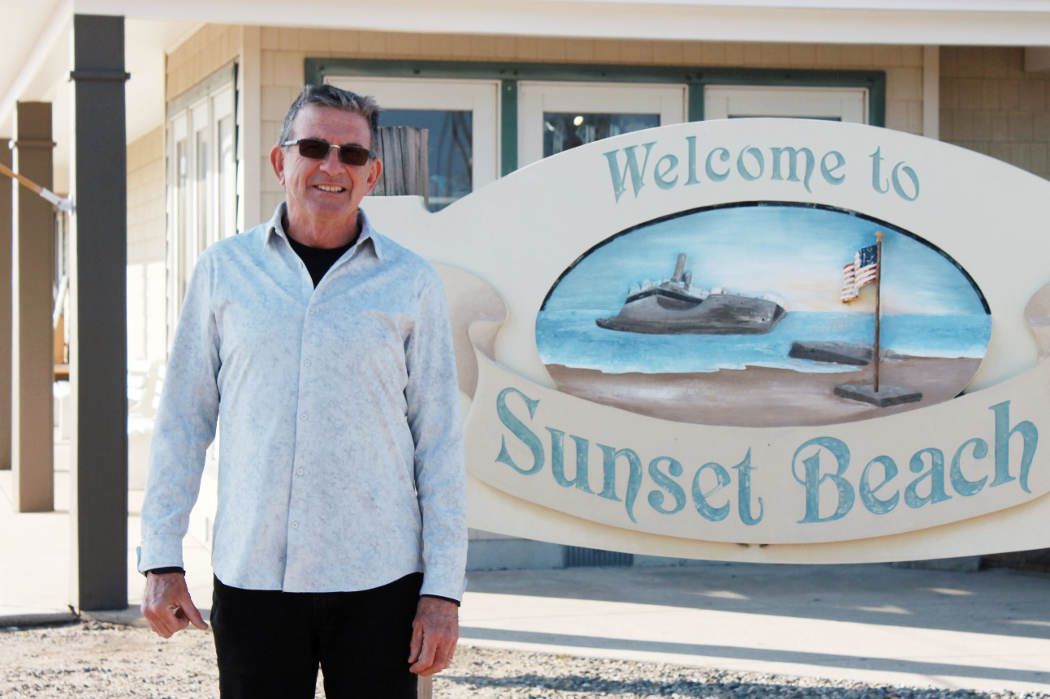

(March 6, 2023) (photo courtesy of Cape May MAC): Larry Hume, of Cape May, N.J. is the Cape May MAC (Museums+Arts+Culture) Volunteer of the Month for March. He is the owner of Sunset Beach Gifts and was nominated by Cape May MAC Director of Tour Operations Nanci Coughlin. Hume goes out of his way to welcome people arriving at Sunset Beach by bus on Cape May MAC group tours. He works with Cape May MAC in advance, arranging for bus parking and supplies for welcome bags for the drivers. Part of a group tour’s experience might be to attend the Sunset Beach Flag Lowering Ceremony, a Hume family tradition for over 40 years that honors veterans. “When the bus arrives, Larry checks if there are any veterans on board, so he can honor and include each of them in the flag-lowering ceremony,” Coughlin said. “He has a special way of making the tour meaningful and personal to our visitors. They come from all over the country and they leave with a special memory to last a lifetime. They feel both welcomed in Cape May, and cherished, thanks to Larry. We are honored to work with him and grateful for what he does.” For information about volunteer opportunities at Cape May MAC, contact Sara Kornacki at 609-224-6029 or skornacki@capemaymac.org. Cape May MAC is a multifaceted not-for-profit organization committed to promoting the preservation, interpretation and cultural enrichment of the Cape May region for its residents and visitors. Cape May MAC membership is open to all. For information about the year-round schedule of tours, festivals and events, visit capemaymac.org.

###

