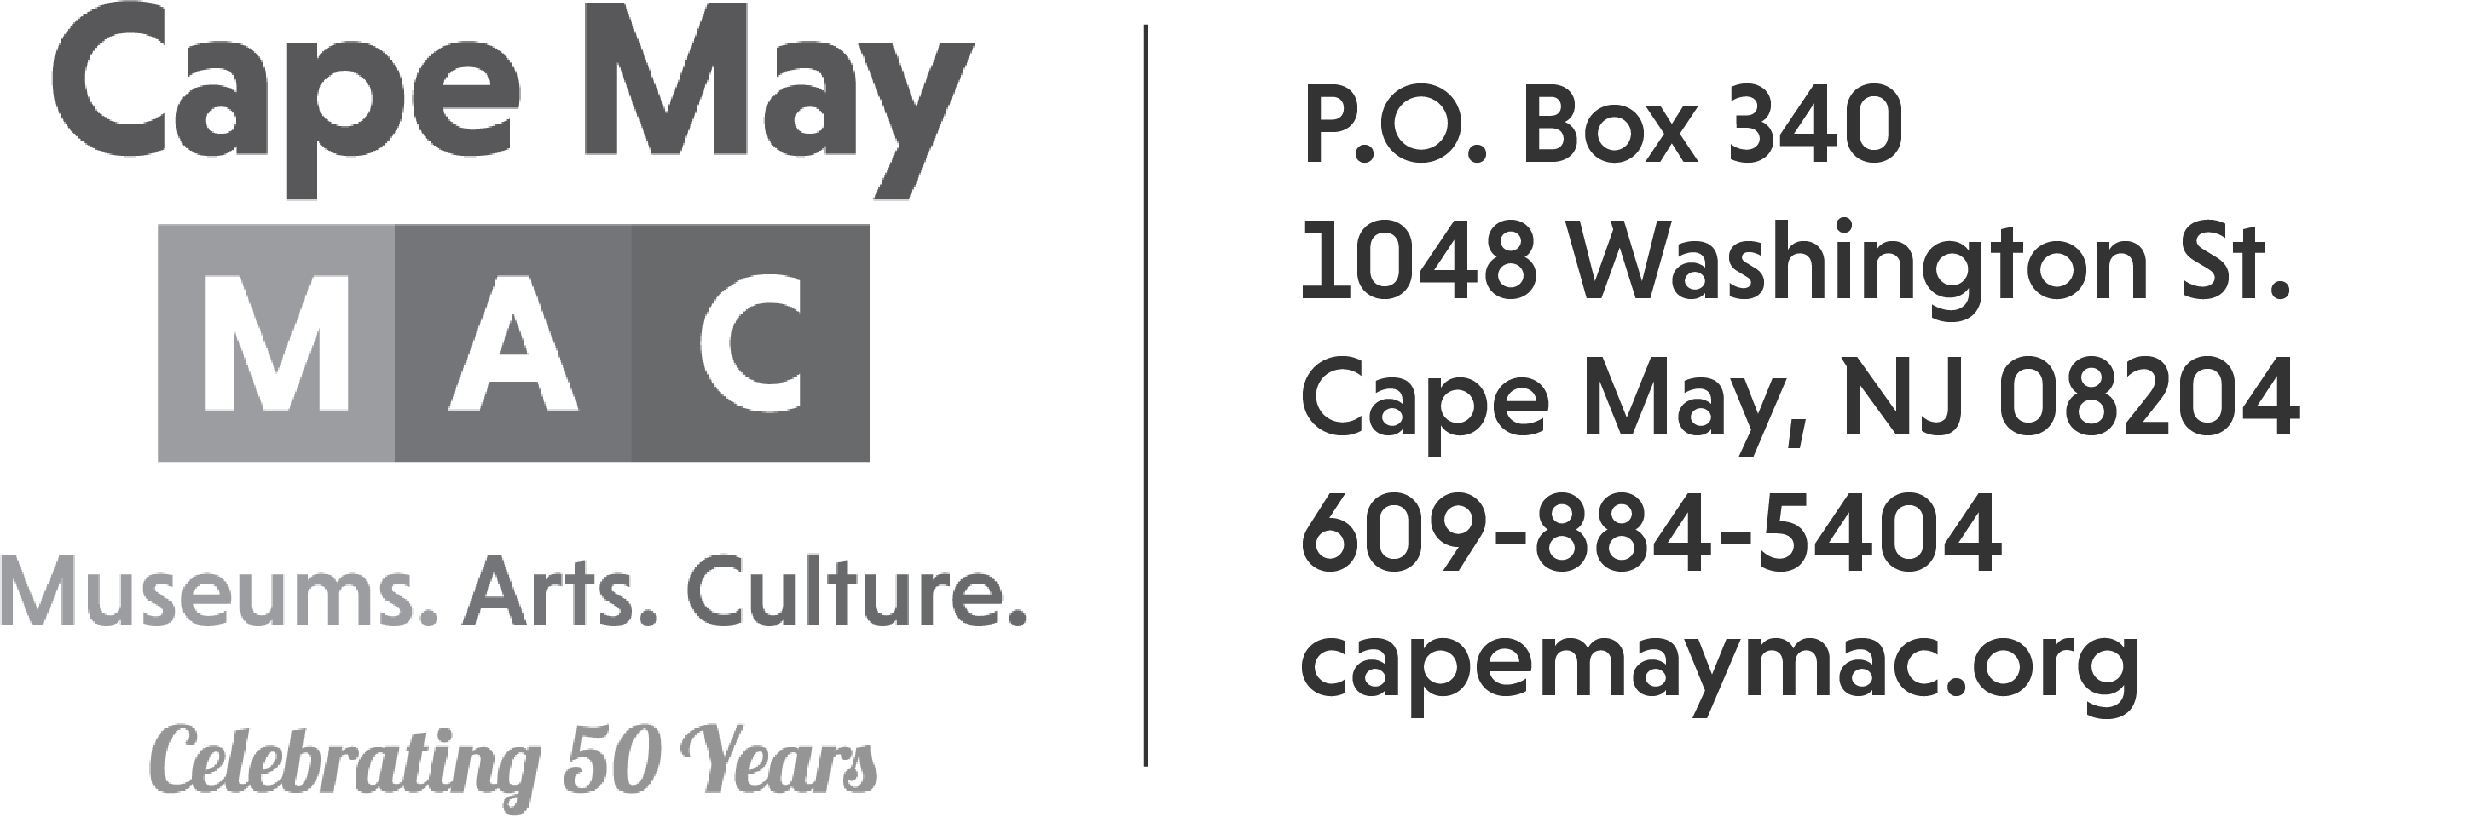

Craft Vendor Contract
Crafts & Collectibles in Winter
Saturday & Sunday, February 17th & 18th 2024

DEADLINE TO REGISTER (as long as vendor space is available)

Name _____________________________________________________

Email Address: ______________________________________________

Address: ___________________________________________________

City: __________________________ State: _________ Zip: _________

Contact Person: ____________________________ Phone: ___________

Description of items offered at event: ____________________________
___________________________________________________________
___________________________________________________________

General Guidelines:
Crafts & Collectibles in Winter will be held at Cape May Convention Hall, 714 Beach Ave on Saturday & Sunday, February 17th & 18th from 10:00am – 4:00pm each day. Each space is 10X10.

*No generators.
*We only accept handmade, original pieces of art or collectibles.
*Spaces will be assigned upon arrival at Convention Hall. Set-up time begins at 7am on Saturday, February 17th. We will not accept anyone after 9:30am.
Insurance Requirements:
Your application MUST have proof of insurance, listing the Mid-Atlantic Center for the Arts & Humanities as additionally insured for a minimum of $100,000 OR you must include an additional $10 fee to cover the insurance cost. Failure to include the proof of insurance or the $10 fee will result in your application being returned.
Payment:
Number of spaces with vendor provided insurance, and no electric at $200____________
Number of spaces without vendor provided insurance, and no electric $210____________
Number of spaces with vendor provided insurance and electric $250 _____________
Number of spaces without vendor provided insurance and electric $260____________

# of 8 foot tables $20 each ____________

There are NO refunds.

Credit Card Number _________________________________Exp Date________ CID#_______

Or Check #_______________

I shall not hold Cape May MAC staff, volunteers or any of its representatives responsible for accidents to me, my staff, or property and I agree to assume all financial responsibility including but not limited to damages to property or injuries to person, which arise or are claimed to arise out of or in connection with my participation in the Crafts & Collectibles in Winter located at the Cape May Convention Hall.

I agree to comply with all applicable Federal, State and Local laws, rules and regulations while participating in the Crafts & Collectibles in Winter.
.
I have read all the rules and regulations of the Crafts & Collectibles in Winter, and agree to abide by them.

Vendor Signature: ________________________________________ Date: _________________

Printed Name: ___________________________________________

RETURN FORMS TO: Janice Corkery jcorkery@capemaymac.org
Cape May MAC
Po Box 340
Cape May, NJ 08204
Contact phone number: 609-224-6027

