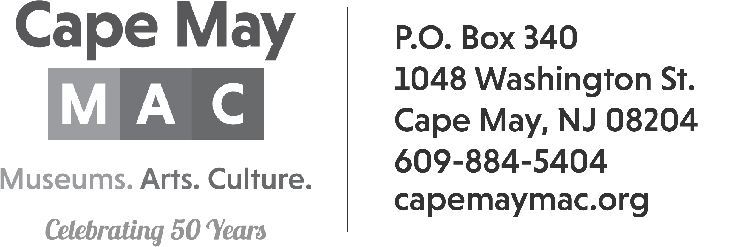

Craft Vendor Contract
Mother’s Day Weekend Crafts & Collectibles
Saturday, May 11th 2024

DEADLINE TO REGISTER (as long as vendor space is available)

Name _____________________________________________________

Email Address: ______________________________________________

Address: ___________________________________________________

City: __________________________ State: _________ Zip: _________

Contact Person: ____________________________ Phone: ___________

Description of items offered at event: ____________________________
___________________________________________________________
___________________________________________________________

General Guidelines:
Mother’s Day Weekend Crafts & Collectibles will be held at the Emlen Physick Estate, 1048 Washington Street, on Saturday, May 11th 2024 from 10:00am – 4:00pm.

*No generators.
*We only accept handmade, original pieces of art or collectibles.
*Spaces will be assigned upon arrival at the Emlen Physick Estate Set-up time begins at 7am. We will not accept anyone after 9:30am. Spaces are 10 X 10.
Insurance Requirements:
Your application MUST have proof of insurance, listing the Mid-Atlantic Center for the Arts & Humanities as additionally insured for a minimum of $100,000 OR you must include an additional $10 fee to cover the insurance cost. Failure to include the proof of insurance or the $10 fee will result in your application being returned.
Payment:
Number of spaces with vendor provided insurance $100____________
Number of spaces without vendor provided insurance $110____________

There are NO refunds. This is a rain or shine event.

Credit Card Number _________________________________Exp Date________ CID#_______

Or Check #_______________

I shall not hold Cape May MAC staff, volunteers or any of its representatives responsible for accidents to me, my staff, or property and I agree to assume all financial responsibility including but not limited to damages to property or injuries to person, which arise or are claimed to arise out of or in connection with my participation in the Mother’s Day Weekend Crafts & Collectibles located at the Emlen Physick Estate.

I agree to comply with all applicable Federal, State and Local laws, rules and regulations while participating in the Mother’s Day Weekend Crafts & Collectibles
.
I have read all the rules and regulations of Mother’s Day Weekend Crafts & Collectibles and agree to abide by them.

Vendor Signature: ________________________________________ Date: _________________

Printed Name: ___________________________________________

RETURN FORMS TO: Janice Corkery jcorkery@capemaymac.org
Cape May MAC
Po Box 340
Cape May, NJ 08204
Contact phone number: 609-224-6027

