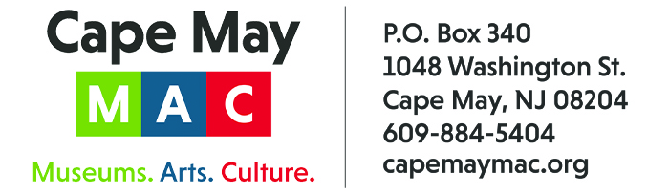

CONTACT: Susan Krysiak FOR IMMEDIATE RELEASE
Director of Media Relations May 12, 2023
(609) 224-6036
skrysiak@capemaymac.org

34th Annual Cape May Music Festival opens May 25 with solo artist and songwriter Okorie ‘OKCello’ Johnson


Photo by Michael Reese
Okorie “OKCello’ Johnson

CAPE MAY— The 34th Cape May Music Festival, which brings together musicians across genres, kicks off on Thursday, May 25 and continues with live events through Thursday, June 22. Cape May MAC is thrilled to be partnering again with Jed Gaylin, the music director of the Bay Atlantic Symphony, and Eliot Bailen, artistic director of the New York Chamber Ensemble. Performances this year include solo artists such as Atlanta-based cellist and songwriter OkCello, and jazz and R&B saxophonist and singer Erich Cawalla, along with ensemble performances from the Bay Atlantic Symphony, the New York Chamber Ensemble, the New Jersey Symphony Chamber Players, the Atlantic Brass Band, and the 11th Annual George Mesterhazy Tribute Concert.
Here's the lineup for the first week of this four-week festival:

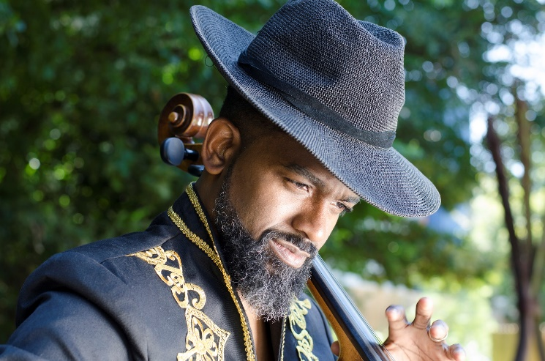
Photo by Michael Reese
Okorie “OKCello” Johnson

Opening the 34th Annual Cape May Music Festival on Thursday, May 25 at 7 p.m. is Okorie “OKCello” Johnson, Atlanta-based cellist and songwriter whose work draws from themes and expressions of the African Diaspora. OKCello’s artistry integrates cello performance, live-sound-looping, improvisation, and storytelling - all culminating in original compositions that collide classical with jazz, EDM, reggae and funk. https://www.okcello.com/welcome OKCello will perform at the Episcopal Church of the Advent. Admission is $35 for adults, $30 for Cape May MAC members, and $25 for students. For tickets visit capemaymac.org.
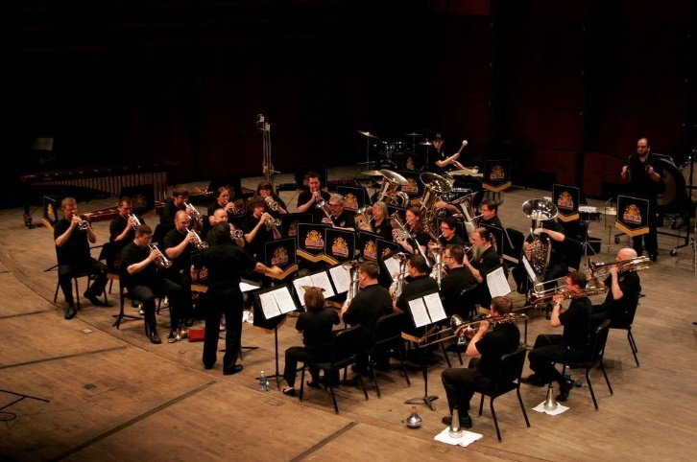
Photo Courtesy of Atlantic Brass Band
Atlantic Brass Band

Memorial Day Weekend celebrations continue May 28 at 7 p.m. with the award-winning Atlantic Brass Band, playing a lively collection of patriotic tunes at the Rotary Park Bandstand (rain location: Cape May Convention Hall). Admission to this concert is free.
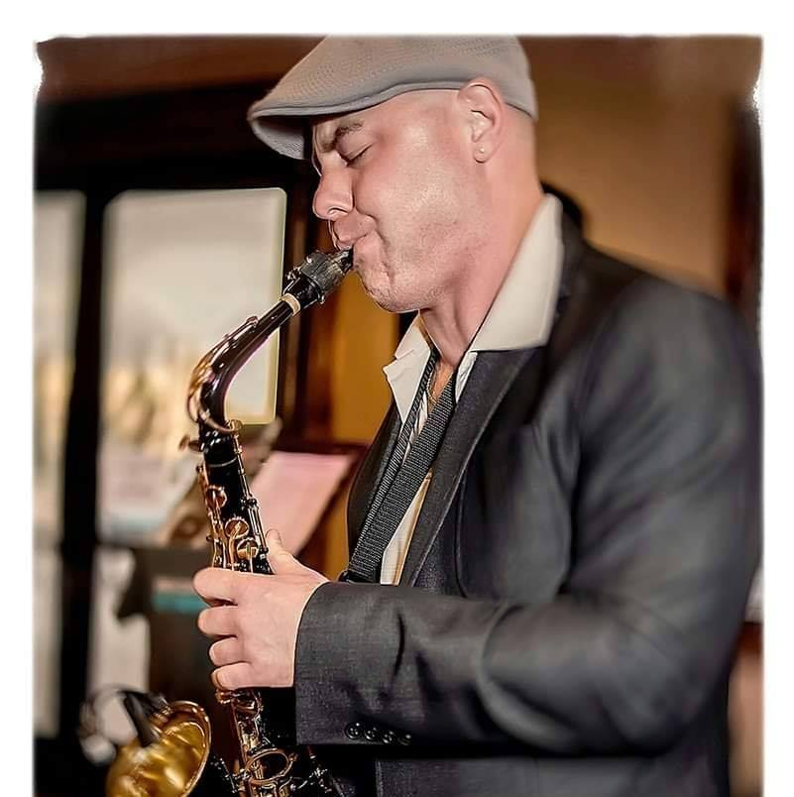
Photo Courtesy of Erich Cawalla
Erich Cawalla

On May 30, singer and saxophonist Erich Cawalla, https://www.erichcawalla.com/, another new addition to the festival, will perform at Cape May Convention Hall. Cawalla is known for his signature blend of jazz with contemporary R&B—and for this performance, Cawalla has assembled a stellar band to perform favorite hits from world-class artists such as Smokey Robinson, Nat King Cole, Frank Sinatra, Tony Bennett, Mel Torme and many more. Admission is $35 for adults, $30 for Cape May MAC members and $25 for students. For tickets visit capemaymac.org.

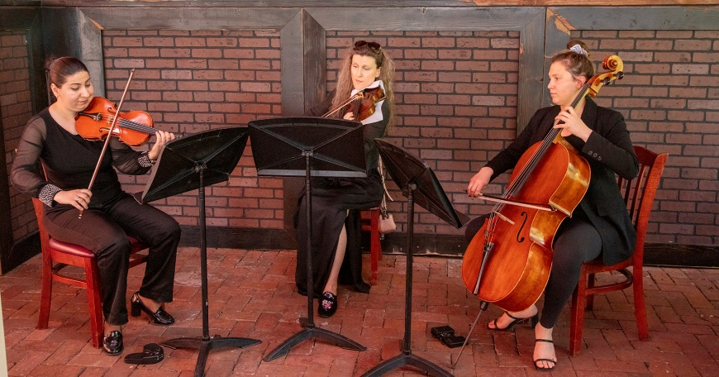
Photo by Joseph Evangelista
Bach’s Lunch

For those who believe that music is best served alongside a tasty meal, the Washington Inn will graciously host a Bach’s Lunch at 12:30 p.m. on May 31, June 7, and again on June 21. Enjoy classical music performed by members of the Bay Atlantic Symphony, while sharing a memorable meal at one of the top-ranked Cape May restaurants. Admission is $50 for adults, $45 for Cape May MAC members. For tickets visit capemaymac.org.

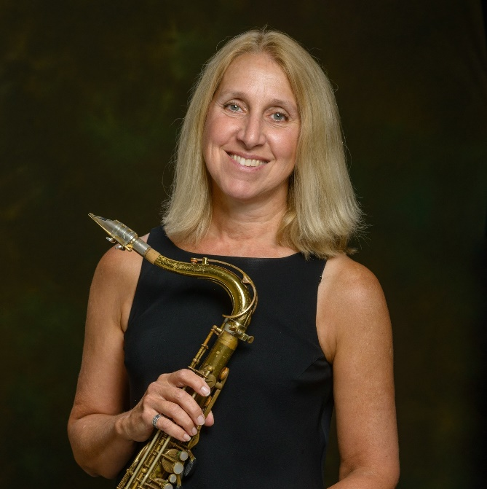
Jazz Brunch – Mary Lou Newnam

On June 4, the food and music pairings continue with a Jazz Brunch, hosted by the newly renovated Inn of Cape May at 10 a.m. Enjoy selections from the Great American Songbook over brunch with jazz performers Mary Lou Newnam on saxophone, clarinet and flute, and Ray Malach on piano. Admission is $50. For tickets visit capemaymac.org.

The 34th annual Cape May Music Festival features 15 great musical performance events from Sunday, May 25 through Thursday, June 22, and is presented by Cape May MAC (Museums+Arts+Culture) with funding from the New Jersey State Council on the Arts.
Cape May MAC is a multifaceted not-for-profit organization committed to promoting the preservation, interpretation and cultural enrichment of the Cape May region for its residents and visitors. Cape May MAC membership is open to all. For information about Cape May MAC’s year-round schedule of tours, festivals and events, visit capemaymac.org or call 609-884-5404.
For information about restaurants, accommodations and shopping, call the Chamber of Commerce of Greater Cape May at 609-884-5508 or visit www.capemaychamber.com. For information about historic accommodations, contact Cape May Historic Accommodations at www.capemaylodging.com.

###

