**CONTACT:** Susan Krysiak **For Immediate Release**

Director of Media Relations April 25, 2023

609-224-6036

skrysiak@capemaymac.org

**Cape May MAC presents ‘Black Footprints on White Sand’ May 5 with Chase Jackson and Chanelle René**

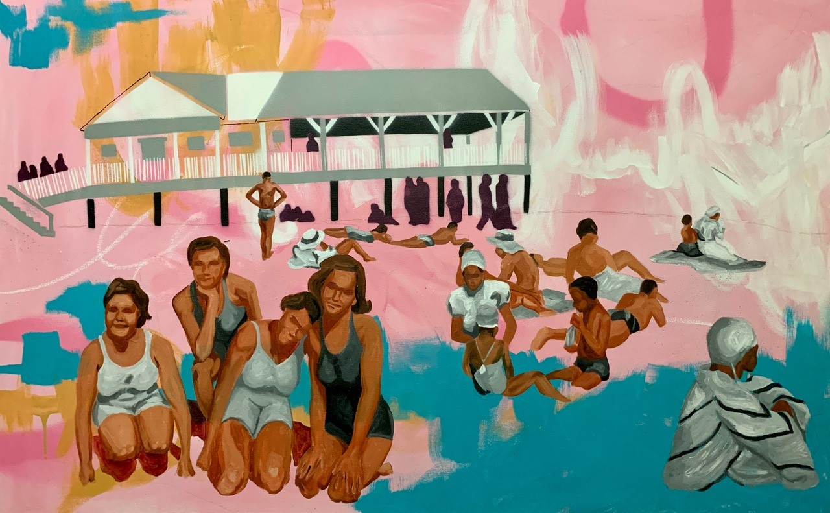

**“Good Times at Grant Street” by Chanelle René**

**CAPE MAY –** Cape May MAC (Museums+Arts+Culture) presents storyteller Chase Jackson in an original program, “Black Footprints on White Sand: Historical African American Beaches and Resorts,” with artwork by Chanelle René. The event is Friday, May 5 at 7 p.m. at Cape May Stage, 405 Lafayette St.

During the Jim Crow era, the very idea of African American people enjoying leisure spaces alongside white persons was a challenge, as it implied equality. Out of necessity, African American activists and businesspeople created their own beach communities. "Black Footprints on White Sand" explores how race and leisure intersect.

“I realized as I told my stories to my grands that I was living history for them,” Jackson said. “So, I began to dig a little more into certain stories to give them a larger view of what and why life was the way it was ‘back in my day.’ That’s what I’m sharing through this presentation — the ‘what,’ the ‘why’ and a bit of ‘did you know?’”

Jackson is an arts administrator and a community arts activist, serving as the executive director of the Ocean City Arts Center. She is an accomplished storyteller, producer, director, actor and blues belter. She is on the steering committee of the Creating Change Network, a program hosted by New Jersey Theatre Alliance and ArtPride New Jersey that aims to build a more equitable, just and anti-racist arts community in New Jersey. During her time in Cape May County, she has produced numerous plays, story and poetry slams through her production company, ChaseArts, and been active with several nonprofits as a consultant and volunteer.

Alongside this presentation, two works by local artist Chanelle René will be displayed and for sale. The two paintings are part of Chanelle René's "Grant Street Beach" series, which depicts the segregated beach of Cape May, N.J. Working from her own family photographs and those of other Black families, these works depict joyful everyday moments of African American beachgoers in Cape May, from the 1920s through the 1960s. Each work explores the complexity and nuance of the human spirit while celebrating generations of Black beachgoers as they transition from segregation to making Grant Street Beach a tradition of choice.

Tickets to this event are $20 and can be purchased online at capemaymac.org <https://capemaymac.org/experience/special-events/black-footprints-on-white-sand/> or by calling 609-884-5404.

Cape May MAC is a multifaceted not-for-profit organization committed to promoting the preservation, interpretation and cultural enrichment of the Cape May region for its residents and visitors. Cape May MAC membership is open to all. For information about our year-round schedule of tours, festivals and events, visit capemaymac.org.

###