**For Immediate Release**

CONTACT: Susan Krysiak, Director of Media Relations

609-224-6036

skrysiak@capemaymac.org

**Professor Robert Watson presents ‘Hamilton: The Man, The Myth, The Musical’ Oct. 8 at Cape May Convention Hall**

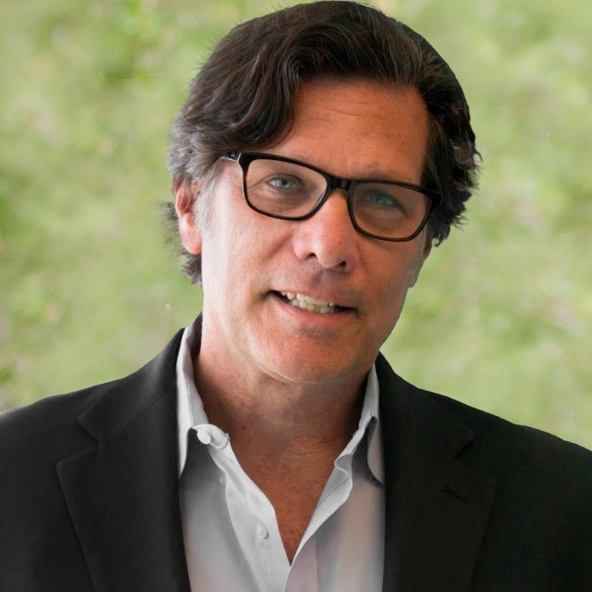

**Robert Watson, Ph.D.**

**(Date) CAPE MAY, N.J. —** Cape May MAC (Museums+Arts+Culture) welcomes award-winning author, professor, distinguished historian and widely-acclaimed speaker Dr. Robert Watson to Cape May to present “Hamilton: The Man, The Myth, The Musical,” on Sunday, Oct. 8 at Cape May Convention Hall, 714 Beach Ave. The lecture is part of the annual Lessons of History: Distinguished Lecture Series that brings renowned speakers to Cape May to offer illuminating insights within their respective fields.

Watson, a distinguished professor of American history and presidential historian, has written over 40 books and won the silver medal in history for his recent book “George Washington's Final Battle” (2021) at the Independent Publishers Book Awards—the world's largest book awards and competition. He has written an exquisite, essential account of history’s most scandalous love affairs, “Affairs of State” and has analyzed Hamilton’s own misdoings in the 2021 Foreword to “Alexander Hamilton: Adultery and Apology,” originally published in 1796, in which Hamilton attempts to explain and rationalize his marital affairs.

In this compelling lecture, Watson examines the life and legacy of Founding Father Alexander Hamilton—from historic truth to modern Broadway interpretation. Watson will explore the lasting impact Hamilton had on the state of New Jersey, including the founding of the U.S. Coast Guard and his fateful duel with Aaron Burr in Weehawken.

"Thanks to the hit Broadway show, Hamilton's legacy has been rediscovered. This talk will go behind the musical and popular narrative to reveal several compelling and complicated facets of his remarkable life,” Watson said. “Hamilton was, without question, one of the most important of all the Founders in shaping the new nation, but he was also perhaps the most interesting, controversial, intelligent—and least likely of the impressive group that forged the republic."

Robert Watson is an award-winning author who has published over 40 books and 200 scholarly articles and essays on topics in political, military, and social history, as well as two multi-edition, multi-volume encyclopedia sets on the presidents and first ladies. Some of his recent books include Affairs of State (2012), America’s First Crisis (2014), The Nazi Titanic (2016), The Ghost Ship of Brooklyn (2017), George Washington’s Final Battle (2021), and Escape (2021), as well as the forthcoming books When Washington Burned (2023) and American’s First Plague (2023). He also wrote the foreward to Alexander Hamilton: Adultery & Apology (2017). Watson’s books have won numerous awards including the Independent Publishers’ Gold Medal in History and Silver Medal in History, John Barry Book Award, and John Lyman Book Award, have been featured on C-SPAN’s Book TV and at prominent literary festivals around the country, and are available in both audiobook and international translation.

A frequent media commentator, Watson has been interviewed thousands of times by news outlets around the world, including CNN, MSNBC, USA Today, The New York Times, NPR, and the BBC, and has appeared on Hardball, The Daily Show, and C-SPAN’s American History TV. He has served as a researcher and on-screen expert for several historical documentaries for the Discovery, Science, National Geographic, History, Fuse, Super Channel, and other TV networks, including three seasons of an international award-winning series on Nazi secrets.

Dr. Watson co-convened several national conferences, co-founded the annual Truman Legacy Symposium for the Truman Presidential Library, and served on the boards of numerous academic associations, community organizations, and the Harry S. Truman Foundation, Calvin Coolidge Foundation, and George McGovern Center for Leadership. Watson also served as the editor of the scholarly journal White House Studies, the assistant editor and book review editor of The Social Science Journal, and the “Presidency Series” editor for the State University of New York Press. He has been a visiting scholar or lecturer with many leading historic sites, including the Truman Presidential Library, Gerald Ford Presidential Museum, Illinois Holocaust Museum, West Point, National Archives, Smithsonian Institution, Pentagon, Museum of the American Revolution, American Revolution Institute, Gilder-Lehrman Institute of American History, National Museum of the US Navy, George Washington’s Mount Vernon, Society of the Cincinnati, James Madison’s Montpelier, Fraunces Tavern Museum, Gettysburg National Battlefield, National Civil War Museum, US Capitol Historical Society, Virginia Museum of History and Culture, Museum of Jewish Heritage in NYC, American Civil War Museum, Andersonville National Historic Site, and the Truman Little White House, to name a few. He is also one of a select group of historians invited every few years to rank the presidents.

Watson is the recipient of many awards for his contributions to the study of the presidency, election commentary, community service, civics programs, and efforts to combat anti-Semitism and incivility. He has been named “Professor of the Year” three times and has won all three campus-wide faculty awards—service, research, and teaching—several times at both Florida Atlantic University and Lynn University.

Watson was born in Harrisburg, Pa., attended public schools in nearby Hershey, and was educated at Virginia Tech, where he lettered on the football and track teams. Winning 10 state championships in three different sports, he was inducted into two sports halls of fame. Watson currently holds the titles Distinguished Professor of American History, Avron Fogelman Research Professor, and Assistant Director of the Center for Citizenship and Civility at Lynn University and Senior Fellow with Senator Bob Graham’s Florida Joint Center for Citizenship. He is the proud father of Alexander and Isabella.

This lecture will begin at 5 p.m., and limited tickets are available for $40. Teachers and students admitted free with valid school I.D.

For more information visit capemaymac.org or call 609-884-5404.

Cape May MAC is a multifaceted not-for-profit organization committed to promoting the preservation, interpretation and cultural enrichment of the Cape May region for its residents and visitors. Cape May MAC membership is open to all. For information about our year-round schedule of tours, festivals and events, visit capemaymac.org.