CONTACT: Susan Krysiak For Immediate Release

Director of Media Relations Jan. 8, 2025

609-224-6036

skrysiak@capemaymac.org

Brenda Leonard

bleonard@capemaymac.org

**Classical Cape May series this winter features unusual instruments, original works, accomplished musicians**

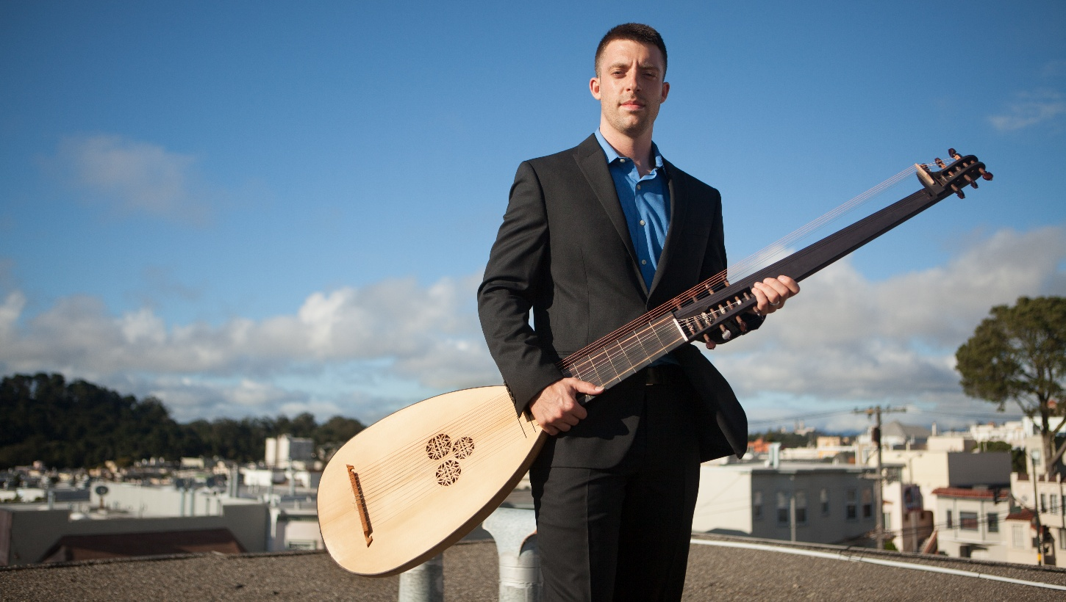

*Photo by Matthew Washburn*

Shown here, Adam Cockerham performs Sunday, Jan. 12 at 4 p.m. at the Episcopal Church of the Advent, 7 Franklin St., Cape May, launching this year’s Classical Cape May series of free concerts.

**CAPE MAY —** This winter in Cape May enjoy four free classical music concerts featuring unusual instruments, original works and accomplished musicians.

Building on the success of its inaugural season, Classical Cape May announces its second season of programs, sponsored by Cape May MAC (Museums+Arts+Culture).

Concerts are scheduled on Sundays, Jan. 12, Feb. 9, March 9 and April 13, from 4 p.m. to 5 p.m. at the Episcopal Church of the Advent at 612 Franklin St. (Franklin and Washington streets) in Cape May and admission is free. Attendees are invited to a reception after each program to meet the artists.

**Sunday, Feb. 9**

**Music of our Time by People of our Place**

**Cape May County musicians performing**

Besides bringing excellent regional performers to our area, Classical Cape May’s mission includes showcasing the best of local classical artists. This year our local musicians are focusing on works written during the past century, featuring vocal performances and pieces on the piano and organ. In addition, Brenda Leonard will be playing a new piece for unaccompanied cello by a talented local composer, Koren Cowgill.

**Sunday, March 9**

**Romantic Love Songs**

**PolyVoce sing the Brahms Liebeslieder Waltzes**

Co-director Robert Bullington brings one of his ensembles for the March program. PolyVoce is an ensemble of four singers — soprano, alto, tenor and baritone — and two pianists. Brahms Liebeslieder Waltzes are a collection of love songs for voices and piano, four hands (two pianists, one piano). Not all of the waltzes use all four voices; there are solos and some pieces featuring two voices.

**Sunday, April 13**

**Piano Quintets**

**Main Street Chamber Players of Fairfax, Va.**

The final concert of the 2025 season features the Main Street Chamber Players of Fairfax, Va. Cellist Kenneth Law teaches at the Main Street Music Studios in Fairfax, teaching and mentoring excellent young cellists from the Washington, D.C. area, including one who was recently featured on NPR’s national program “From the Top.”

The Main Street Chamber Players include violin, viola, cello, double bass and piano. The musicians will play as a quintet and as various smaller ensembles. On the program is the rarely heard Vaughn-Williams Piano Quintet, as well as works by three women composers: the early 20th century composer Rebecca Clarke, Belize-born composer Errolyn Waller, and one of Argentina’s most celebrated young composers, Adriana Figueroa Manas.

Classical Cape May is co-founded and co-directed by Brenda Leonard and Robert Bullington. The mission is to bring a variety of free classical performances to Cape May during the winter season, and to celebrate local and regional classical music talent. The series is open to all ages and interests, and donations are appreciated.

The Classical Cape May series is in partnership with the annual Cape May Music Festival, now in its 36th year, presented by Cape May MAC and supported in part by a grant from the New Jersey State Council on the Arts.

Cape May MAC (Museums+Arts+Culture) is a multifaceted not-for-profit organization committed to promoting the preservation, interpretation, and cultural enrichment of the Cape May region for its residents and visitors. We operate and manage the 1879 Emlen Physick Estate, the 1859 Cape May Lighthouse and the 1942 World War II Lookout Tower, and are the leading organization to offer visitors tours, activities and events year-round in America’s National Historic Landmark City. Cape May MAC is the organization that saved the 1879 Emlen Physick Estate from demolition, helping secure the City of Cape May as an internationally recognized historic destination. For information about our year-round schedule of tours, festivals, and special events, call 609-884-5404 or visit capemaymac.org.