**CONTACT:** Susan Krysiak **For Immediate Release**

Director of Media Relations Jan. 9, 2025

609-224-6036

[skrysiak@capemaymac.org](mailto:skrysiak@capemaymac.org)

**‘Routes of Black Travel: The Green Book in Cape May and Wildwood’ exhibit Jan. 18-March 23 in Cape May**

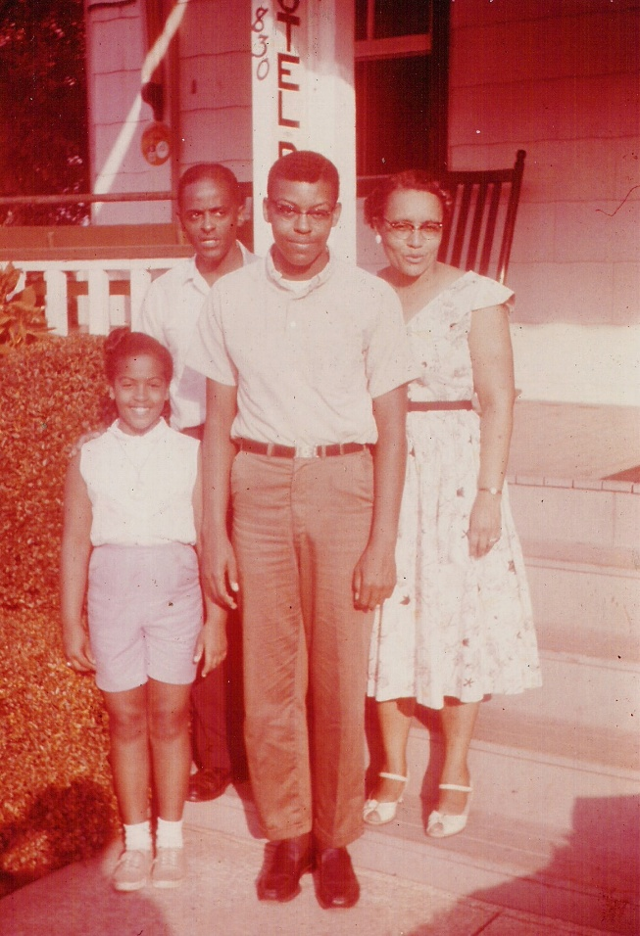

*Photo courtesy of Center for Community Arts Nash Collection / Gift of Becki Vance Wilson*

Shown here, Griffin family members in front of Hotel DeGriff, on Corgie Street, Cape May, N.J.: James, Georgia, James Jr., and Patricia. The hotel was owned by James' mother, Della Griffin, and later his sister, Helena.

**CAPE MAY, N.J. –**  A new Carroll Gallery exhibit at the Emlen Physick Estate opens Martin Luther King, Jr. weekend and explores how Black travelers during the Jim Crow era used The Green Book and other publications to more safely travel in the United States, including travel for vacation or business to Wildwood and Cape May, N.J. “Routes of Black Travel: ‘The Green Book’ in Cape May and Wildwood” is presented by Cape May MAC (Museums+Arts+Culture) in association with Center for Community Arts (CCA) at the Carroll Gallery, Emlen Physick Estate, 1048 Washington St. The exhibit opens Saturday, Jan. 18, with an opening reception on Martin Luther King, Jr. Day, Monday, Jan. 20, from 3 p.m. to 5 p.m.

“The Negro Motorist Green Book,” later renamed “The Negro Travelers’ Green Book,” was an annual guidebook first published in 1936 that gave African American travelers essential information about safe places to stay, dine, and obtain services while traveling in the segregated United States during the Jim Crow era. Jim Crow laws forced racial segregation and were enforced harshly, often with violence. The laws lasted close to 100 years until the Civil Rights laws of the 1960s. The Green Book and similar publications helped keep Black travelers safe during this time and provided them some measure of freedom of movement.

Learn how Esso stations created safe havens for Black motorists to fill their gas tanks and how hotels such as the Banneker House, the Hotel Dale, and Richardson’s Hotel, among others in Cape May, along with guest houses in Wildwood, gave Black visitors safe spaces to relax at the seaside on holiday or for business.

The public is invited to the exhibit in the Carroll Gallery on the grounds of the Physick Estate, 1048 Washington St. and to the opening reception. The exhibit is open Saturday, Jan. 18 to Sunday, March 23. Admission is free. For schedule visit capemaymac.org.

The Center for Community Arts (CCA) is a multicultural education organization whose arts and humanities programs foster creativity, community building, and appreciation for the rich diversity of our world. centerforcommunityarts.org. Cape May MAC (Museums+Arts+Culture) is a multifaceted not-for-profit organization committed to promoting the preservation, interpretation and cultural enrichment of the Cape May region for its residents and visitors. Cape May MAC membership is open to all. For information about Cape May MAC’s year-round schedule of tours, festivals and events, visit capemaymac.org or call 609-884-5404.

###