CONTACT: Susan Krysiak For Immediate Release

Director of Media Relations Jan. 22, 2025

609-224-6036

skrysiak@capemaymac.org

**Exploring American Literature of the 1800s with Cape May Poet Laureate Sylvia Baer**

*Three online seminars will focus on Emerson, Thoreau and Alcott, Emily Dickinson and Helen Hunt Jackson, and Hawthorne, Poe and Melville*

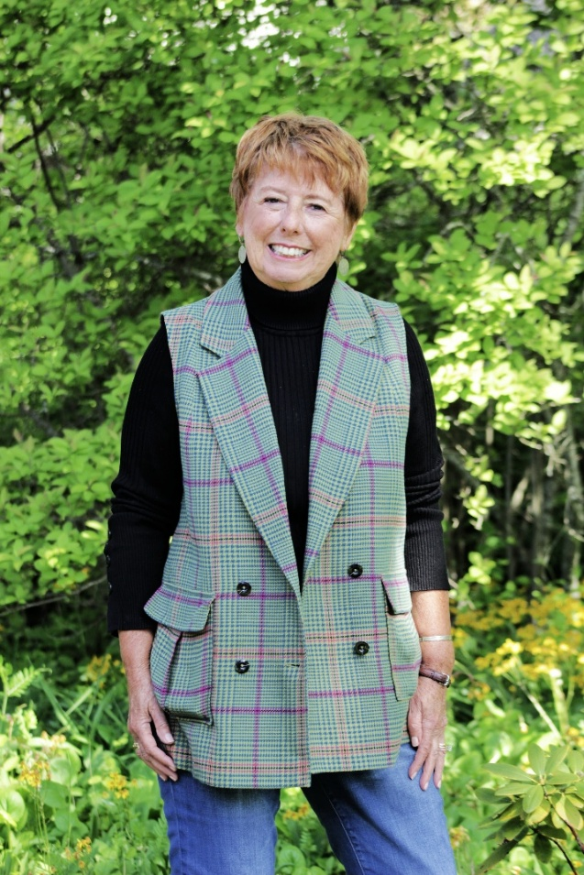

*Photo courtesy of Cape May MAC*

**Cape May Poet Laureate Sylvia Baer, Ph.D.**

**CAPE MAY —** Cape May’s Poet Laureate Sylvia Baer hosts three 1.5-hour interactive online seminars via Zoom this March that delve into American literature of the Victorian age. “The Concord Gang” on Monday, March 10 highlights Emerson, Thoreau and Alcott. “The Amherst Gang” on Monday, March 17 features Emily Dickinson and Helen Hunt Jackson. “The Fear Gang” on Monday, March 24 delves into Hawthorne, Poe and Melville.

These seminars are designed for those at any level of knowledge and experience who wish to learn more about and discuss literature. This will be an engaging, interactive learning experience. Seminars will not be recorded, but video cameras shall be on to encourage the energetic flow of ideas and active participation. Reading selections will be provided in advance at no extra cost and are not required reading. Offered Mondays, March 10, 17, 24, 5:30 p.m. to 7 p.m. Each seminar is sold separately at $15. For more information and to register for one, two or all three seminars, visit capemaymac.org at <https://capemaymac.org/exploring-american-literature/>. After purchase each participant will be sent Zoom registration information and additional information. Seats are limited.

Dr. Sylvia Baer has been a professor of literature for 51 years and is also the Poet Laureate of Cape May, a playwright, a memoirist, a writer of scholarly works, a translator of Spanish poetry (into English), and a Fellow at Yale University. She has curated haiku and photography exhibitions at Rowan University and Yale University, been founding editor of international academic journals, and presented at conferences and workshops throughout the country. In Cape May she is the creator of The Poet-Tree where she hangs about 60 poems written by a whole panoply of writers, and with signage encourages passers-by to pick any poem that appeals to them and to take it with them. So many folks enjoy this that each day the tree is replenished once or twice. Her latest book, “Building Life, A Memoir,” published in June 2024, is the second volume in an unconventional memoir that began with “Learning Life, a Memoir, published in August 2022. Both are published by Nostos Press. She has deep connections to Cape May MAC, spanning five decades, and is proud to say that her father was the first president of Cape May MAC in 1971.

Cape May MAC (Museums+Arts+Culture) is a multifaceted not-for-profit organization committed to promoting the preservation, interpretation, and cultural enrichment of the Cape May region for its residents and visitors. We operate and manage the 1879 Emlen Physick Estate, the 1859 Cape May Lighthouse and the 1942 World War II Lookout Tower, and are the leading organization to offer visitors tours, activities and events year-round in America’s National Historic Landmark City. Cape May MAC is the organization that saved the 1879 Emlen Physick Estate from demolition, helping secure the City of Cape May as an internationally recognized historic destination. For information about our year-round schedule of tours, festivals, and special events, call 609-884-5404 or visit capemaymac.org.