**CONTACT:** Susan Krysiak **For Immediate Release**

Director of Media Relations February 27, 2025

609-224-6036

skrysiak@capemaymac.org

**Gardens of Cape May Tour May 10**

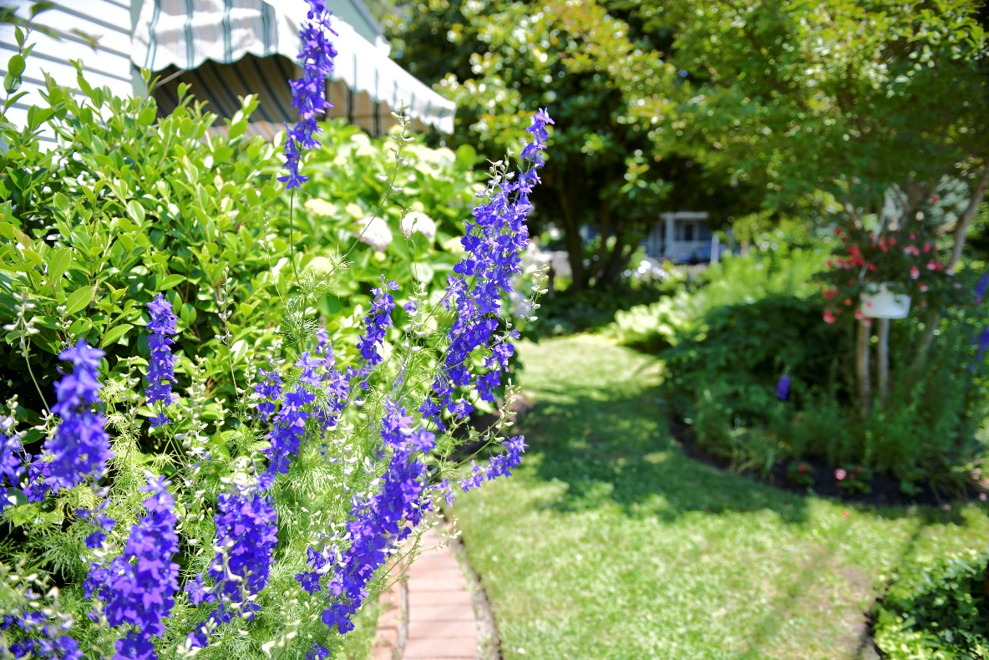Take home ideas for your own garden from a variety of seaside landscapes

**Photo Courtesy of Cape May MAC**

**(Feb. 27, 2025) CAPE MAY, N.J.-** Immerse yourself in colorful lush landscapes that will spark your creativity during The Gardens of Cape May Tour on Saturday, May 10. This is a self-guided tour that shows private and public gardens in the charming coastal town of Cape May. Whether you're a seasoned gardener or a budding enthusiast, this tour offers endless inspiration and fresh ideas to bring back to your own garden.

This is your invitation to explore Cape May’s unique natural areas and the plants, blooms and landscape designs of area gardeners. See what’s flourishing in several different seashore locations dominated by sunlight, ocean breezes, and sand and salt, each uniquely situated. Cape May’s Emlen Physick Estate gardens are included. The grounds of the Emlen Physick Estate, 1048 Washington St., will host local and regional vendors, including Rutgers master gardeners, plus a complimentary wine tasting by Cape May Winery. A trolley shuttle will be available. The event is from 1 p.m. to 4 p.m. and tickets are $35 and can be purchased on the capemaymac.org website under events.

Cape May MAC is a multifaceted not-for-profit organization committed to promoting the preservation, interpretation and cultural enrichment of the Cape May region for its residents and visitors. Cape May MAC membership is open to all. For information about our year-round schedule of tours, festivals and events, visit capemaymac.org.