**CONTACT:** Susan Krysiak **FOR IMMEDIATE RELEASE**

Director of Media Relations

(609) 224-6036

[skrysiak@capemaymac.org](mailto:skrysiak@capemaymac.org)

**Cape May MAC (Museums+Arts+Culture) announces the Volunteer of the Month for February is Joe Martucci**

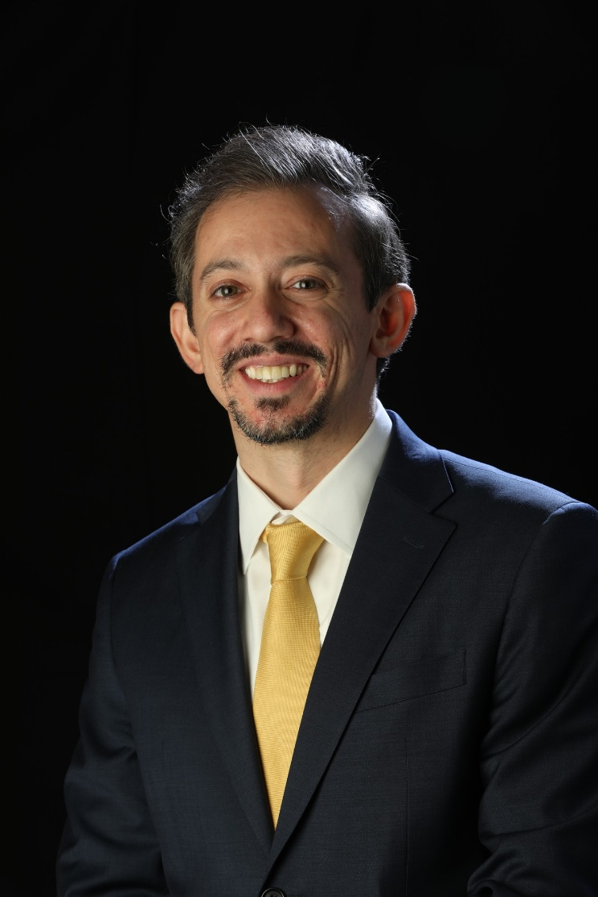

***(Feb. 5, 2025) (Photo courtesy of Joe Martucci***): Cape May MAC (Museums+Arts+Culture) announces the Volunteer of the Month for February is Joe Martucci. Our topic for Lunch & Learn on November 20th was: Why the Cape May Bubble is real and our 2024-2025 winter outlook! Cape May is known to miss the big thunderstorms and the heaviest snowstorms. Meteorologist Joe Martucci, Certified Broadcast and Digital Meteorologist, came to talk about the scientific research that backs up the folklore of the "Cape May Bubble” and our 2024-2025 winter outlook. Chief Outreach Strategist Mary Stewart nominated Joe stating “It was a fascinating presentation that kept the audience captivated and we truly appreciate it along with all the support you have given Cape May MAC!”

For information about volunteer opportunities at Cape May MAC, contact Volunteer Coordinator Maria Amin at 609-224-6029 or mamin@capemaymac.org. Cape May MAC is a multifaceted not-for-profit organization committed to promoting the preservation, interpretation and cultural enrichment of the Cape May region for its residents and visitors. Cape May MAC membership is open to all. For information about the year-round schedule of tours, festivals and events, visit capemaymac.org.

###