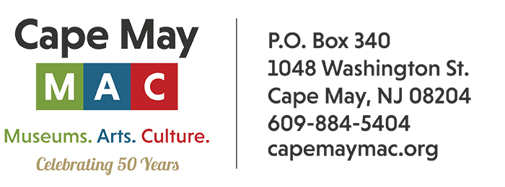

**CONTACT:** Susan Krysiak **FOR IMMEDIATE RELEASE**

Director of Media Relations March 12, 2025

(609) 224-6036

[skrysiak@capemaymac.org](mailto:skrysiak@capemaymac.org)

**Cape May MAC launches new sign language interpreted tours for the deaf and hard of hearing**

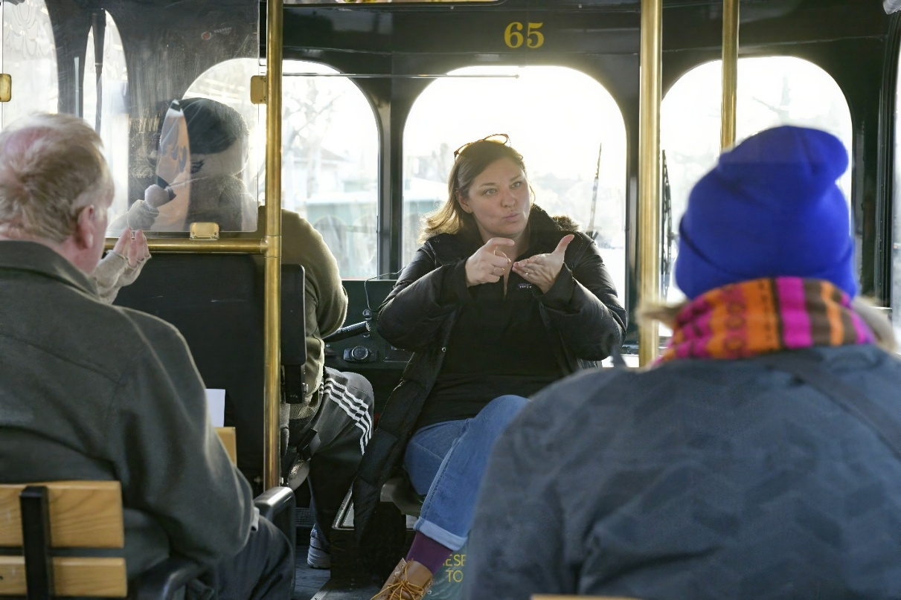

*(Photo by Susan Krysiak/courtesy of Cape May MAC) American Sign Language interpreter Emily Krause interprets during a new Cape May MAC trolley tour created especially for the deaf community.*

**(March 12, 2025) CAPE MAY, N.J. -** Cape May MAC (Museums+Arts+Culture) is taking an important step toward greater accessibility with special American Sign Language (ASL) interpreted trolley and walking tours, available on select dates throughout the year. These tours are thoughtfully designed for individuals who are deaf or hard of hearing, offering an immersive experience of Cape May's rich history in a way that’s welcoming to all.

The initiative, brought to life by Director of Tour Operations Nanci Coughlin, is inspired by a moment from her teenage years when she saw her friend's deaf sister miss out on shared experiences. That powerful moment stayed with Nanci and led her to work with deaf children during college. After returning home, she pursued ASL classes and soon discovered the thriving deaf community in Cape May and Atlantic Counties.

Last year, when Cape May MAC received a request for an ASL-interpreted tour, Nanci reached out to her former ASL instructor, Tiffany Narciso, along with Emily Krause, a local professional sign language interpreter. Their collaboration brought Cape May MAC's first ASL-interpreted tour to life, and it was a huge success. For 2025, Cape May MAC will expand this offering, providing ten months of tours specifically designed to be accessible and engaging for deaf participants.

Nanci emphasizes that these tours go beyond just providing an interpreter — they’re about completely reimagining the tour experience.

“Since deaf guests must focus on the interpreter to fully follow along, it’s important to allow extra time at the end for questions and even a second drive around to appreciate the sights without distraction,” she said. “These tours aren’t only for deaf participants — hearing guests are encouraged to join as well, providing a unique opportunity to raise awareness and create a more inclusive environment.”

“This is a learning experience for everyone, and a meaningful step toward expanding accessibility at Cape May MAC,” Director and CEO Jody Alessandrine said. “The ultimate goal is to ensure that everyone, regardless of ability, can enjoy the beauty and history of Cape May in an inclusive and welcoming way.”

To explore more about these tours and see what is being offered, visit <https://cmmac.ticketapp.org/portal/product/260/events>. For more information and to make reservations email ncoughlin@capemaymac.org.

Cape May MAC (Museums+Arts+Culture) is a multifaceted not-for-profit organization committed to promoting the preservation, interpretation, and cultural enrichment of the Cape May region for its residents and visitors. Cape May MAC membership is open to all. For information about Cape May MAC’s year-round schedule of tours, festivals, and special events call 609-884-5404 or visit capemaymac.org.