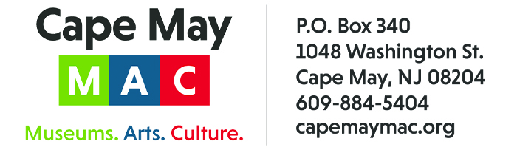

CONTACT: Susan Krysiak For Immediate Release
Director of Media Relations March 26, 2025
609-224-6036
skrysiak@capemaymac.org
Cape May Music Festival May 25 to June 28 celebrates 36 years of bringing beautiful music to Cape May

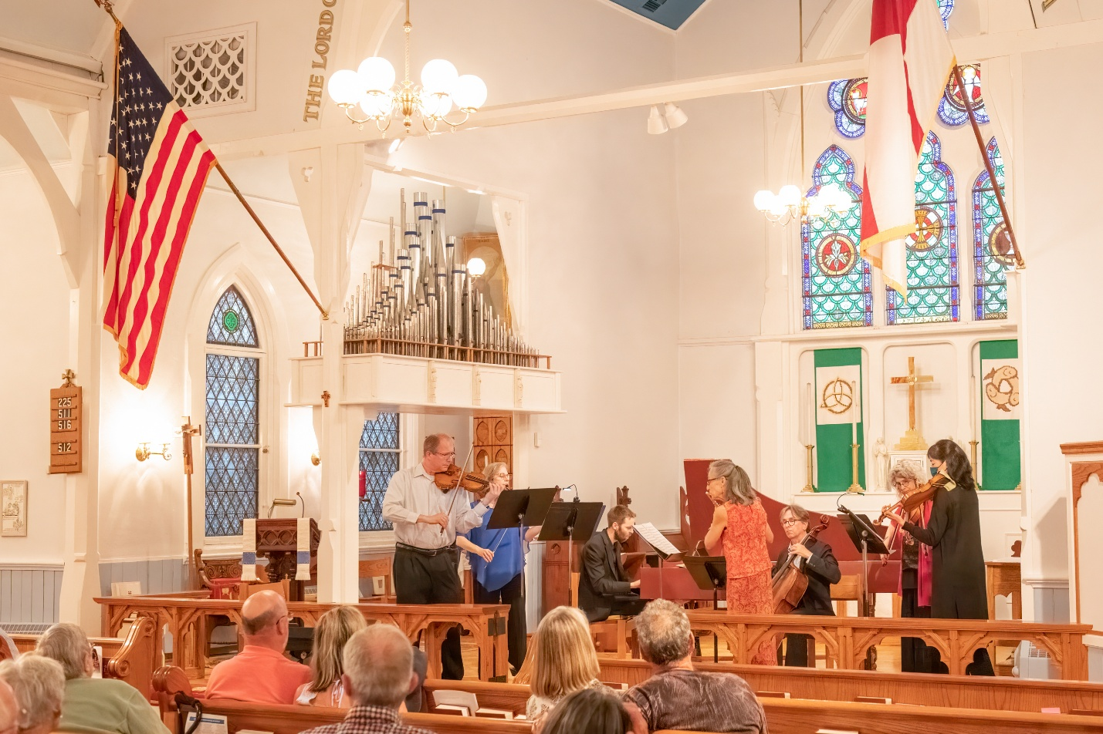

PHOTO CAPTION: (Photo by Frank Scott/Courtesy of Cape May MAC) The New York Chamber Ensemble performs three concerts in this year’s Cape May Music Festival.

CAPE MAY, N.J. — Now celebrating its 36th year, the annual Cape May Music Festival presented by Cape May MAC (Museums+Arts+Culture), with major support by the New Jersey State Council on the Arts, returns to this seaside resort with an engaging variety of musical concerts that launch on Memorial Day weekend. There are 14 classical, chamber, jazz, funk and brass band musical performances, some free to attend, from May 25-June 28.
Evening concerts are scheduled this year on Thursdays, Saturdays and Sundays. The award-winning Atlantic Brass Band opens the festival in a free outdoor concert May 25 at Rotary Park.
Classical music lovers will welcome the New York Chamber Ensemble, the New Jersey Symphony Chamber Players, and the Bay Atlantic Symphony in performance. Bach's Lunches at the Inn of Cape May and Mid-day Music and More at The Washington Inn feature classical mini-concerts with delicious meals. New this year is the hot new group from Philadelphia, SNACKTIME, bringing their seven-piece funk and soul to Cape May. “Combining their influences, which range from jazz to rap to rock to punk and R&B, SNACKTIME is one of the most original ensembles out there right now,” said Paste Magazine. A Jazz Brunch with Paula Johns at the Shore Club and the heartfelt George Mesterhazy Tribute Concert in the intimate setting of the Episcopal Church of the Advent round out the series for jazz lovers.
For more information about concerts, performers or venues, and to purchase tickets, visit capemaymac.org or call 609-884-5404.
Here’s the 36th Annual Cape May Music Festival lineup:

May 25
36th Annual Cape May Music Festival: Atlantic Brass Band
The award-winning, 35-piece Atlantic Brass Band, under the baton of Salvatore Scarpa, returns to Cape May with an exciting new program of rousing band music, the perfect high note for Memorial Day Weekend. 7 p.m. Rotary Bandstand, 400-498 Lafayette St. (Rain location: Cape May Convention Hall, 714 Beach Ave.) Free admission. capemaymac.org

June 1
36th Annual Cape May Music Festival: New Jersey Symphony Chamber Players
Symphony members Bart Feller, flute, Bob Ingliss, oboe, Juan Esteban Martinez, clarinet, Andrea Menousek, horn and Bob Wagner, bassoon, form a woodwind quintet to delight audiences with a program including Jacques Ibert’s playful Trois Pièces Brèves, Valerie Coleman’s anthem of freedom and unity, “Umoja,” and Franz Danzi’s lyrically beautiful Quintet in G minor, among other pieces. 7 p.m. The Episcopal Church of the Advent, 612 Franklin St. Visit capemaymac.org for tickets.

June 4, 11, 18
36th Annual Cape May Music Festival: Bach’s Lunches
Lunch and a Classical music mini-concert combine for a wonderful afternoon at the historic Inn of Cape May. These intimate performances feature members of the Bay Atlantic Symphony. 12:30 p.m. Inn of Cape May, 7 Ocean St. Visit capemaymac.org for tickets.

June 5
36th Annual Cape May Music Festival: New York Chamber Ensemble presents “Classical Meets Pop, with Beethoven and BAILEN”
Featuring Artistic Director Eliot Bailen, cello, Susan Rotholz, flute, and the pop trio BAILEN, the New York Chamber Ensemble presents a beautiful Beethoven String Quartet and the soulful music of BAILEN with strings and flute. 7 p.m. The Episcopal Church of the Advent, 612 Franklin St. Visit capemaymac.org for tickets.

June 6
36th Annual Cape May Music Festival: Midday Music & More
Enjoy an intimate classical music performance over lunch at the historic Washington Inn, presented by Friends of the Cape May Music Festival, featuring Eliot Bailen, Susan Rotholz and Jed Gaylin. 12:30 p.m. Washington Inn, 801 Washington St. Visit capemaymac.org for tickets.

June 7
36th Annual Cape May Music Festival: Jazz Brunch with Paula Johns
Savor a delicious jazz brunch with Paula Johns at the phenomenal Shore Club. Paula is an accomplished cabaret singer and jazz vocalist who hails from Philadelphia. She is often compared to Ella Fitzgerald, and some of the great contemporaries of that era, but Paula brings her own distinctive panache to each song she sings, featuring songs from The Great American Songbook, including Porter, Rodgers & Hart, Jobim, Bacharach and others.11 a.m. Shore Club, 1170 Golf Club Road, Cape May Court House. Visit capemaymac.org for tickets.

June 8
36th Annual Cape May Music Festival: 13th Annual George Mesterhazy Tribute Concert: “We Love Being Here With You”
Once again the late George Mesterhazy’s close-knit musical colleagues will perform a beautiful tribute concert at the Cape May Music Festival to honor the memory of their beloved friend George. These musicians have always enjoyed performing in this annual event because of the warm and enthusiastic reception they receive, and all the familiar faces they see in the audience. This concert will feature special arrangements of songs that celebrate the joys of being together, including classic songs from the Great American Songbook and beyond. 7 p.m. The Episcopal Church of the Advent, 612 Franklin St. Visit capemaymac.org for tickets.

June 12
36th Annual Cape May Music Festival: Bay Atlantic Symphony presents “Serenades and Song”
Bay Atlantic Symphony presents "Serenades and Songs” for intimate string orchestra highlighting sweeping melodies and snappy rhythms by composers from America, Sweden, England, Georgia/Russia and Germany. 7 p.m. The Episcopal Church of the Advent, 612 Franklin St. Visit capemaymac.org for tickets.

June 14
36th Annual Cape May Music Festival: SNACKTIME
SNACKTIME is Philadelphia’s already beloved seven-piece band with soul, funk, punk, hip hop and rock influences. SNACKTIME recently released their debut studio EP, This is Dance Music, recorded and produced by Grammy-nominated Will Yip (Lauryn Hill, Turnstile, Bartees Strange). In describing the band's sound, Paste Magazine said, “combining their influences, which range from jazz to rap to rock to punk and R&B, SNACKTIME is one of the most original ensembles out there right now." Cape May Convention Hall, 714 Beach Ave. 7 p.m. Visit capemaymac.org for tickets.

June 15
36th Annual Cape May Music Festival: New York Chamber Ensemble presents “The Pinnacle of Chamber Music: Schubert’s Quintet in C Major”
The New York Chamber Ensemble, featuring Artistic Director Eliot Bailen, cello, and Susan Rotholz, flute, and guests.
Antonin Dvorak: Terzetto
Franz Schubert: Quintet in C Major with two cellos
4 p.m. The Episcopal Church of the Advent, 612 Franklin St. Visit capemaymac.org for tickets.

June 26
36th Annual Cape May Music Festival: New York Chamber Ensemble presents “The Virtuosic Piano in Chamber Music”
Featuring Margaret Kampmeier, piano
Paul Schoenfeld: Three Bagatelles
Frank Bridge: Phantasy Piano Quartet
Felix Mendelssohn: Piano Quartet No. 3
7 p.m. The Episcopal Church of the Advent, 612 Franklin St. Visit capemaymac.org for tickets.

June 28
36th Annual Cape May Music Festival: Bay Atlantic Symphony presents "Alpine Jazz Adventure”
Celebrity cellist Amit Peled joins the Bay Atlantic Symphony and will play a work he has long championed, the eclectic concerto by Austrian pianist/composer/philosopher Friederich Gulda. The concerto is for cello and wind orchestra with a jazz rhythm section and bounces between swing and funk, to rustic Austrian folk melodies. It is tuneful and dramatic, with wildly expressive passages. The evening's program begins with one of the greatest of all wind serenades, by W.A. Mozart. The audience will also have the joy of experiencing Mr. Peled’s intensely expressive artistry performing solo Bach. 7:30 p.m. The Episcopal Church of the Advent, 612 Franklin St. Visit capemaymac.org for tickets.

Tickets may be purchased in advance by phone at 609-884-5404, online at capemaymac.org or in person by visiting Hill House Visitor Service Center or Carriage House Visitor Service Center, both at the Emlen Physick Estate, 1048 Washington St., or the Washington Street Mall Information Booth at Washington Street at Ocean Street. Cape May MAC (Museums+Arts+Culture) is a multifaceted not-for-profit organization committed to promoting the preservation, interpretation, and cultural enrichment of the Cape May region for its residents and visitors. We maintain and manage the 1879 Emlen Physick Estate, the 1859 Cape May Lighthouse and the 1942 World War II Lookout Tower, and are the leading organization to offer visitors tours, activities and events year-round in America’s National Landmark City. Cape May MAC is the organization that saved the 1879 Emlen Physick Estate from destruction and helped secure Cape May’s renaissance as a historic destination. For information about our year-round schedule of tours, festivals, and special events, call 609-884-5404 or visit capemaymac.org.

