**CONTACT:** Susan Krysiak **For Immediate Release**

Director of Media Relations March 21, 2025

609-224-6036

[skrysiak@capemaymac.org](mailto:skrysiak@capemaymac.org)

**Carroll Gallery exhibit ‘Tattoos: Modern Expression & Ancient Art’ open April 11 through Nov. 2 in Cape May**

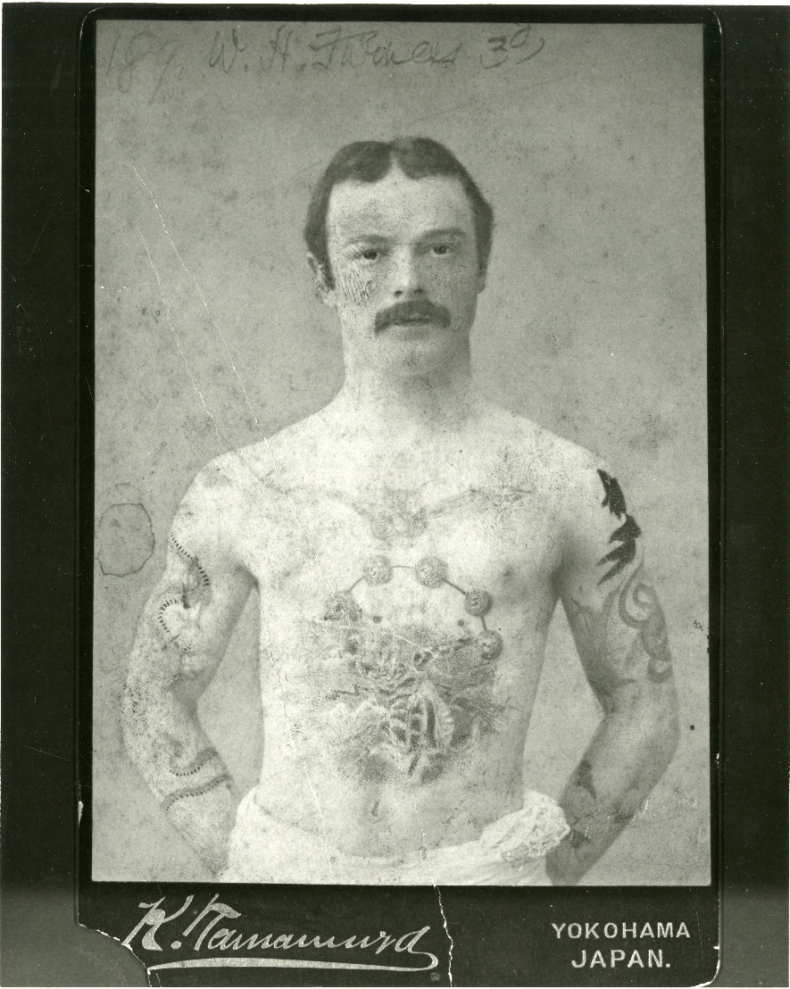

*Public domain*

William Henry Furness III in Yokohama, Japan in the 1890s

**CAPE MAY, N.J. –**  A new, visually engaging Carroll Gallery exhibit at the Emlen Physick Estate opening Friday, April 11, on display through Sunday, Nov. 2, explores the art, history and self-expression of tattooing. Learn about the range of expression and history of this ancient art form in this Carroll Gallery Exhibit on the grounds of the Emlen Physick Estate, 1048 Washington St. The public is invited to the exhibit opening on Friday, April 11 at 5 p.m. Tattoo Girl wine will be served for adults over age 21.

For millennia, humans have tattooed their bodies to express their individuality, chronicling loves, losses, beliefs, victories, affiliations, hopes and dreams. The oldest human discovered — 5,300 years old — had 60 tattoos, and his contemporaries, from the South Pacific to the indigenous people of New Jersey, were also inked.

There is a long tradition of sailors using tattoos to chronicle adventures at sea. Even Victorians were tattooed. William Henry Furness III was a pioneer ethnographer and anthropologist, a physician, and a much-published academic author. An 1894 article in *The Oregonian* described Furness as "the most artistically tattooed man in the world." It reported that during a long trip to Japan, he had been heavily tattooed. William was the nephew of renowned Victorian architect, Frank Furness, who designed Cape May’s 1879 Physick House, Cape May’s Victorian house museum. Queen Victoria’s son and many of her grandsons and nephews, who were rulers of Europe in the 1800s, were tattooed.

Tattooing has become increasingly popular in the last 20 years, and today, eight out of 10 Americans believe society is more accepting of people with tattoos. This exhibit will celebrate the contemporary community of Cape May in several ways. Tattoo artists from Perigee Moon Tattoo in West Cape May are decorating mannequins for display with a variety of historic and traditional designs. Six original, contemporary photographic portraits will be on display as a distinct Cape May component of the exhibit. Mary Pat Myers of M.P. Myers Photography Studio, Cape May family and portrait photographer for more than 32 years, is the featured photographer. With her distinctive warmth and style she has created unique portraits of individuals and their tattoos. Each from the Cape May region, they represent different walks of life, some with many, some with only one tattoo. Their stories will accompany their photographs. Submissions from the community also will be included as part of the exhibition, with a variety of additional stories to tell.

The exhibit is open daily Friday, April 11 to Sunday, Nov. 2 (except Easter, Thanksgiving and Christmas). Times vary. Admission is free. For schedule visit capemaymac.org.

Cape May MAC (Museums+Arts+Culture) is a multifaceted not-for-profit organization committed to promoting the preservation, interpretation and cultural enrichment of the Cape May region for its residents and visitors. Cape May MAC membership is open to all. For information about Cape May MAC’s year-round schedule of tours, festivals and events, visit capemaymac.org or call 609-884-5404.