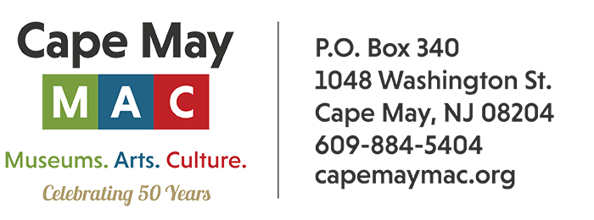

**CONTACT:** Susan Krysiak **FOR IMMEDIATE RELEASE**

Director of Media Relations March 17, 2025

(609) 224-6036

[skrysiak@capemaymac.org](mailto:skrysiak@capemaymac.org)

*Photo courtesy of Cape May MAC* – Shown here, Vintage Restaurant at the Emlen Physick Estate reopens for the season on April 11.

**Savor the Flavors of Spring in Cape May**

**(March 17, 2025) CAPE MAY -** As spring settles in, Cape May comes alive with a vibrant mix of food and beverage events that locals and visitors can enjoy, presented by Cape May MAC (Museums+Arts+Culture). The Victorian town is a thriving culinary scene that features fresh local ingredients, seasonal menus, and a lively calendar of festivals and tastings. Whether you’re a foodie or just looking to experience the town in a new way, spring in Cape May offers plenty of opportunities to indulge your senses.

**Uncle Nearest Whiskey Tasting at the Routes of Black Travel Exhibit Finale - March 21**

Whiskey brand, "Uncle Nearest", is having a tasting event the closing weekend of the exhibit "Routes of Black Travel: The Green Book in Cape May and Wildwood" at the Carroll Gallery. The label is named after the first Black whiskey distiller, as they state "The best whiskey maker the world never knew". Don't miss your final chance to see this powerful exhibit. Emlen Physick Estate, 1048 Washington St.

**Vintage Restaurant Opening - April 11** Cape May MAC has partnered with the KARA Group (George’s Place, Y.B., and more), to create a modern, eclectic, and delicious dining experience on the grounds of the Emlen Physick Estate. Vintage is dog-friendly, has plenty of outside seating, and offers takeout! Vintage opens up for the 2025 season April 11 and will be open weekends for the months of April and May and will go to full-time hours in June. Emlen Physick Estate, 1048 Washington St. For reservations and more information visit <https://kararestaurantgroup.com/vintage/>.

**Brunch & Bingo at Marquis de Lafayette - April 19**

Laugh along with your friends as you play a little bingo, compete for prizes and enjoy a fashion show by Lace Silhouettes/Cotton Company. It’s all over a scrumptious breakfast buffet  in the Ocean Room at the Marquis de Lafayette, 501 Beach Ave., Cape May.

**Channeling Dinner - May 2, June 13**

Enjoy a three-course prix fixe dinner at the Inn of Cape May followed by a two-hour channeling session with Medium Craig McManus. McManus will read the energies in the room and channel messages from the spirits of departed family and friends. While he does not read everyone present and cannot control where messages come through, he will bring through as many messages from spirits as possible during the two-hour channeling. Inn of Cape May, 7 Ocean St. This event is not recommended for people under the age of 16. Tickets sell quickly! Refunds are unavailable within 14 days of the event.

**Brunch & Bingo at Inn of Cape May - May 10**

Laugh along with your friends as you play a little bingo, compete for prizes and enjoy a fashion show by Lace Silhouettes/Cotton Company. It’s all over a scrumptious breakfast buffet at The Inn of Cape May, 7 Ocean St. Cape May.

**Murder Mystery Dinners - June 4, June 11, June 18**

Enjoy a three-course dinner in the historic Chalfonte Hotel as an original murder mystery by Jacky Fazio artfully unfolds around you, in “Betrothal or Betrayal?” Another social season is drawing to a close, and Lady Richfield has yet to find an appropriate suitor for any of her three available and aging daughters. As time runs out, desperation sets in! A scandalous murder at the final ball of the season sends all of society into a frenzy. Will you be able to separate rumor from the truth? Limited event. Advance purchase required. The Chalfonte Hotel, 301 Howard St.

**Cape May Beer Trail - June 15**

Cape May County is home to a selection of outstanding breweries. Hop on a Cape May MAC trolley and visit Cape May Brewing Co., Behr Brewing, Cold Spring Brewery and Gusto Brewing Co. for tasting flights of local beers. Lunch is included at Cold Spring Grange Restaurant. This tour is for adults ages 21 and over.

Cape May MAC (Museums+Arts+Culture) is a multifaceted not-for-profit organization committed to promoting the preservation, interpretation, and cultural enrichment of the Cape May region for its residents and visitors. Cape May MAC membership is open to all. For information about Cape May MAC’s year-round schedule of tours, festivals, and special events call 609-884-5404 or visit capemaymac.org.