**CONTACT:** Susan Krysiak **FOR IMMEDIATE RELEASE**

Director of Media Relations

(609) 224-6036

[skrysiak@capemaymac.org](mailto:skrysiak@capemaymac.org)

**Cape May MAC (Museums+Arts+Culture) announces its Volunteer of the Month for April is Donna Wicker**

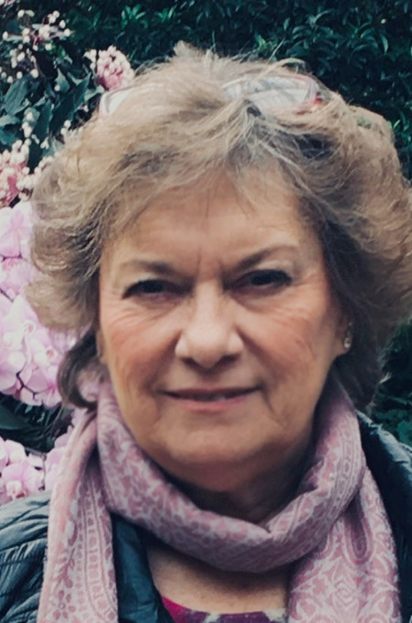

**(April 10, 2025) CAPE MAY - *(Photo courtesy of Cape May MAC) -*** Cape May MAC (Museums+Arts+Culture) announces the Volunteer of the Month for April is Donna Wicker of Villas. Wicker was nominated by Volunteer Coordinator Maria Amin. “This is our way to say thank you for Donna generously volunteering her time to open the Our Lady Star of the Sea church, and for sharing her vast knowledge of church history with our visitors during our annual Christmas Candlelight House tours in December,” said Amin. “We appreciate the time and effort she put into creating an engaging experience while making it possible for us to have the church on tour.” For information about volunteer opportunities at Cape May MAC, contact Volunteer Coordinator Maria Amin at 609-224-6029 or mamin@capemaymac.org. Cape May MAC is a multifaceted not-for-profit organization committed to promoting the preservation, interpretation and cultural enrichment of the Cape May region for its residents and visitors. Cape May MAC membership is open to all. For information about the year-round schedule of tours, festivals and events, visit capemaymac.org.

###