

CONTACT: Susan Krysiak FOR IMMEDIATE RELEASE
Director of Media Relations
(609) 224-6036
skrysiak@capemaymac.org

Cape May MAC (Museums+Arts+Culture) announces its March Volunteer of the Month is Lynda Anderson-Towns

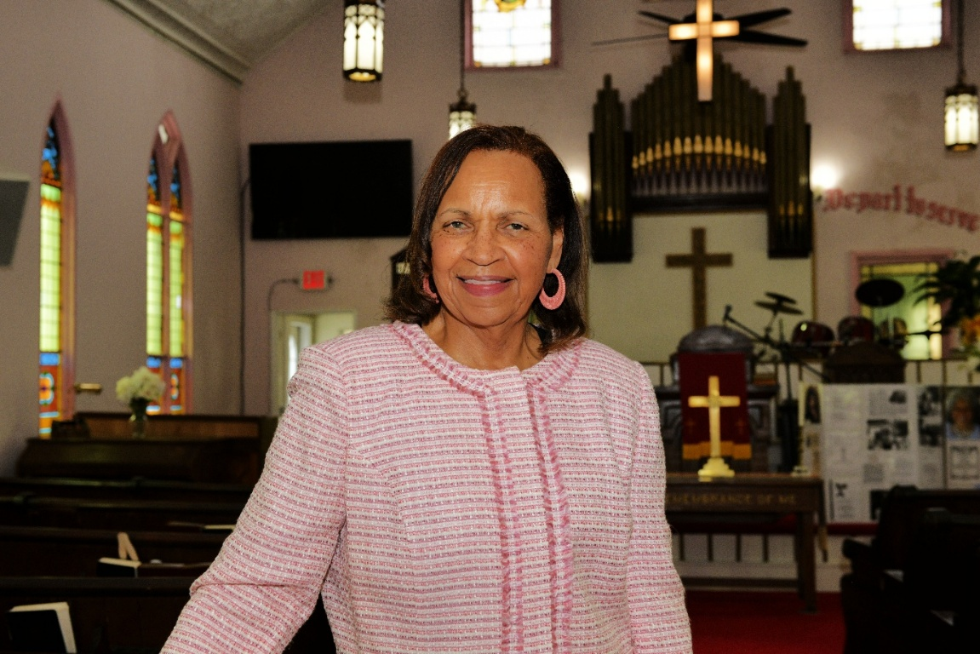
(March 20, 2025) CAPE MAY - (Photo courtesy of Cape May MAC) - Cape May MAC (Museums+Arts+Culture) announces the Volunteer of the Month for March is Lynda Anderson-Towns of West Cape May. Cape May MAC Volunteer Coordinator Maria Amin nominated Anderson-Towns for the honor, for volunteering and hosting visitors at the historic Macedonia Baptist Church during Cape May MAC’s annual Christmas Candlelight House tours, which attract thousands each season on three nights in December. The Macedonia Baptist Church is Cape May’s last remaining historically African American church with an active congregation. Anderson-Towns gave a talk and video presentation to crowds as they entered the church and gathered during each night of the tour. The presentation included inspiring video recordings of the late Rev. Robert O. Davis leading the renowned Macedonia Baptist Choir singing Negro spirituals. Anderson-Towns shared stories from Cape May’s African American history and even shared some of her own memories growing up in Cape May during the civil rights era. “We are so grateful to have had the Macedonia Baptist Church on our Christmas Candlelight tours this past holiday season,” said Amin. “It is thanks to Lynda and her team that we were able to open and share this important and historic building that plays such a vital role in the Cape May community. Not only that, but Lynda went above and beyond to create an educational and engaging experience for visitors on the candlelight tour. We are so very grateful to her.” For information about volunteer opportunities at Cape May MAC, contact Volunteer Coordinator Maria Amin at 609-224-6029 or mamin@capemaymac.org. Cape May MAC is a multifaceted not-for-profit organization committed to promoting the preservation, interpretation and cultural enrichment of the Cape May region for its residents and visitors. Cape May MAC membership is open to all. For information about the year-round schedule of tours, festivals and events, visit capemaymac.org.
###

