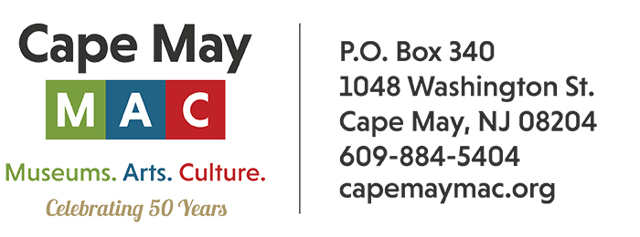

**CONTACT:** Susan Krysiak **FOR IMMEDIATE RELEASE**

Director of Media Relations May 8, 2025

(609) 224-6036

[skrysiak@capemaymac.org](mailto:skrysiak@capemaymac.org)

**Cape May MAC launches new sign language interpreted tours for the deaf and hard of hearing**

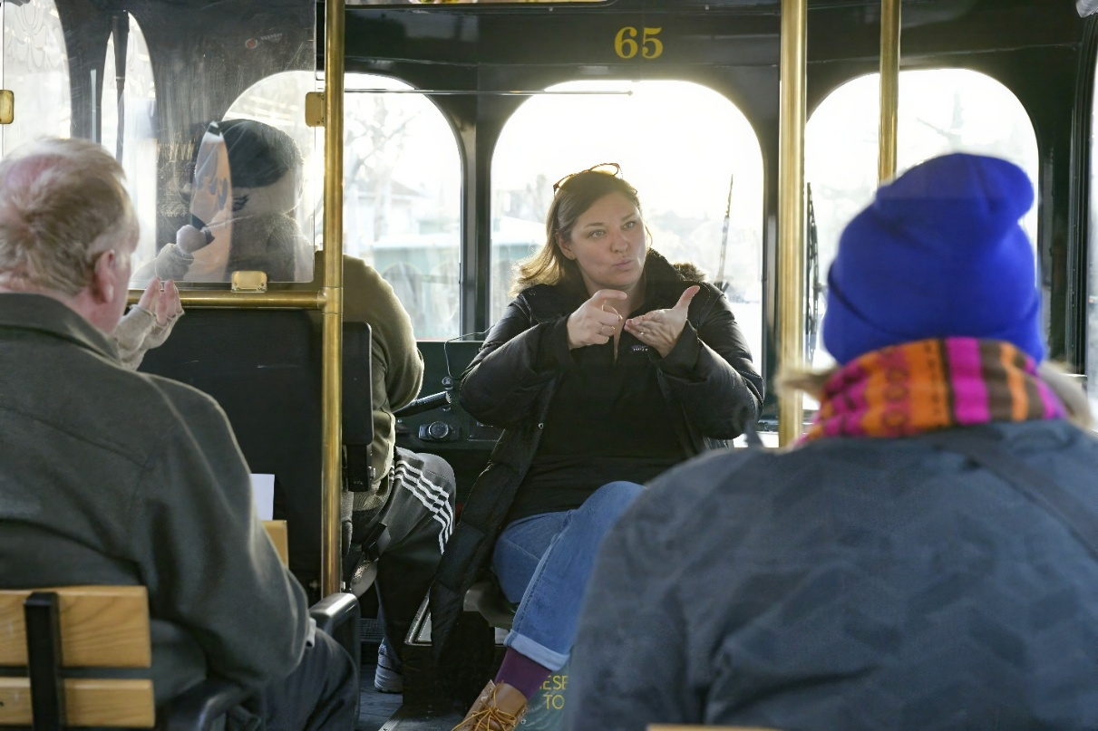

*(Photo by Susan Krysiak/courtesy of Cape May MAC) American Sign Language interpreter Emily Krause interprets during a new Cape May MAC trolley tour created especially for the deaf community.*

**(March 12, 2025) CAPE MAY, N.J. -** Cape May MAC (Museums+Arts+Culture) is taking an important step toward greater accessibility with special American Sign Language (ASL) interpreted trolley and walking tours, available on select dates throughout the year. These tours are thoughtfully designed for individuals who are deaf or hard of hearing, offering an immersive experience of Cape May's rich history in a way that’s welcoming to all.

The initiative, brought to life by Director of Tour Operations Nanci Coughlin, is inspired by a moment from her teenage years when she saw her friend's deaf sister miss out on shared experiences. That powerful moment stayed with Nanci and led her to work with deaf children during college. After returning home, she pursued ASL classes and soon discovered the thriving deaf community in Cape May and Atlantic Counties.

Last year, when Cape May MAC received a request for an ASL-interpreted tour, Nanci reached out to her former ASL instructor, Tiffany Narciso, along with Emily Krause, a local professional sign language interpreter. Their collaboration brought Cape May MAC's first ASL-interpreted tour to life, and it was a huge success. For 2025, Cape May MAC will expand this offering, providing ten months of tours specifically designed to be accessible and engaging for deaf participants.

Nanci emphasizes that these tours go beyond just providing an interpreter — they’re about completely reimagining the tour experience.

“Since deaf guests must focus on the interpreter to fully follow along, it’s important to allow extra time at the end for questions and even a second drive around to appreciate the sights without distraction,” she said. “These tours aren’t only for deaf participants — hearing guests are encouraged to join as well, providing a unique opportunity to raise awareness and create a more inclusive environment.”

“This is a learning experience for everyone, and a meaningful step toward expanding accessibility at Cape May MAC,” Director and CEO Jody Alessandrine said. “The ultimate goal is to ensure that everyone, regardless of ability, can enjoy the beauty and history of Cape May in an inclusive and welcoming way.”

To explore more about these tours visit <https://capemaymac.org/plan/group-tours/> For more information and to make reservations email [ncoughlin@capemaymac.org](mailto:ncoughlin@capemaymac.org) or call Susan Gibson at 609-224-6030. TTY customers can use the New Jersey Relay Center at 800-852-7899 (if calling from New Jersey, dial 711) to order brochures or tickets.

Here are the ASL offerings for this year:

**Friday, July 18 6 p.m. – 7:15 p.m. Cape May’s Maritime Trolley Tour**

Whaling, wartime and wild weather. The remarkable maritime history of our seaside town has long defined the Cape May story. Board the trolley and rediscover the important places and natural phenomena that have shaped, literally and figuratively, the Cape May we know today.

**Saturday, Aug. 16 10 a.m. – 11:30 a.m. Fisherman’s Wharf Walking Tour**

Take this guided tour of Fisherman’s Wharf at the Lobster House Restaurant at Schellenger’s Landing and you’ll learn how your seafood gets from the sea to your table and discover how Cape May is a major commercial fishing port. Comfortable shoes recommended.

**Sunday, Sept. 14 11 a.m. – 12:30 p.m. Emlen Physick Estate and Carroll Gallery Exhibit**

The 2025 Physick Estate Tour, The Art of Home, explores the rich artistry of Victorian life. Designed by architect Frank Furness, the home showcases Stick Style architecture with intricate moldings, custom furniture, and vibrant wallpapers. Tour Cape May’s 1879 Victorian House Museum and learn about its key role in Cape May’s decades-long renaissance story as you appreciate its beauty and craftsmanship.

Queen Victoria’s husband, son, and many of her grandsons and nephews, who were rulers of Europe, were tattooed. There is a long tradition of sailors using tattoos to chronicle adventures at sea. Tattooing has become increasingly popular in the last 20 years, and today, eight out of 10 Americans believe society is more accepting of people with tattoos. Learn about the range of expression and history of this ancient art form in this Carroll Gallery Exhibit on the grounds of the Emlen Physick Estate.

**Sunday, Sept. 14 11 a.m. – 12:30 p.m. Natural Habitats Trolley Tour**

Beyond the charming Victorian homes and sandy beaches, Cape May is world famous for its birdwatching, monarch migration, and natural history. Join Cape May Bird Observatory naturalists on a trolley tour to local natural habitats (with the opportunity to disembark at Cape May Point State Park), learning about the beauty, diversity, abundance (millions of birds, butterflies, and dragonflies pass through each year), geography, and extensive history of this amazing spectacle. Relax and be entertained in the birding capital of North America!

**Saturday, Oct. 4 2 p.m. – 3:30 p.m. Welcome to Cape May Trolley Tour and Picture This Selfie Ride**

This is the best introduction to Cape May for first timers and also for those who haven’t been to Cape May in some time. Find the hidden gems and the little-known treasures of this glorious seaside town and learn about natural and cultural points of interest. This narrated tour highlights the many cultural, historical and natural attractions on the island. Then, see some of historic Cape May’s lesser-known picturesque locations that you might not otherwise visit or know about. The trolley will travel to three special spots where there will be ample time to step off the trolley, see the sights, and take some photos. Along the way, knowledgeable and entertaining guides will dispense interesting tidbits about Cape May. Many of these trolley rides are scheduled in late afternoon, approaching the golden hour, also known as magic hour, when the sun is low in the sky, creating a warm glow that's ideal for photography.

**Saturday, Dec. 13 4 p.m. – 5 p.m. All That Glitters: Victorians Ring in the New Century**

It’s the winter holiday season in the late Victorian age. Join us on a ride around town as we regale with then and now stories of the lively Cape Island holiday social landscape of the time. Learn about charming rituals and superstitions that promise good fortune in the new year. Hear how the New Year’s ball drop tradition got started and continues today, right here on Cape Island. Learn where Cape May Victorians shopped and entertained during the winter holidays with numerous stories about the food and drink traditions that make New Year’s celebrations festive and bright.

Cape May MAC (Museums+Arts+Culture) is a multifaceted not-for-profit organization committed to promoting the preservation, interpretation, and cultural enrichment of the Cape May region for its residents and visitors. We operate and manage the 1879 Emlen Physick Estate, the 1859 Cape May Lighthouse and the 1942 World War II Lookout Tower, and are the leading organization to offer visitors tours, activities and events year-round in America’s National Historic Landmark City. Cape May MAC is the organization that saved the 1879 Emlen Physick Estate from demolition, helping secure the City of Cape May as an internationally recognized historic destination. For information about our year-round schedule of tours, festivals, and special events, call 609-884-5404 or visit capemaymac.org

***