**CONTACT:** Susan Krysiak **FOR IMMEDIATE RELEASE**

Director of Media Relations

(609) 224-6036

[skrysiak@capemaymac.org](mailto:skrysiak@capemaymac.org)

**Cape May MAC (Museums+Arts+Culture) announces its May Volunteer of the Month is Mary Pat Myers**

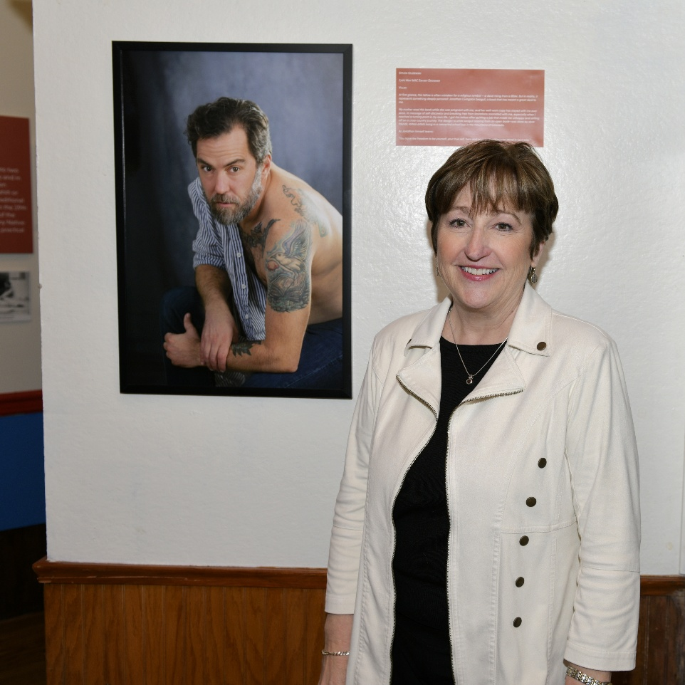

Photo by Susan Krysiak courtesy of Cape May MAC  
Shown here, Mary Pat Myers with one of seven photographic portraits she created for the Cape May MAC exhibit, "Tattoos: Modern Expression & Ancient Art," open now through Nov. 2 at the Carroll Gallery, Physick Estate. This portrait is of Cape May MAC’s exhibit designer, Steven Olszewski.

**(May 1, 2025) CAPE MAY - *(Photo by Susan Krysiak/Cape May MAC) -*** Cape May MAC (Museums+Arts+Culture) announces the Volunteer of the Month for May is photographer Mary Pat Myers of Cape May. Director of Media Relations Susan Krysiak nominated Myers for the honor, for offering her professional photography services pro bono for the exhibit, “Tattoos: Modern Expression & Ancient Art” at the Carroll Gallery, Emlen Physick Estate, 1048 Washington St. “Not only did she offer her services for free, she took on this project with such enthusiasm and organization, that it made the process of creating portraits of members of the community with their tattoos run very smoothly,” Krysiak said. Myers has been creating family and individual photographic portraits for 32 years as M.P. Myers Photography, and is a well-known and highly respected photographer. “We thank Mary Pat for generously volunteering her time, skill, artistry and experience to create this celebration of tattoos and their stories and meanings to individuals in the community through this photo gallery within the exhibit,” Krysiak said. “It turned out beautifully. We are all thrilled that it celebrates the wonderful Cape May community in a very special way.” The exhibit is open through Nov. 2 at the Emlen Physick Estate, 1048 Washington St., Cape May. Admission is free.

For information about volunteer opportunities at Cape May MAC, contact Volunteer Coordinator Maria Amin at 609-224-6029 or mamin@capemaymac.org. Cape May MAC is a multifaceted not-for-profit organization committed to promoting the preservation, interpretation and cultural enrichment of the Cape May region for its residents and visitors. Cape May MAC membership is open to all. For information about the year-round schedule of tours, festivals and events, visit capemaymac.org.

###