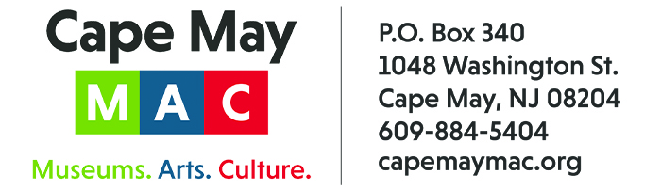

CONTACT: Susan Krysiak FOR IMMEDIATE RELEASE
Director of Media Relations June 6, 2025
(609) 224-6036
skrysiak@capemaymac.org

Cape May MAC announces Volunteers of the Month for June are the artists at Perigee Moon Tattoo Shop

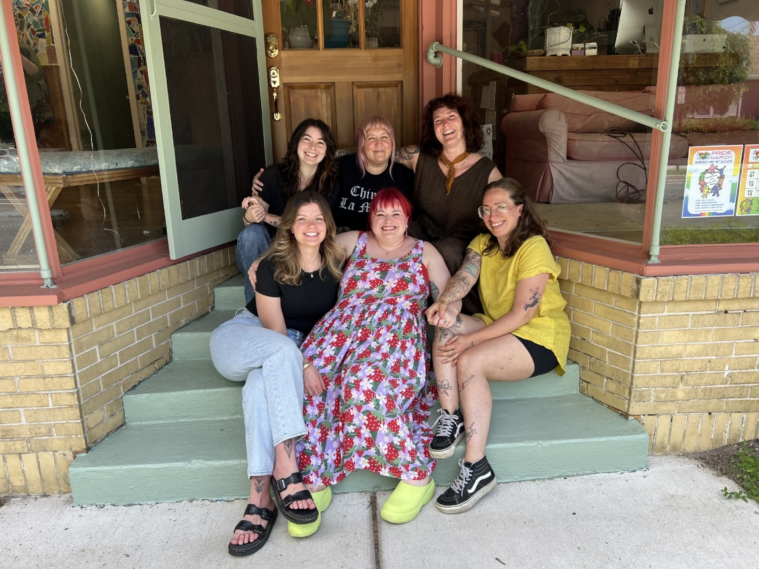
(June 9, 2025) CAPE MAY - (Photo courtesy of Cape May MAC) - Cape May MAC (Museums+Arts+Culture) announces the Volunteers of the Month for June are the Perigee Moon Studio Artists: Kirsten Ewing, Destanie Stafford, Jess McCole, Sandy Bove, Kayloria Stephen and Gia Leotta. They were nominated by Chief Outreach Officer Eliza Lotozo. “I am nominating the artists of Perigee Moon Tattoo Parlor in West Cape May for their contributions to Cape May MAC’s 2025 annual exhibit, “Tattoos: Modern Expression, Ancient Art”. “The Perigee Moon artists agreed to paint traditional and historical tattoo styles onto two dress forms, two mannequin arms, and a mannequin head, all to be used as visual displays in the exhibit. Their artistry is exceptional and their contributions really added to the design of the exhibit,” said Lotozo.
In addition to the painted forms, one of the artists, Kayloria Stephen, designed a Victorian-era inspired flash sheet (a collection of pre-designed tattoo images), which Cape May MAC handed out as temporary tattoos at the opening and that are also available at their parlor as permanent tattoos. Perigee Moon tattoo shop is located at 301 Broadway, West Cape May, NJ 08204. For information about volunteer opportunities at Cape May MAC, contact Volunteer Coordinator Maria Amin at 609-224-6029 or mamin@capemaymac.org. Cape May MAC is a multifaceted not-for-profit organization committed to promoting the preservation, interpretation and cultural enrichment of the Cape May region for its residents and visitors. Cape May MAC membership is open to all. For information about the year-round schedule of tours, festivals and events, visit capemaymac.org.
###

