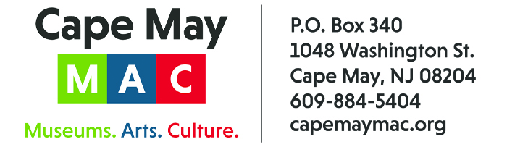

CONTACT:
Susan Krysiak For Immediate Release
Director of Media Relations June 5, 2025
609-224-6036
skrysiak@capemaymac.org

Cape May Poet Laureate Sylvia Baer hosts writing workshops on poetry, fiction, memoir and children's literature this July

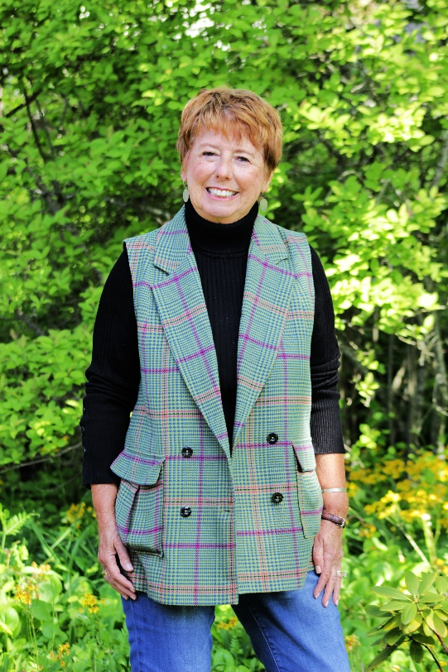
Dr. Sylvia Baer

CAPE MAY, N.J. – Cape May MAC (Museums+Arts+Culture) once again presents Cape May Poet Laureate Sylvia Baer in a new series of in-person writing workshops this summer open to writers of all levels. Sylvia brings her engaging teaching style and deep literary knowledge to this series that will explore four different genres of writing: poetry, fiction, memoir and children’s literature.
The Third Annual Writing Workshops with Poet Laureate Sylvia Baer: Poetry, Fiction, Memoir and Children’s Literature is open to everyone with an interest in writing, regardless of experience. Participants will learn about the essentials of each genre, with each workshop dedicated to one style: poetry on July 7, fiction on July 14, memoir on July 21 and children’s literature on July 28. Participants will have time for writing during each workshop. Sharing work is a personal choice and will not be required. After each session there will be time for discussion The workshops will be held in air-conditioned Cape May Convention Hall.
Dr. Sylvia Baer, a professor of literature for 51 years, is an engaging instructor and facilitator and the author of the memoir “Learning Life,” along with the sequel to that memoir, “Building Life Volume II,” She is a playwright, memoirist, writer of scholarly works, translator of Spanish poetry (into English), and a fellow at Yale University. She has curated haiku and photography exhibitions at Rowan University and Yale University, been founding editor of international academic journals, and is the creator of The Poet-Tree in Cape May, where she hangs about 60 poems with signage encouraging passers-by to pick any poem that appeals to them.
Third Annual Writing Workshops with Poet Laureate Sylvia Baer: Poetry, Fiction, Memoir and Children’s Literature is presented by Cape May MAC (Museums+Arts+Culture) and will be held at Cape May Convention Hall, 714 Beach Ave., on Monday, July 7, 14, 21 and 28 from 10 a.m. to 12 p.m. Each workshop is $25. For more information or tickets visit capemaymac.org and go to the Events tab or call 609-884-5404.
Cape May MAC is a multifaceted not-for-profit organization committed to promoting the preservation, interpretation and cultural enrichment of the Cape May region for its residents and visitors. Cape May MAC membership is open to all. For information about our year-round schedule of tours, festivals and events, visit capemaymac.org.

