

CONTACT: Susan Krysiak FOR IMMEDIATE RELEASE
Director of Media Relations
(609) 224-6036
skrysiak@capemaymac.org

Challenge your inner sleuth during Clueless at the Physick Estate: ‘Death of the Party’ in Cape May

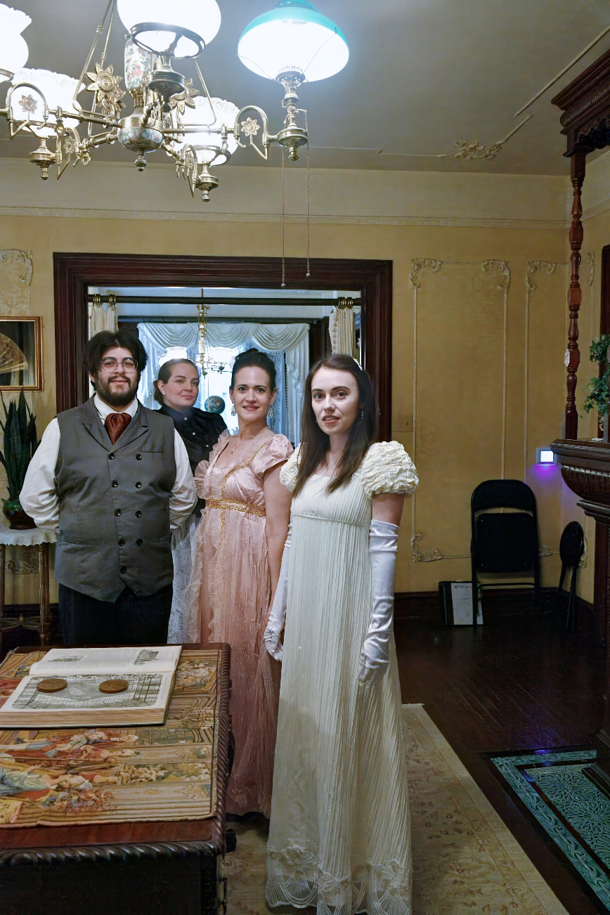

(Jul. 15, 2025) (photo courtesy of Cape May MAC): When the guest of honor at the birthday party is found dead, everyone is suspect. Was it the daughter, the business partner, the maid, or someone else? Hear their stories and accusations and see if you can guess "whodunit" in the interactive murder mystery “Clueless at the Physick Estate: Death of the Party” this summer at the Emlen Physick Estate, 1048 Washington St., as this original mystery unfolds from room to room. Don’t miss this chance to challenge your imagination and deduction skills in a one-of-a-kind historic Cape May setting. Accessible with advance notice. Don’t miss the chance to challenge your imagination and deduction skills in this one-of-a-kind historic Cape May setting. Adult admission $25, children (ages 3-12) $20. “Clueless at the Physick Estate: Death of the Party” is Mondays and Wednesdays through Aug. 27, 6:30 p.m. and 8:30 p.m. Tickets may be purchased online at capemaymac.org, in person at the Washington Street Mall Information Booth at Ocean Street or at the Physick Estate, 1048 Washington St. in the Carriage House Visitor’s Center or the Hill House Office. Hill House is open daily, 9 a.m. to 5 p.m. Admission is limited. Presented by Cape May MAC (Museums+Arts+Culture). capemaymac.org.

###

