**CONTACT:** Susan Krysiak **For Immediate Release**

Director of Media Relations July 15, 2025

609-224-6036

skrysiak@capemaymac.org

**Two new Cape May MAC tours highlight untold local history, focus on picturesque hot spots**

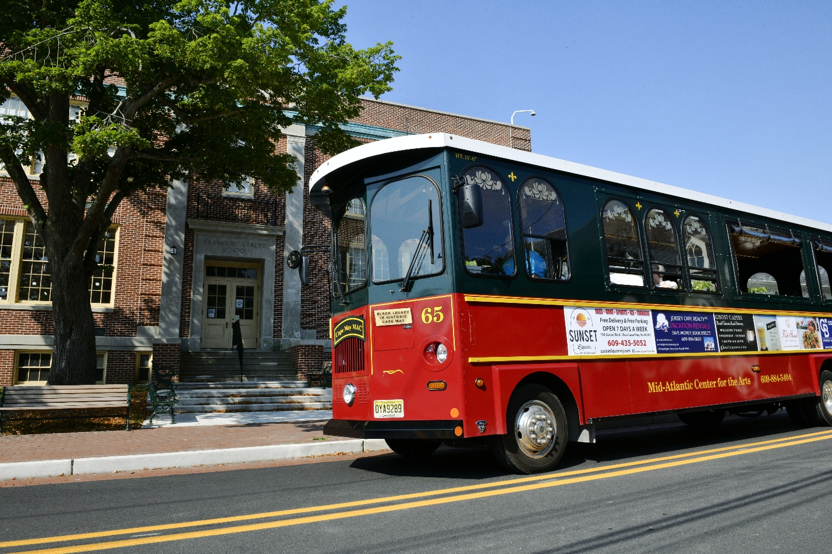

**Photo by Susan Krysiak**

**One of Cape May MAC’s new trolley tours this year is the Black Legacy in Historic Cape May Trolley Tour, shown here, passing by the Franklin Street School building, once a segregated school for African American children.**

**CAPE MAY –** Cape May MAC (Museums+Arts+Culture) is offering two new Cape May trolley tours and has updated some of its classic trolley tours to include new stories, new information and new experiences.

Cape May is the nation’s oldest seaside resort. Its Historic District, which encompasses the entire city, was placed on the New Jersey and National Registers of Historic Places in 1970 and designated as a National Historic Landmark by the Secretary of the Interior in 1976. The reason for the designation was based on the “almost complete showcase and largest collection of late 19th and early 20th century wood frame buildings left standing in the United States.”  Cape May remains the only city in the United States designated as such.

However, that designation did not include any reference to the African American history of the city during the late 19th and early 20th centuries. In the last several years, an extensive project was undertaken by the city to provide detail on the African American ethnic and cultural heritage contributions to the City of Cape May. In 2024, this documentation of the contributions of Cape May’s Black community led to approval and entry into the New Jersey Register of Historic Places and into the National Register of Historic Places.

***New!* Black Legacy in Historic Cape May Trolley Tour**

One of Cape May MAC’s new tours, Black Legacy in Historic Cape May Trolley Tour, celebrates these stories. Get ready to experience history in the making! We’re shining a spotlight on the incredible contributions of Cape May’s African American community — an essential part of the city’s story that’s finally getting the understanding and recognition it deserves.  The African American community was a significant influence on the social, economic, and cultural development of Cape May City.   As the trolley rolls through town, you’ll hear these stories and see homes, businesses, churches, and schools that stand as powerful symbols of resilience, innovation, and community.

***New!* Picture This Selfie Trolley Ride**

New this year, this afternoon trolley ride is the best way to see some of historic Cape May’s lesser-known picturesque locations that you might not otherwise visit or know about. The Picture This Selfie Trolley Ride travels to three special spots where there will be ample time to step off the trolley, see the sights, and take some photos. Along the way, knowledgeable and entertaining guides will dispense interesting tidbits about Cape May. Many of these trolley rides are scheduled in late afternoon, approaching the golden hour, also known as magic hour, when the sun is low in the sky, creating a warm glow that's ideal for photography.

***Updated!* Historic District Trolley Tour**

Known as the “Queen of the Seaside Resorts” for its quaint Victorian cottages and pristine beaches, Cape May is the oldest seaside resort in the country, and in 1976, the entire city was declared a National Historic Landmark. Possessing one of the country's largest collections of 19th century seaside wood framed buildings, the historic district features a variety of styles of Victorian architecture. On the Historic District Trolley Tour, tour guides will explain Cape May’s history and architecture and how and why it has survived and thrives to this day. The tour is newly updated with contributions of Cape May’s Black community recently documented and entered into the New Jersey Register of Historic Places and into the National Register of Historic Places. This tour is offered year-round either separately or as a combination tour with the guided house tour of the 1879 Emlen Physick Estate.

***Updated!* Welcome to Cape May Trolley Tour**

The Welcome to Cape May Trolley Tour is the best introduction to Cape May for first timers and for those who haven’t been to Cape May in some time. This narrated trolley tour highlights the many cultural, historical and natural attractions on the island. See and learn about the hidden gems and the little-known treasures of this glorious seaside town. The tour is newly updated with contributions of Cape May’s Black community recently documented and entered into the New Jersey Register of Historic Places and into the National Register of Historic Places.

***Updated!* Mansions by the Sea Trolley Tour: Then & Now**

This trolley tour examines Cape May's development and evolution through the lens of architectural practices, social changes and local history. On the Mansions by the Sea Trolley Tour: Then & Now, you’ll see the homes and grand seaside “cottages” of the 1800s along with the modern designs of today, travelling from the historic district eastward, covering a large swath of the city. See some of the most magnificent structures ever erected in Cape May. This tour is newly updated and expanded to a full 60 minutes.

For more information visit capemaymac.org or call 609-884-5404.

Cape May MAC (Museums+Arts+Culture) is a multifaceted not-for-profit organization committed to promoting the preservation, interpretation, and cultural enrichment of the Cape May region for its residents and visitors. We operate and manage the 1879 Emlen Physick Estate, the 1859 Cape May Lighthouse and the 1942 World War II Lookout Tower, and are the leading organization to offer visitors tours, activities and events year-round in America’s National Historic Landmark City. Cape May MAC is the organization that saved the 1879 Emlen Physick Estate from demolition, helping secure the City of Cape May as an internationally recognized historic destination. Cape May MAC membership is open to all. Visit [capemaymac.org/support/membership](https://capemaymac.org/support/membership/) to learn more. For information about Cape May MAC’s year-round schedule of tours, festivals and special events, visit [capemaymac.org](http://www.capemaymac.org). For information about historic accommodations, contact Cape May Historic Accommodations at [capemaylodging.com](http://www.capemaylodging.com). For information about restaurants, accommodations and shopping, call the Chamber of Commerce of Greater Cape May at 609-884-5508.