**CONTACT:** Susan Krysiak **FOR IMMEDIATE RELEASE**

Director of Media Relations July 15, 2025

(609) 224-6036

[skrysiak@capemaymac.org](mailto:skrysiak@capemaymac.org)

**Wendy Collins is Volunteer of the Month for July**

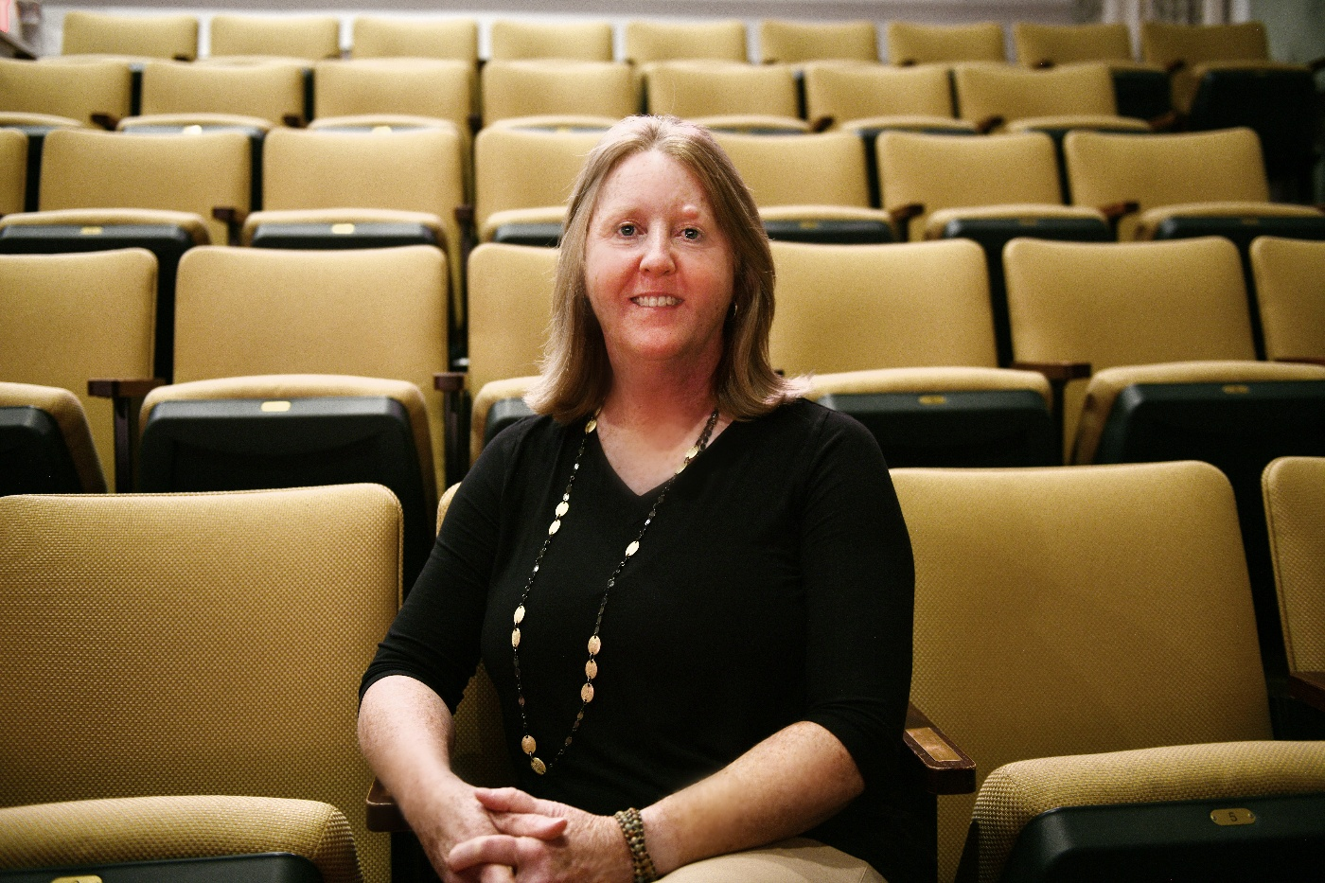

**(July 15, 2025) CAPE MAY - *(Photo courtesy of Cape May MAC) -*** Cape May MAC (Museums+Arts+Culture) announces the Volunteer of the Month for July is Cape May MAC board trustee Wendy Collins. She was nominated by Cape May MAC Chief Outreach Strategist Mary Stewart. “Wendy has been Cape May MAC’s primary contact for use of the Cape May Stage theater and has always been accommodating to our needs,” Stewart said. “In the month of May, we used the theater for two programs — “By the Book” and “Tattoo Uprising.” For both programs, Wendy opened the building, set up the screen and projector, generally served as our events manager and welcomed our guests! In addition, Wendy used Cape May Stage’s social media platform to help us advertise the events. Her assistance made both seamless, worry-free events. We are very grateful to her and to Cape May Stage for being outstanding partners.” For information about volunteer opportunities at Cape May MAC, contact Volunteer Coordinator Maria Amin at 609-224-6029 or mamin@capemaymac.org. Cape May MAC is a multifaceted not-for-profit organization committed to promoting the preservation, interpretation and cultural enrichment of the Cape May region for its residents and visitors. Cape May MAC membership is open to all. For information about the year-round schedule of tours, festivals and events, visit capemaymac.org.

###