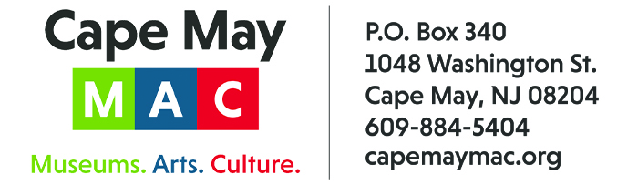

CONTACT: Susan Krysiak FOR IMMEDIATE RELEASE
Director of Media Relations Aug. 19, 2025
(609) 224-6036
skrysiak@capemaymac.org

Hannah Vaught-Crumbock is Cape May MAC Volunteer of the Month for August


(Aug. 19, 2025) CAPE MAY - (Photo courtesy of Cape May MAC) - Cape May MAC (Museums+Arts+Culture) announces the Volunteer of the Month for August is Hannah Vaught-Crumbock of Del Haven. She was nominated by Cape May MAC Chief Outreach Strategist Mary Stewart. “Hannah began volunteering as an assistant at our Lunch & Learn in January, after Brenda Leonard, who runs the program, asked for a technology and logistics back-up. Hannah is a college student and fits the position perfectly,” Stewart said. “She enjoys interacting with our audience and easily handles the technology. We want to thank her for being so generous with her time and talent.” For information about volunteer opportunities at Cape May MAC, contact Volunteer Coordinator Maria Amin at 609-224-6029 or mamin@capemaymac.org. Cape May MAC is a multifaceted not-for-profit organization committed to promoting the preservation, interpretation and cultural enrichment of the Cape May region for its residents and visitors. Cape May MAC membership is open to all. For information about the year-round schedule of tours, festivals and events, visit capemaymac.org.
###

